Microsoft Certified: Fabric Data Engineer Associate
121 Real Exam Question and Answers

Case Study 1:

This is a case study. Case studies are not timed separately. You can use as much exam time as you would like to complete each case. However, there may be additional case studies and sections on this exam. You must manage your time to ensure that you are able to complete all questions included on this exam in the time provided.
To answer the questions included in a case study, you will need to reference information that is provided in the case study. Case studies might contain exhibits and other resources that provide more information about the scenario that is described in the case study. Each question is independent of the other questions in this case study.
At the end of this case study, a review screen will appear. This screen allows you to review your answers and to make changes before you move to the next section of the exam. After you begin a new section, you cannot return to this section.
To start the case study
To display the first question in this case study, click the Next button. Use the buttons in the left pane to explore the content of the case study before you answer the questions. Clicking these buttons displays information such as business requirements, existing environment, and problem statements. If the case study has an All Information tab, note that the information displayed is identical to the information displayed on the subsequent tabs.
When you are ready to answer a question, click the Question button to return to the question.

Overview:

Litware, Inc. is a publishing company that has an online bookstore and several retail bookstores worldwide. Litware also manages an online advertising business for the authors it represents.

Existing Environment. Fabric Environment
Litware has a Fabric workspace named Workspace1. High concurrency is enabled for Workspace1.
The company has a data engineering team that uses Python for data processing.

Existing Environment. Data Processing
The retail bookstores send sales data at the end of each business day, while the online bookstore constantly provides logs and sales data to a central enterprise resource planning (ERP) system.
Litware implements a medallion architecture by using the following three layers: bronze, silver, and gold. The sales data is ingested from the ERP system as Parquet files that land in the Files folder in a lakehouse. Notebooks are used to transform the files in a Delta table for the bronze and silver layers. The gold layer is in a warehouse that has V-Order disabled.
Litware has image files of book covers in Azure Blob Storage. The files are loaded into the Files folder.

Existing Environment. Sales Data
Month-end sales data is processed on the first calendar day of each month. Data that is older than one month never changes.
In the source system, the sales data refreshes every six hours starting at midnight each day. The sales data is captured in a Dataflow Gen2 dataflow.
When the dataflow runs, new and historical data is captured. The dataflow captures the following fields of the
source:
Sales Date Author Price Units
SKU
A table named AuthorSales stores the sales data that relates to each author. The table contains a column named AuthorEmail. Authors authenticate to a guest Fabric tenant by using their email address.
Existing Environment. Security Groups Litware has the following security groups:
Sales
Fabric Admins Streaming Admins
Existing Environment. Performance Issues
Business users perform ad-hoc queries against the warehouse. The business users indicate that reports against the warehouse sometimes run for two hours and fail to load as expected. Upon further investigation, the data engineering team receives the following error message when the reports fail to load: "The SQL query

The data engineering team wants to debug the issue and find queries that cause more than one failure. When the authors have new book releases, there is often an increase in sales activity. This increase slows the data ingestion process.
The company's sales team reports that during the last month, the sales data has NOT been up-to-date when they arrive at work in the morning.

Requirements. Planned Changes
Litware recently signed a contract to receive book reviews. The provider of the reviews exposes the data in
Amazon Simple Storage Service (Amazon S3) buckets.
Litware plans to manage Search Engine Optimization (SEO) for the authors. The SEO data will be streamed from a REST API.

Requirements. Version Control
Litware plans to implement a version control solution in Fabric that will use GitHub integration and follow
the principle of least privilege.

Requirements. Governance Requirements
To control data platform costs, the data platform must use only Fabric services and items. Additional Azure resources must NOT be provisioned.

Requirements. Data Requirements
Litware identifies the following data requirements:
Process the SEO data in near-real-time (NRT).
Make the book reviews available in the lakehouse without making a copy of the data.
When a new book cover image arrives in the Files folder, process the image as soon as possible.

Case Study 2:


This is a case study. Case studies are not timed separately. You can use as much exam time as you would like to complete each case. However, there may be additional case studies and sections on this exam. You must manage your time to ensure that you are able to complete all questions included on this exam in the time provided.
To answer the questions included in a case study, you will need to reference information that is provided in the case study. Case studies might contain exhibits and other resources that provide more information about the scenario that is described in the case study. Each question is independent of the other questions in this case study.
At the end of this case study, a review screen will appear. This screen allows you to review your answers and to make changes before you move to the next section of the exam. After you begin a new section, you cannot return to this section.
To start the case study
To display the first question in this case study, click the Next button. Use the buttons in the left pane to explore the content of the case study before you answer the questions. Clicking these buttons displays information such as business requirements, existing environment, and problem statements. If the case study has an All Information tab, note that the information displayed is identical to the information displayed on the subsequent tabs.
When you are ready to answer a question, click the Question button to return to the question.

Overview:
- Company Overview
Contoso, Ltd. is an online retail company that wants to modernize its analytics platform by moving to Fabric. The company plans to begin using Fabric for marketing analytics.

Overview:
- IT Structure
The company's IT department has a team of data analysts and a team of data engineers that use analytics
systems.
The data engineers perform the ingestion, transformation, and loading of data. They prefer to use Python or SQL to transform the data.
The data analysts query data and create semantic models and reports. They are qualified to write queries in Power Query and T-SQL.

Existing Environment. Fabric
Contoso has an F64 capacity named Cap1. All Fabric users are allowed to create items.
Contoso has two workspaces named WorkspaceA and WorkspaceB that currently use Pro license mode.

Existing Environment. Source Systems

Contoso has a point of sale (POS) system named POS1 that uses an instance of SQL Server on Azure Virtual Machines in the same Microsoft Entra tenant as Fabric. The host virtual machine is on a private virtual network that has public access blocked. POS1 contains all the sales transactions that were processed on the company's website.
The company has a software as a service (SaaS) online marketing app named MAR1. MAR1 has seven entities. The entities contain data that relates to email open rates and interaction rates, as well as website interactions. The data can be exported from MAR1 by calling REST APIs. Each entity has a different endpoint. Contoso has been using MAR1 for one year. Data from prior years is stored in Parquet files in an Amazon Simple Storage Service (Amazon S3) bucket. There are 12 files that range in size from 300 MB to 900 MB and relate to email interactions.

Existing Environment. Product Data
POS1 contains a product list and related data. The data comes from the following three tables:
Products ProductCategories ProductSubcategories
In the data, products are related to product subcategories, and subcategories are related to product
categories.

Existing Environment. Azure
Contoso has a Microsoft Entra tenant that has the following mail-enabled security groups:
DataAnalysts: Contains the data analysts DataEngineers: Contains the data engineers Contoso has an Azure subscription.
The company has an existing Azure DevOps organization and creates a new project for repositories that relate to Fabric.

Existing Environment. User Problems
The VP of marketing at Contoso requires analysis on the effectiveness of different types of email content. It typically takes a week to manually compile and analyze the data. Contoso wants to reduce the time to less than one day by using Fabric.
The data engineering team has successfully exported data from MAR1. The team experiences transient
connectivity errors, which causes the data exports to fail.

Requirements. Planned Changes
Contoso plans to create the following two lakehouses:
Lakehouse1: Will store both raw and cleansed data from the sources
Lakehouse2: Will serve data in a dimensional model to users for analytical queries
Additional items will be added to facilitate data ingestion and transformation. Contoso plans to use Azure Repos for source control in Fabric.

Requirements. Technical Requirements
The new lakehouses must follow a medallion architecture by using the following three layers: bronze, silver, and gold. There will be extensive data cleansing required to populate the MAR1 data in the silver layer, including deduplication, the handling of missing values, and the standardizing of capitalization.
Each layer must be fully populated before moving on to the next layer. If any step in populating the lakehouses fails, an email must be sent to the data engineers.
Data imports must run simultaneously, when possible.
The use of email data from the Amazon S3 bucket must meet the following requirements:
Minimize egress costs associated with cross-cloud data access. Prevent saving a copy of the raw data in the lakehouses.
Items that relate to data ingestion must meet the following requirements:
The items must be source controlled alongside other workspace items. Ingested data must land in the bronze layer of Lakehouse1 in the Delta format.
No changes other than changes to the file formats must be implemented before the data lands in the bronze
layer.
Development effort must be minimized and a built-in connection must be used to import the source data. In the event of a connectivity error, the ingestion processes must attempt the connection again.
Lakehouses, data pipelines, and notebooks must be stored in WorkspaceA. Semantic models, reports, and
dataflows must be stored in WorkspaceB.
Once a week, old files that are no longer referenced by a Delta table log must be removed.

Requirements. Data Transformation
In the POS1 product data, ProductID values are unique. The product dimension in the gold layer must include only active products from product list. Active products are identified by an IsActive value of 1. Some product categories and subcategories are NOT assigned to any product. They are NOT analytically relevant and must be omitted from the product dimension in the gold layer.

Requirements. Data Security
Security in Fabric must meet the following requirements:
The data engineers must have read and write access to all the lakehouses, including the underlying files.
The data analysts must only have read access to the Delta tables in the gold layer. The data analysts must NOT have access to the data in the bronze and silver layers. The data engineers must be able to commit changes to source control in WorkspaceA.

Case Study 3:

This is a case study. Case studies are not timed separately. You can use as much exam time as you would like to complete each case. However, there may be additional case studies and sections on this exam.
You must manage your time to ensure that you are able to complete all questions included on this exam in
the time provided.
To answer the questions included in a case study, you will need to reference information that is provided in the case study. Case studies might contain exhibits and other resources that provide more information about the scenario that is described in the case study. Each question is independent of the other questions in this case study.
At the end of this case study, a review screen will appear. This screen allows you to review your answers and to make changes before you move to the next section of the exam. After you begin a new section, you cannot return to this section.
To start the case study
To display the first question in this case study, click the Next button. Use the buttons in the left pane to explore the content of the case study before you answer the questions. Clicking these buttons displays information such as business requirements, existing environment, and problem statements. If the case study has an All Information tab, note that the information displayed is identical to the information displayed on the subsequent tabs.
When you are ready to answer a question, click the Question button to return to the question.

Overview:

Litware, Inc. is a publishing company that has an online bookstore and several retail bookstores worldwide. Litware also manages an online advertising business for the authors it represents.

Existing Environment. Fabric Environment
Litware has a Fabric workspace named Workspace1. High concurrency is enabled for Workspace1.
The company has a data engineering team that uses Python for data processing.

Existing Environment. Data Processing
The retail bookstores send sales data at the end of each business day, while the online bookstore constantly provides logs and sales data to a central enterprise resource planning (ERP) system.
Litware implements a medallion architecture by using the following three layers: bronze, silver, and gold. The sales data is ingested from the ERP system as Parquet files that land in the Files folder in a lakehouse. Notebooks are used to transform the files in a Delta table for the bronze and silver layers. The gold layer is in a warehouse that has V-Order disabled.
Litware has image files of book covers in Azure Blob Storage. The files are loaded into the Files folder.

Existing Environment. Sales Data
Month-end sales data is processed on the first calendar day of each month. Data that is older than one month never changes.
In the source system, the sales data refreshes every six hours starting at midnight each day.
The sales data is captured in a Dataflow Gen2 dataflow.
When the dataflow runs, new and historical data is captured. The dataflow captures the following fields of the source:
Sales Date Author Price Units
SKU
A table named AuthorSales stores the sales data that relates to each author. The table contains a column named AuthorEmail. Authors authenticate to a guest Fabric tenant by using their email address.

Existing Environment. Security Groups Litware has the following security groups: Sales
Fabric Admins Streaming Admins

Existing Environment. Performance Issues
Business users perform ad-hoc queries against the warehouse. The business users indicate that reports against the warehouse sometimes run for two hours and fail to load as expected. Upon further investigation, the data engineering team receives the following error message when the reports fail to load: "The SQL query failed while running."
The data engineering team wants to debug the issue and find queries that cause more than one failure. When the authors have new book releases, there is often an increase in sales activity. This increase slows the data ingestion process.
The company's sales team reports that during the last month, the sales data has NOT been up-to-date when they arrive at work in the morning.

Requirements. Planned Changes
Litware recently signed a contract to receive book reviews. The provider of the reviews exposes the data in Amazon Simple Storage Service (Amazon S3) buckets.
Litware plans to manage Search Engine Optimization (SEO) for the authors. The SEO data will be streamed from a REST API.

Requirements. Version Control
Litware plans to implement a version control solution in Fabric that will use GitHub integration and follow the principle of least privilege.

Requirements. Governance Requirements
To control data platform costs, the data platform must use only Fabric services and items. Additional Azure resources must NOT be provisioned.

Requirements. Data Requirements
Litware identifies the following data requirements:
Process the SEO data in near-real-time (NRT).
Make the book reviews available in the lakehouse without making a copy of the data.
When a new book cover image arrives in the Files folder, process the image as soon as possible.

Case Study 4:

This is a case study. Case studies are not timed separately. You can use as much exam time as you would like to complete each case. However, there may be additional case studies and sections on this exam.
You must manage your time to ensure that you are able to complete all questions included on this exam in the time provided.
To answer the questions included in a case study, you will need to reference information that is provided in the case study. Case studies might contain exhibits and other resources that provide more information about the scenario that is described in the case study. Each question is independent of the other questions in this case study.
At the end of this case study, a review screen will appear. This screen allows you to review your answers and to make changes before you move to the next section of the exam. After you begin a new section, you cannot return to this section.
To start the case study
To display the first question in this case study, click the Next button. Use the buttons in the left pane to explore the content of the case study before you answer the questions. Clicking these buttons displays information such as business requirements, existing environment, and problem statements. If the case study has an All Information tab, note that the information displayed is identical to the information displayed on the subsequent tabs.
When you are ready to answer a question, click the Question button to return to the question.

Overview:
- Company Overview
Contoso, Ltd. is an online retail company that wants to modernize its analytics platform by moving to Fabric.
The company plans to begin using Fabric for marketing analytics.

Overview:
- IT Structure
The company's IT department has a team of data analysts and a team of data engineers that use analytics systems.
The data engineers perform the ingestion, transformation, and loading of data. They prefer to use Python
or SQL to transform the data.
The data analysts query data and create semantic models and reports. They are qualified to write queries in Power Query and T-SQL.

Existing Environment. Fabric
Contoso has an F64 capacity named Cap1. All Fabric users are allowed to create items.
Contoso has two workspaces named WorkspaceA and WorkspaceB that currently use Pro license mode.

Existing Environment. Source Systems
Contoso has a point of sale (POS) system named POS1 that uses an instance of SQL Server on Azure Virtual Machines in the same Microsoft Entra tenant as Fabric. The host virtual machine is on a private virtual network that has public access blocked. POS1 contains all the sales transactions that were processed on the company's website.
The company has a software as a service (SaaS) online marketing app named MAR1. MAR1 has seven entities. The entities contain data that relates to email open rates and interaction rates, as well as website interactions. The data can be exported from MAR1 by calling REST APIs. Each entity has a different endpoint.
Contoso has been using MAR1 for one year. Data from prior years is stored in Parquet files in an Amazon Simple Storage Service (Amazon S3) bucket. There are 12 files that range in size from 300 MB to 900 MB and relate to email interactions.

Existing Environment. Product Data
POS1 contains a product list and related data. The data comes from the following three tables:
Products ProductCategories ProductSubcategories
In the data, products are related to product subcategories, and subcategories are related to product categories.

Existing Environment. Azure
Contoso has a Microsoft Entra tenant that has the following mail-enabled security groups:
DataAnalysts: Contains the data analysts DataEngineers: Contains the data engineers Contoso has an Azure subscription.
The company has an existing Azure DevOps organization and creates a new project for repositories that relate to Fabric.

Existing Environment. User Problems
The VP of marketing at Contoso requires analysis on the effectiveness of different types of email content. It typically takes a week to manually compile and analyze the data. Contoso wants to reduce the time to less than one day by using Fabric.
The data engineering team has successfully exported data from MAR1. The team experiences transient
connectivity errors, which causes the data exports to fail.

Requirements. Planned Changes
Contoso plans to create the following two lakehouses:
Lakehouse1: Will store both raw and cleansed data from the sources
Lakehouse2: Will serve data in a dimensional model to users for analytical queries
Additional items will be added to facilitate data ingestion and transformation. Contoso plans to use Azure Repos for source control in Fabric.

Requirements. Technical Requirements
The new lakehouses must follow a medallion architecture by using the following three layers: bronze, silver, and gold. There will be extensive data cleansing required to populate the MAR1 data in the silver layer, including deduplication, the handling of missing values, and the standardizing of capitalization.
Each layer must be fully populated before moving on to the next layer. If any step in populating the lakehouses fails, an email must be sent to the data engineers.
Data imports must run simultaneously, when possible.
The use of email data from the Amazon S3 bucket must meet the following requirements:
Minimize egress costs associated with cross-cloud data access. Prevent saving a copy of the raw data in the lakehouses.
Items that relate to data ingestion must meet the following requirements:
The items must be source controlled alongside other workspace items. Ingested data must land in the bronze layer of Lakehouse1 in the Delta format.
No changes other than changes to the file formats must be implemented before the data lands in the bronze
layer.
Development effort must be minimized and a built-in connection must be used to import the source data. In the event of a connectivity error, the ingestion processes must attempt the connection again.
Lakehouses, data pipelines, and notebooks must be stored in WorkspaceA. Semantic models, reports, and
dataflows must be stored in WorkspaceB.
Once a week, old files that are no longer referenced by a Delta table log must be removed.

Requirements. Data Transformation
In the POS1 product data, ProductID values are unique. The product dimension in the gold layer must include only active products from product list. Active products are identified by an IsActive value of 1. Some product categories and subcategories are NOT assigned to any product. They are NOT analytically relevant and must be omitted from the product dimension in the gold layer.

Requirements. Data Security
Security in Fabric must meet the following requirements:
The data engineers must have read and write access to all the lakehouses, including the underlying files. The data analysts must only have read access to the Delta tables in the gold layer.
The data analysts must NOT have access to the data in the bronze and silver layers. The data engineers must be able to commit changes to source control in WorkspaceA.

Case Study 5:

This is a case study. Case studies are not timed separately. You can use as much exam time as you would like to complete each case. However, there may be additional case studies and sections on this exam.
You must manage your time to ensure that you are able to complete all questions included on this exam in the time provided.
To answer the questions included in a case study, you will need to reference information that is provided in the case study. Case studies might contain exhibits and other resources that provide more information about the scenario that is described in the case study. Each question is independent of the other questions in this case study.
At the end of this case study, a review screen will appear. This screen allows you to review your answers and to make changes before you move to the next section of the exam. After you begin a new section, you cannot return to this section.
To start the case study
To display the first question in this case study, click the Next button. Use the buttons in the left pane to explore the content of the case study before you answer the questions. Clicking these buttons displays information such as business requirements, existing environment, and problem statements. If the case study has an All Information tab, note that the information displayed is identical to the information displayed on the subsequent tabs.
When you are ready to answer a question, click the Question button to return to the question.

Overview:

Litware, Inc. is a publishing company that has an online bookstore and several retail bookstores worldwide. Litware also manages an online advertising business for the authors it represents.

Existing Environment. Fabric Environment
Litware has a Fabric workspace named Workspace1. High concurrency is enabled for Workspace1. The company has a data engineering team that uses Python for data processing.

Existing Environment. Data Processing
The retail bookstores send sales data at the end of each business day, while the online bookstore constantly provides logs and sales data to a central enterprise resource planning (ERP) system.
Litware implements a medallion architecture by using the following three layers: bronze, silver, and gold. The sales data is ingested from the ERP system as Parquet files that land in the Files folder in a lakehouse. Notebooks are used to transform the files in a Delta table for the bronze and silver layers. The gold layer is in a warehouse that has V-Order disabled.
Litware has image files of book covers in Azure Blob Storage. The files are loaded into the Files folder.

Existing Environment. Sales Data
Month-end sales data is processed on the first calendar day of each month. Data that is older than one month
never changes.
In the source system, the sales data refreshes every six hours starting at midnight each day. The sales data is captured in a Dataflow Gen2 dataflow.
When the dataflow runs, new and historical data is captured. The dataflow captures the following fields of the source:
Sales Date Author Price Units
SKU
A table named AuthorSales stores the sales data that relates to each author. The table contains a column
named AuthorEmail. Authors authenticate to a guest Fabric tenant by using their email address.

Existing Environment. Security Groups Litware has the following security groups: Sales
Fabric Admins
Streaming Admins

Existing Environment. Performance Issues

Business users perform ad-hoc queries against the warehouse. The business users indicate that reports against the warehouse sometimes run for two hours and fail to load as expected. Upon further investigation, the data engineering team receives the following error message when the reports fail to load: "The SQL query failed while running."
The data engineering team wants to debug the issue and find queries that cause more than one failure. When the authors have new book releases, there is often an increase in sales activity. This increase slows the data ingestion process.
The company's sales team reports that during the last month, the sales data has NOT been up-to-date when they arrive at work in the morning.

Requirements. Planned Changes
Litware recently signed a contract to receive book reviews. The provider of the reviews exposes the data in Amazon Simple Storage Service (Amazon S3) buckets.
Litware plans to manage Search Engine Optimization (SEO) for the authors. The SEO data will be streamed from a REST API.

Requirements. Version Control
Litware plans to implement a version control solution in Fabric that will use GitHub integration and follow the principle of least privilege.

Requirements. Governance Requirements
To control data platform costs, the data platform must use only Fabric services and items.
Additional Azure resources must NOT be provisioned.

Requirements. Data Requirements
Litware identifies the following data requirements:
Process the SEO data in near-real-time (NRT).
Make the book reviews available in the lakehouse without making a copy of the data.
When a new book cover image arrives in the Files folder, process the image as soon as possible.

Case Study 6:

This is a case study. Case studies are not timed separately. You can use as much exam time as you would like to complete each case. However, there may be additional case studies and sections on this exam. You must manage your time to ensure that you are able to complete all questions included on this exam in the time provided.
To answer the questions included in a case study, you will need to reference information that is provided in the case study. Case studies might contain exhibits and other resources that provide more information about the scenario that is described in the case study. Each question is independent of the other questions in this case study.
At the end of this case study, a review screen will appear. This screen allows you to review your answers and to make changes before you move to the next section of the exam. After you begin a new section, you cannot return to this section.
To start the case study
To display the first question in this case study, click the Next button. Use the buttons in the left pane to explore the content of the case study before you answer the questions. Clicking these buttons displays information such as business requirements, existing environment, and problem statements. If the case study has an All Information tab, note that the information displayed is identical to the information displayed on the subsequent tabs.
When you are ready to answer a question, click the Question button to return to the question.

Overview:
- Company Overview
Contoso, Ltd. is an online retail company that wants to modernize its analytics platform by moving to Fabric. The company plans to begin using Fabric for marketing analytics.

Overview:
- IT Structure
The company's IT department has a team of data analysts and a team of data engineers that use analytics
systems.
The data engineers perform the ingestion, transformation, and loading of data. They prefer to use Python or SQL to transform the data.
The data analysts query data and create semantic models and reports. They are qualified to write queries in Power Query and T-SQL.

Existing Environment. Fabric
Contoso has an F64 capacity named Cap1. All Fabric users are allowed to create items.
Contoso has two workspaces named WorkspaceA and WorkspaceB that currently use Pro license mode.

Existing Environment. Source Systems
Contoso has a point of sale (POS) system named POS1 that uses an instance of SQL Server on Azure Virtual Machines in the same Microsoft Entra tenant as Fabric. The host virtual machine is on a private virtual network that has public access blocked. POS1 contains all the sales transactions that were processed on the company's website.
The company has a software as a service (SaaS) online marketing app named MAR1. MAR1 has seven entities. The entities contain data that relates to email open rates and interaction rates, as well as website interactions. The data can be exported from MAR1 by calling REST APIs. Each entity has a different endpoint. Contoso has been using MAR1 for one year. Data from prior years is stored in Parquet files in an Amazon Simple Storage Service (Amazon S3) bucket. There are 12 files that range in size from 300 MB to 900 MB and relate to email interactions.
Existing Environment. Product Data
POS1 contains a product list and related data. The data comes from the following three tables:
Products ProductCategories ProductSubcategories
In the data, products are related to product subcategories, and subcategories are related to product categories.
Existing Environment. Azure
Contoso has a Microsoft Entra tenant that has the following mail-enabled security groups: DataAnalysts: Contains the data analysts
DataEngineers: Contains the data engineers Contoso has an Azure subscription.

The company has an existing Azure DevOps organization and creates a new project for repositories that relate
to Fabric.

Existing Environment. User Problems
The VP of marketing at Contoso requires analysis on the effectiveness of different types of email content. It typically takes a week to manually compile and analyze the data. Contoso wants to reduce the time to less than one day by using Fabric.
The data engineering team has successfully exported data from MAR1. The team experiences transient
connectivity errors, which causes the data exports to fail.

Requirements. Planned Changes
Contoso plans to create the following two lakehouses:
Lakehouse1: Will store both raw and cleansed data from the sources
Lakehouse2: Will serve data in a dimensional model to users for analytical queries
Additional items will be added to facilitate data ingestion and transformation. Contoso plans to use Azure Repos for source control in Fabric.

Requirements. Technical Requirements
The new lakehouses must follow a medallion architecture by using the following three layers: bronze, silver, and gold. There will be extensive data cleansing required to populate the MAR1 data in the silver layer, including deduplication, the handling of missing values, and the standardizing of capitalization.
Each layer must be fully populated before moving on to the next layer. If any step in populating the lakehouses fails, an email must be sent to the data engineers.

Data imports must run simultaneously, when possible.
The use of email data from the Amazon S3 bucket must meet the following requirements:
Minimize egress costs associated with cross-cloud data access. Prevent saving a copy of the raw data in the lakehouses.
Items that relate to data ingestion must meet the following requirements:
The items must be source controlled alongside other workspace items. Ingested data must land in the bronze layer of Lakehouse1 in the Delta format.
No changes other than changes to the file formats must be implemented before the data lands in the bronze layer. Development effort must be minimized and a built-in connection must be used to import the source data. In the event of a connectivity error, the ingestion processes must attempt the connection again.
Lakehouses, data pipelines, and notebooks must be stored in WorkspaceA. Semantic models, reports, and dataflows must be stored in WorkspaceB.
Once a week, old files that are no longer referenced by a Delta table log must be removed.
Requirements. Data Transformation
In the POS1 product data, ProductID values are unique. The product dimension in the gold layer must include only active products from product list. Active products are identified by an IsActive value of 1.
Some product categories and subcategories are NOT assigned to any product. They are NOT analytically relevant and must be omitted from the product dimension in the gold layer.
Requirements. Data Security
Security in Fabric must meet the following requirements:
The data engineers must have read and write access to all the lakehouses, including the underlying files. The data analysts must only have read access to the Delta tables in the gold layer.
The data analysts must NOT have access to the data in the bronze and silver layers. The data engineers must be able to commit chan^{h}g^{tt}e^{ps}s://t^{s}o^{hap}s^{in}o^{gp}u^{ix}r^{e}c^{l.c}e^{om}control in WorkspaceA.

    - You need to ensure that the data analysts can access the gold layer lakehouse. ( Case Study 2)

What should you do?

- Add the DataAnalyst group to the Viewer role for WorkspaceA.
- Share the lakehouse with the DataAnalysts group and grant the Build reports on the default semantic model permission.
- Share the lakehouse with the DataAnalysts group and grant the Read all SQL Endpoint data permission.
- Share the lakehouse with the DataAnalysts group and grant the Read all Apache Spark permission.

Correct Answer: C

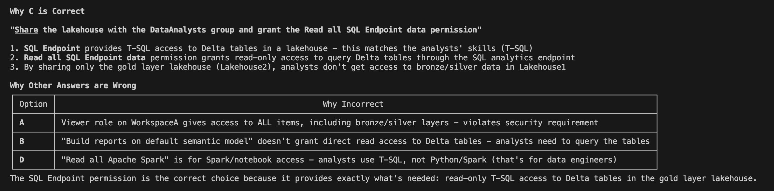

- You have a Fabric workspace. You have semi-structured data.
You need to read the data by using T-SQL, KQL, and Apache Spark. The data will only be written by using Spark.
What should you use to store the data?
- a lakehouse
- an eventhouse
- a datamart
- a warehouse

Correct Answer: A

- You have a Fabric workspace that contains a warehouse named Warehouse1. You have an on-premises Microsoft SQL Server database named Database1 that is accessed by using an on-premises data gateway.
You need to copy data from Database1 to Warehouse1. Which item should you use?

A. a Dataflow Gen1 dataflow
B. a data pipeline
C. a KQL queryset
D. a notebook

- You have a Fabric workspace that contains a warehouse named Warehouse1. You have an on-premises Microsoft SQL Server database named Database1 that is accessed by using an on-premises data gateway.
You need to copy data from Database1 to Warehouse1. Which item should you use?

A. a Dataflow Gen1 dataflow
B. a data pipeline
C. a KQL queryset
D. a notebook

Correct Answer: B

https://learn.microsoft.com/en-us/fabric/data-factory/how-to-access-on-premises-data

- You have a Fabric workspace that contains a warehouse named Warehouse1. You have an on-premises Microsoft SQL Server database named Database1 that is accessed by using an on-premises data gateway.
You need to copy data from Database1 to Warehouse1. Which item should you use?

  - an Apache Spark job definition
  - a data pipeline
  - a Dataflow Gen1 dataflow
  - an eventstream

- You have a Fabric workspace that contains a warehouse named Warehouse1. You have an on-premises Microsoft SQL Server database named Database1 that is accessed by using an on-premises data gateway.
You need to copy data from Database1 to Warehouse1. Which item should you use?

  - an Apache Spark job definition
  - a data pipeline
  - a Dataflow Gen1 dataflow
  - an eventstream

Correct Answer: B

- You have a Fabric F32 capacity that contains a workspace. The workspace contains a warehouse named DW1 that is
modelled by using MD5 hash surrogate keys.
DW1 contains a single fact table that has grown from 200 million rows to 500 million rows during the past year. You have Microsoft Power BI reports that are based on Direct Lake. The reports show year-over-year values.
Users report that the performance of some of the reports has degraded over time and some visuals show errors. You need to resolve the performance issues. The solution must meet the following requirements:
Provide the best query performance. Minimize operational costs.
Which should you do?

  - Change the MD5 hash to SHA256.
  - Increase the capacity.
  - Enable V-Order.
  - Modify the surrogate keys to use a different data type.
  - Create views.

- You have a Fabric F32 capacity that contains a workspace. The workspace contains a warehouse named DW1 that is
modelled by using MD5 hash surrogate keys.
DW1 contains a single fact table that has grown from 200 million rows to 500 million rows during the past year. You have Microsoft Power BI reports that are based on Direct Lake. The reports show year-over-year values.
Users report that the performance of some of the reports has degraded over time and some visuals show errors. You need to resolve the performance issues. The solution must meet the following requirements:
Provide the best query performance. Minimize operational costs.
Which should you do?

  - Change the MD5 hash to SHA256.
  - Increase the capacity.
  - Enable V-Order.
  - Modify the surrogate keys to use a different data type.
  - Create views.

Correct Answer: D

Why Answer D is Correct

The key issue in this scenario is that the warehouse uses MD5 hash surrogate keys, which are string-based (32 hexadecimal characters = 32
bytes per key).

The Problem with MD5 Hash Keys
┌───────────────────┬──────────────┬────────────────────────────────┐
│ Key Type │ Storage Size │ Impact on 500M rows │
├───────────────────┼──────────────┼────────────────────────────────┤
│ MD5 Hash (string) │ 32 bytes │ ~16 GB just for one key column │
├───────────────────┼──────────────┼────────────────────────────────┤
│ BIGINT (integer) │ 8 bytes │ ~4 GB for the same column │
└───────────────────┴──────────────┴────────────────────────────────┘
Why D Solves the Problem

Modifying surrogate keys to use integer data types (like BIGINT):

1. Reduces storage significantly - Integer keys are 4x smaller than MD5 strings
2. Improves join performance - Integer comparisons are far faster than string comparisons
3. Stays within Direct Lake guardrails - Direct Lake has limits on total memory per column; smaller data types help avoid hitting these
limits
4. Minimizes operational costs - No need to purchase higher capacity

Why Other Options Are Wrong

- A (SHA256): Would make keys larger (64 chars vs 32), worsening performance
- B (Increase capacity): Violates "minimize operational costs" requirement
- C (V-Order): Helps with compression/read patterns but doesn't address the fundamental inefficiency of string-based keys
- E (Create views): Views are just query abstractions; they don't improve underlying performance

The "visuals show errors" symptom likely indicates Direct Lake is falling back to DirectQuery mode due to exceeding guardrails—a problem
that smaller integer keys would resolve.
- You have a Fabric workspace that contains a warehouse named DW1. DW1 contains the following tables and columns.

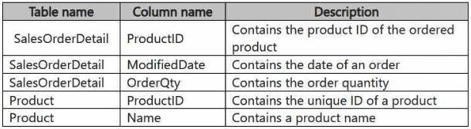

You need to create an output that presents the summarized values of all the order quantities by year and product. The results must include a summary of the order quantities at the year level for all the products. How should you complete the code? To answer, select the appropriate options in the answer area.
NOTE: Each correct selection is worth one point.

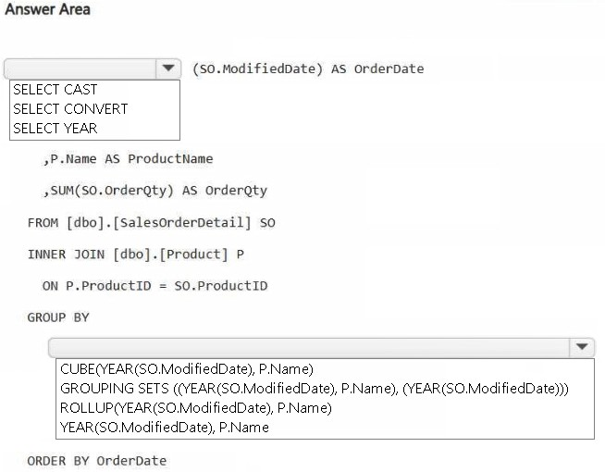



- You have a Fabric workspace that contains a lakehouse named Lakehouse1. Data is
ingested into Lakehouse1 as one flat table. The table contains the following columns.
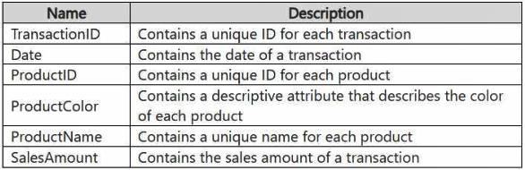
You plan to load the data into a dimensional model and implement a star schema. From the original flat table, you create two tables named FactSales and DimProduct. You will track changes in DimProduct.
You need to prepare the data.
Which three columns should you include in the DimProduct table? Each correct answer presents part of the solution. NOTE: Each correct selection is worth one point.
  - Date
  - ProductName
  - ProductColor
  - TransactionID
  - SalesAmount
  - ProductID

Correct Answer: BCF

- You have a Fabric workspace named Workspace1 that contains a notebook named Notebook1. In Workspace1, you create a new notebook named Notebook2.
You need to ensure that you can attach Notebook2 to the same Apache Spark session as Notebook1.
What should you do?

  - Enable high concurrency for notebooks.
  - Enable dynamic allocation for the Spark pool.
  - Change the runtime version.
  - Increase the number of executors.

Correct Answer: A

Why "Enable High Concurrency for Notebooks" Is Correct

The Requirement

You need two notebooks to share the same Spark session.

What High Concurrency Mode Does

High Concurrency Mode in Microsoft Fabric allows:
- Multiple notebooks to share a single Spark session
- Multiple users to run notebooks on the same Spark cluster simultaneously
- Session resources to be shared across notebooks in the same workspace

This is exactly what the question asks for—attaching Notebook2 to the same Spark session as Notebook1.

Why Other Options Are Wrong
┌──────────────────────────────┬──────────────────────────────────────────────────────────┬───────────────────────────────────────────────────┐
│ Option │ What It Does │ Why It's Wrong │
├──────────────────────────────┼──────────────────────────────────────────────────────────┼───────────────────────────────────────────────────┤
│ B. Enable dynamic allocation │ Automatically scales executors up/down based on workload │ Manages resources, doesn't enable session sharing │
├──────────────────────────────┼──────────────────────────────────────────────────────────┼───────────────────────────────────────────────────┤
│ C. Change runtime version │ Switches Spark/Python versions │ Has nothing to do with session sharing │
├──────────────────────────────┼──────────────────────────────────────────────────────────┼───────────────────────────────────────────────────┤
│ D. Increase executors │ Adds more parallel processing power │ More resources, but still separate sessions │
└──────────────────────────────┴──────────────────────────────────────────────────────────┴───────────────────────────────────────────────────┘
Key Concept

By default, each notebook in Fabric gets its own isolated Spark session. This provides:
- Isolation between workloads
- Independent resource allocation

High Concurrency Mode changes this behavior, allowing notebooks to:
- Attach to a shared session
- Share cached data and variables
- Reduce startup time (no need to spin up new sessions)
- Share compute costs across multiple notebooks

This is particularly useful when you have related notebooks that need to work with the same data or when you want to optimize resource usage.
- You have a Fabric workspace named Workspace1 that contains a lakehouse named Lakehouse1. Lakehouse1 contains the
following tables:
Orders - Customer - Employee -
The Employee table contains Personally Identifiable Information (PII).
A data engineer is building a workflow that requires writing data to the Customer table, however, the user does NOT have the
elevated permissions required to view the contents of the Employee table.
You need to ensure that the data engineer can write data to the Customer table without reading data from the Employee table.
Which three actions should you perform? Each correct answer presents part of the solution. NOTE: Each correct selection is worth one point.
  - Share Lakehouse1 with the data engineer.
  - Assign the data engineer the Contributor role for Workspace2.
  - Assign the data engineer the Viewer role for Workspace2.
  - Assign the data engineer the Contributor role for Workspace1.
  - Migrate the Employee table from Lakehouse1 to Lakehouse2.
  - Create a new workspace named Workspace2 that contains a new lakehouse named Lakehouse2.
  - Assign the data engineer the Viewer role for Workspace1.

Correct Answer: DEF

Why D, E, F Are the Correct Answers

The Challenge
┌──────────────────────────────────────────────────┬────────────────────────────────────────┐
│ Requirement │ Problem │
├──────────────────────────────────────────────────┼────────────────────────────────────────┤
│ Data engineer must write to Customer table │ Needs write permissions │
├──────────────────────────────────────────────────┼────────────────────────────────────────┤
│ Data engineer must NOT read Employee table (PII) │ Both tables are in the same Lakehouse1 │
└──────────────────────────────────────────────────┴────────────────────────────────────────┘
Key issue: In Fabric, workspace permissions apply to ALL items in the workspace. You cannot set different permissions for different tables within the same lakehouse.

The Solution: Separate the Sensitive Data

The three steps work together:
┌──────┬────────────────────────────────────────┬───────────────────────────────────────────────────────┐
│ Step │ Action │ Purpose │
├──────┼────────────────────────────────────────┼───────────────────────────────────────────────────────┤
│ F │ Create Workspace2 with Lakehouse2 │ Create isolated location for PII data │
├──────┼────────────────────────────────────────┼───────────────────────────────────────────────────────┤
│ E │ Migrate Employee table to Lakehouse2 │ Move sensitive data to isolated workspace │
├──────┼────────────────────────────────────────┼───────────────────────────────────────────────────────┤
│ D │ Assign Contributor role for Workspace1 │ Grant write access to Customer (Employee is now gone) │
└──────┴────────────────────────────────────────┴───────────────────────────────────────────────────────┘
Result

Workspace1 (Data engineer = Contributor)
└── Lakehouse1
├── Orders ✓ Can read/write
└── Customer ✓ Can read/write

Workspace2 (Data engineer = No access)
└── Lakehouse2
└── Employee ✗ Cannot access

Why Other Options Are Wrong
┌───────────────────────────────┬────────────────────────────────────────────────────────────┐
│ Option │ Why It Fails │
├───────────────────────────────┼────────────────────────────────────────────────────────────┤
│ A. Share Lakehouse1 │ Sharing gives read access to ALL tables including Employee │
├───────────────────────────────┼────────────────────────────────────────────────────────────┤
│ B. Contributor for Workspace2 │ Wrong! That's where Employee goes - should NOT have access │
├───────────────────────────────┼────────────────────────────────────────────────────────────┤
│ C. Viewer for Workspace2 │ Wrong workspace + Viewer cannot write anyway │
├───────────────────────────────┼────────────────────────────────────────────────────────────┤
│ G. Viewer for Workspace1 │ Viewer role = read only, cannot write to Customer │
└───────────────────────────────┴────────────────────────────────────────────────────────────┘
Key Concept

Physical separation is required when you need different access levels for different tables. Fabric's security model is workspace-based, so sensitive data must be moved to a
separate workspace with restricted access.

- You have a Fabric warehouse named DW1. DW1 contains a table that stores sales data and is used by
multiple sales representatives.
You plan to implement row-level security (RLS).
You need to ensure that the sales representatives can see only their respective data. Which warehouse object do you require to implement RLS?

  - STORED PROCEDURE
  - CONSTRAINT
  - SCHEMA
  - FUNCTION

Correct Answer: D

- HOTSPOT -
You have a Fabric workspace named Workspace1_DEV that contains the following items: 10 reports
Four notebooks –
Three lakehouses –
Two data pipelines -
Two Dataflow Gen1 dataflows -

Three Dataflow Gen2 dataflows -

Five semantic models that each has a scheduled refresh policy

You create a deployment pipeline named Pipeline1 to move items from Workspace1_DEV to a new workspace named Workspace1_TEST.
You deploy all the items from Workspace1_DEV to Workspace1_TEST.
For each of the following statements, select Yes if the statement is true. Otherwise, select No. NOTE: Each correct selection is worth one point.

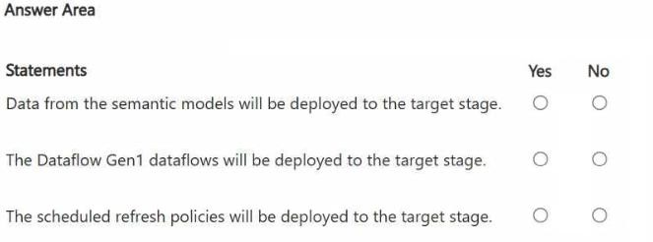

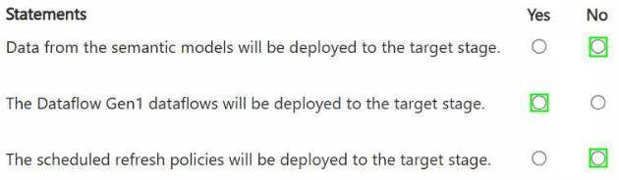

- You have a Fabric deployment pipeline that uses three workspaces named Dev, Test, and Prod. You need to deploy an eventhouse as part of the deployment process.
What should you use to add the eventhouse to the deployment process?

- GitHub Actions
- a deployment pipeline
- an Azure DevOps pipeline

Correct Answer: B

Fabric Deployment Pipeline is like a simplified, specialized version designed only for Fabric. GitHub Actions and Azure DevOps are full CI/CD platforms that can do much more but require more setup

- You have a Fabric workspace named Workspace1 that contains a warehouse named Warehouse1.
You plan to deploy Warehouse1 to a new workspace named Workspace2.
As part of the deployment process, you need to verify whether Warehouse1 contains invalid references. The solution must minimize development effort.
What should you use?

A. a database project
B. a deployment pipeline
C. a Python script
D. a T-SQL script

Correct Answer: B

- You have a Fabric workspace that contains a Real-Time Intelligence solution and an eventhouse. Users report that from OneLake file explorer, they cannot see the data from the eventhouse.
You enable OneLake availability for the eventhouse. What will be copied to OneLake?

  - only data added to new databases that are added to the eventhouse
  - only the existing data in the eventhouse
  - no data
  - both new data and existing data in the eventhouse
  - only new data added to the eventhouse

Correct Answer: E

- You have a Fabric workspace named Workspace1. You plan to integrate Workspace1 with Azure DevOps.
You will use a Fabric deployment pipeline named deployPipeline1 to deploy items from Workspace1 to higher environment workspaces as part of a medallion architecture. You will run deployPipeline1 by using an API call from an Azure DevOps pipeline.
You need to configure API authentication between Azure DevOps and Fabric. Which type of authentication should you use?

  - service principal
  - Microsoft Entra username and password
  - managed private endpoint
  - workspace identity

Correct Answer: A

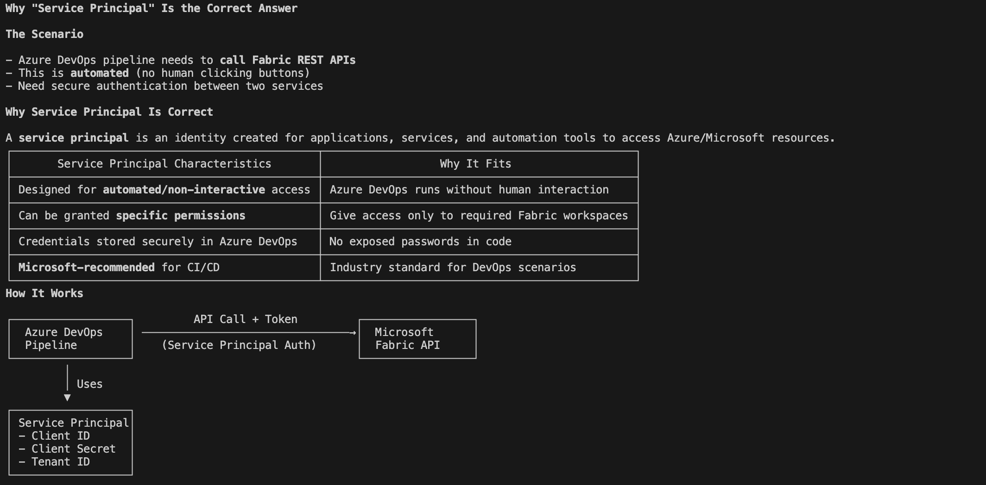
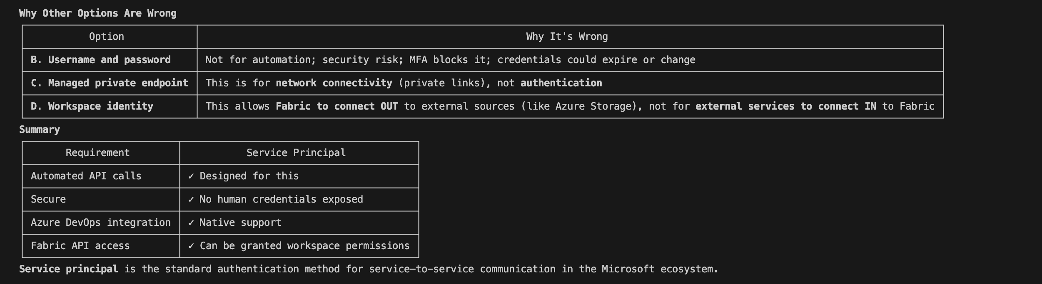

- You have a Google Cloud Storage (GCS) container named storage1 that contains the
files shown in the following table.

You have a Fabric workspace named Workspace1 that has the cache for shortcuts enabled. Workspace1 contains a
lakehouse named Lakehouse1. Lakehouse1 has the shortcuts shown in the following table.
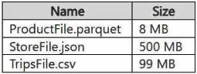
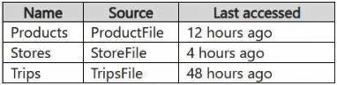
You need to read data from all the shortcuts. Which shortcuts will retrieve data from the cache?
  - Stores only
  - Products only
  - Stores and Products only
  - Products, Stores, and Trips
  - Trips only
  - Products and Trips only

Correct Answer: C

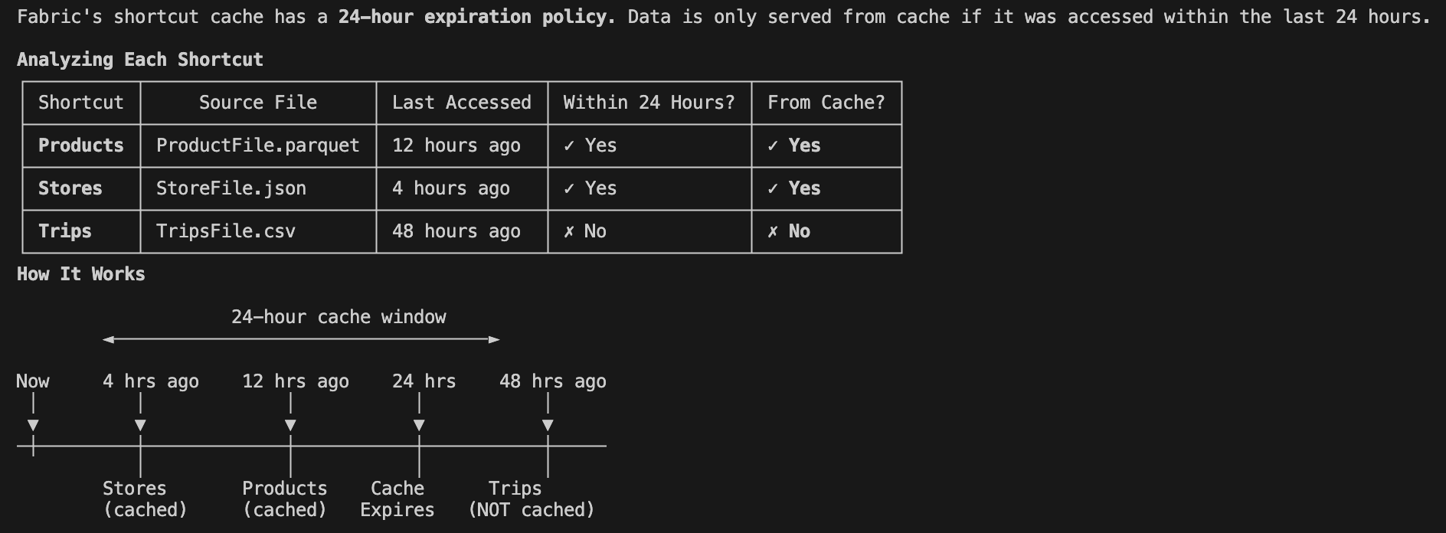

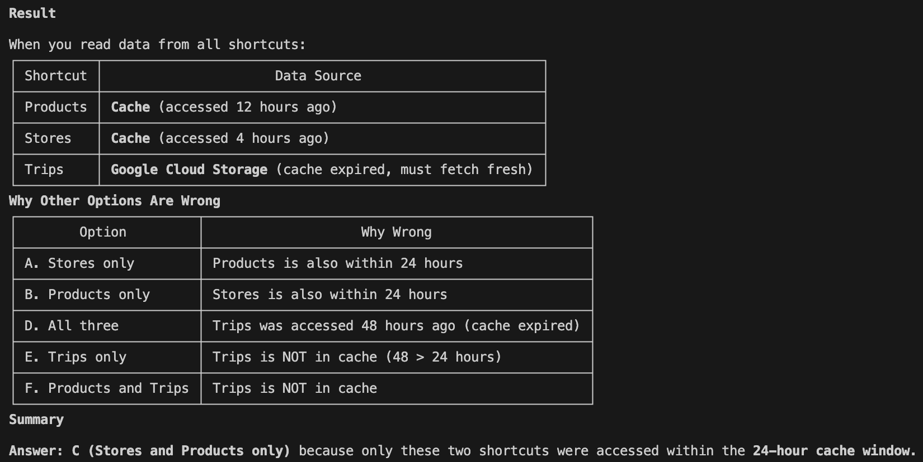

- You have two Fabric workspaces named Workspace1 and Workspace2.
You have a Fabric deployment pipeline named deployPipeline1 that deploys items from Workspace1 to Workspace2. DeployPipeline1 contains all the items in Workspace1.
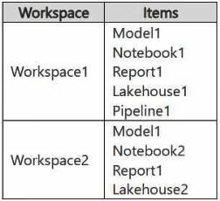
You recently modified the items in Workspaces1.
The workspaces currently contain the items shown in the following table.
Items in Workspace1 that have the same name as items in Workspace2 are currently paired.
You need to ensure that the items in Workspace1 overwrite the corresponding items
in Workspace2. The solution must minimize effort. What should you do?

  - Delete all the items in Workspace2, and then run deployPipeline1.
  - Rename each item in Workspace2 to have the same name as the items in Workspace1.
  - Back up the items in Workspace2, and then run deployPipeline1.
  - Run deployPipeline1 without modifying the items in Workspace2.

- You have two Fabric workspaces named Workspace1 and Workspace2.
You have a Fabric deployment pipeline named deployPipeline1 that deploys items from Workspace1 to Workspace2. DeployPipeline1 contains all the items in Workspace1.

You recently modified the items in Workspaces1.
The workspaces currently contain the items shown in the following table.
Items in Workspace1 that have the same name as items in Workspace2 are currently paired.
You need to ensure that the items in Workspace1 overwrite the corresponding items in Workspace2. The solution must minimize effort.
What should you do?
  - Delete all the items in Workspace2, and then run deployPipeline1.
  - Rename each item in Workspace2 to have the same name as the items in Workspace1.
  - Back up the items in Workspace2, and then run deployPipeline1.
  - Run deployPipeline1 without modifying the items in Workspace2.
Answer : D
When running a deployment pipeline in Fabric, if the items in Workspace1 are paired with the corresponding items in Workspace2 (based on the same name), the deployment pipeline will automatically overwrite the existing items in Workspace2 with the modified items from Workspace1. There's no need to delete, rename, or back up items manually unless you need to keep versions. By simply running deployPipeline1, the pipeline will handle overwriting the existing items in Workspace2 based on the pairing, ensuring the latest version of the items is deployed with minimal effort.

- You have a Fabric capacity that contains a workspace named Workspace1. Workspace1 contains a lakehouse named Lakehouse1, a data pipeline, a notebook, and several Microsoft Power BI reports.
A user named User1 wants to use SQL to analyze the data in Lakehouse1.
You need to configure access for User1. The solution must meet the following requirements: What should you do?
  - Share Lakehouse1 with User1 directly and select Read all SQL endpoint data.
  - Assign User1 the Viewer role for Workspace1. Share Lakehouse1 with User1 and select Read all SQL endpoint data.
  - Share Lakehouse1 with User1 directly and select Build reports on the default semantic model.
  - Assign User1 the Member role for Workspace1. Share Lakehouse1 with User1 and select
Read all SQL endpoint data.
Answer : B

To meet the specified requirements for User1, the solution must ensure:
Read access to the table data in Lakehouse1: User1 needs permission to access the data within Lakehouse1. By sharing Lakehouse1 with User1 and selecting the Read all SQL endpoint data option, User1 will be able to query the data via SQL endpoints.
Prevent Apache Spark usage: By sharing the lakehouse directly and selecting the SQL endpoint data option, you specifically enable SQL-based access to the data, preventing User1 from using Apache Spark to query the data.
Prevent access to other items in Workspace1: Assigning User1 the Viewer role for Workspace1 ensures that User1 can only view the shared items (in this case, Lakehouse1), without accessing other resources such as notebooks, pipelines, or Power BI reports within Workspace1.
This approach provides the appropriate level of access while restricting User1 to only the required resources and preventing access to other workspace assets.

- You have a Fabric workspace named Workspace1 that contains a warehouse named DW1 and a data pipeline named Pipeline1.
You plan to add a user named User3 to Workspace1.
You need to ensure that User3 can perform the following actions:
View all the items in Workspace1. Update the tables in DW1.
The solution must follow the principle of least privilege.
You already assigned the appropriate object-level permissions to DW1.
Which workspace role should you assign to User3?

  - Admin
  - Member
  - Viewer
  - Contributor

Answer : D

To ensure User3 can view all items in Workspace1 and update the tables in DW1, the most appropriate workspace role to assign is the Contributor role. This role allows User3 to:
View all items in Workspace1: The Contributor role provides the ability to view all objects within the workspace, such as data pipelines, warehouses, and other resources.
Update the tables in DW1: The Contributor role allows User3 to modify or update resources within the workspace, including the tables in DW1, assuming that appropriate object-level permissions are set for the warehouse.
This role adheres to the principle of least privilege, as it provides the necessary permissions without granting broader
administrative rights.

- Your company has a sales department that uses two Fabric workspaces named Workspace1 and Workspace2. The company decides to implement a domain strategy to organize the workspaces.
You need to ensure that a user can perform the following tasks:
Create a new domain for the sales department.
Create two subdomains: one for the east region and one for the west region. Assign Workspace1 to the east region subdomain.
Assign Workspace2 to the west region subdomain.
The solution must follow the principle of least privilege. Which role should you assign to the user?

  - workspace Admin
  - domain admin
  - domain contributor
  - Fabric admin

Answer : B

To implement a domain strategy and manage subdomains within Fabric, the domain admin role is the appropriate role for the user. A domain admin has the permissions necessary to:
Create a new domain (for the sales department). Create subdomains (for the east and west regions).
Assign workspaces (such as Workspace1 and Workspace2) to the appropriate subdomains.
The domain admin role allows for managing the structure and organization of workspaces in the context of domains and subdomains while maintaining the principle of least privilege by limiting the user's access to managing the domain structure specifically.

- You have an Azure Data Lake Storage Gen2 account named storage1 and an Amazon S3 bucket named storage2.
You have the Delta Parquet files shown in the following table.

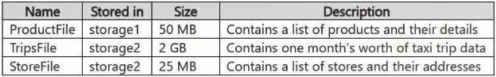
You have a Fabric workspace named Workspace1 that has the cache for shortcuts enabled. Workspace1 contains a lakehouse named Lakehouse1.
Lakehouse1 has the following shortcuts:
The data from which shortcuts will be retrieved from the cache?
- Trips and Stores only
- Products and Store only
- Stores only
- Products only
- Products. Stores, and Trips

Answer : B

Caching
Shortcut caching can reduce egress costs associated with cross-cloud data access. As OneLake reads files through an external shortcut, the service stores the files in a cache for the Fabric workspace. OneLake responds to subsequent read requests from the cache rather than the remote storage provider. You can set the retention period for cached files between 1-28 days. Each time you access the file, the retention period is reset. If the remote storage provide has a more recent version of the file than the cache's version, then OneLake serves the request from the remote storage provider and updates the file in the cache. If you don't access a file within the selected retention period, it's purged from the cache. Individual files greater than 1 GB in size aren't cached.

When the cache for shortcuts is enabled in Fabric, the data retrieval is governed by the caching behavior, which generally retains data for a specific period after it was last accessed. The data from the shortcuts will be retrieved from the cache if the data is stored in locations that support caching. Here's a breakdown based on the data's location:
Products: The ProductFile is stored in Azure Data Lake Storage Gen2 (storage1). Since Azure Data Lake is a supported storage system in Fabric and the file is relatively small (50 MB), this data is most likely cached and can be retrieved from the cache.
Stores: The StoreFile is stored in Amazon S3 (storage2), and even though it is stored in a different cloud provider, Fabric can cache data from Amazon S3 if caching is enabled. This data (25 MB) is likely cached and retrievable.
Trips: The TripsFile is stored in Amazon S3 (storage2) and is significantly larger (2 GB) compared to the other files. While Fabric can cache data from Amazon S3, the larger size of the file (2 GB) may exceed typical cache sizes or retention windows, causing this file to likely be retrieved directly from the source instead of the cache.

- You have a Fabric workspace named Workspace1 that contains an Apache Spark job definition named Job1. You have an Azure SQL database named Source1 that has public internet access disabled.
You need to ensure that Job1 can access the data in Source1. What should you create?
- an on-premises data gateway

- a managed private endpoint

- an integration runtime

- a data management gateway
Answer : B
To allow Job1 in Workspace1 to access an Azure SQL database (Source1) with public internet access disabled, you need to create a managed private endpoint. A managed private endpoint is a secure, private connection that enables services like Fabric (or other Azure services) to access resources such as databases, storage accounts, or other services within a virtual network (VNet) without requiring public internet access. This approach maintains the security and integrity of your data while enabling access to the Azure SQL database.


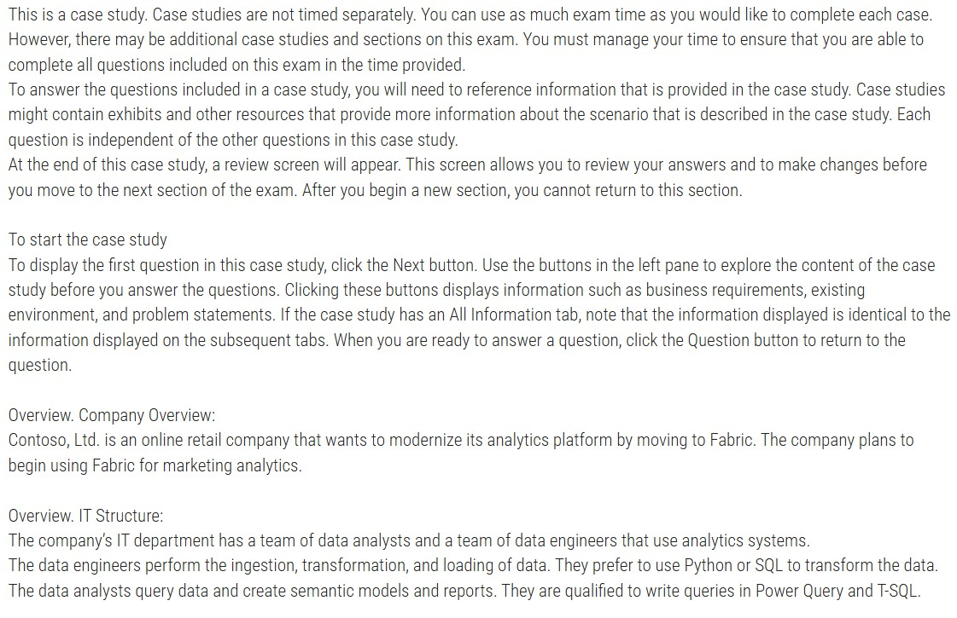


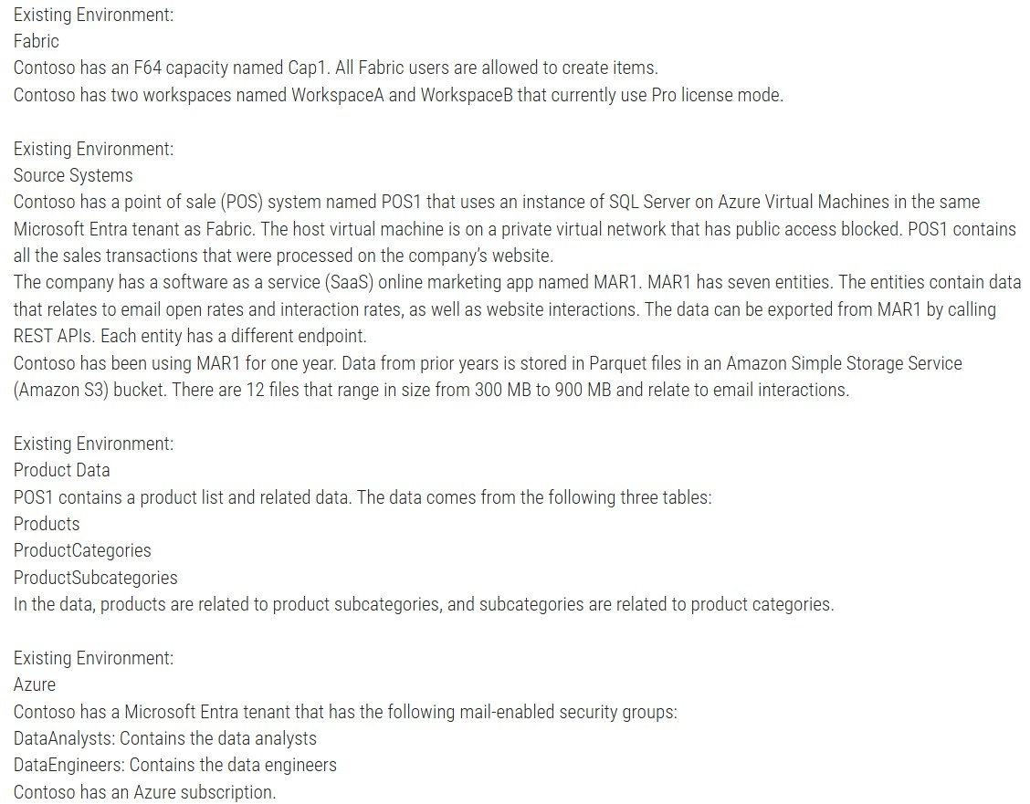


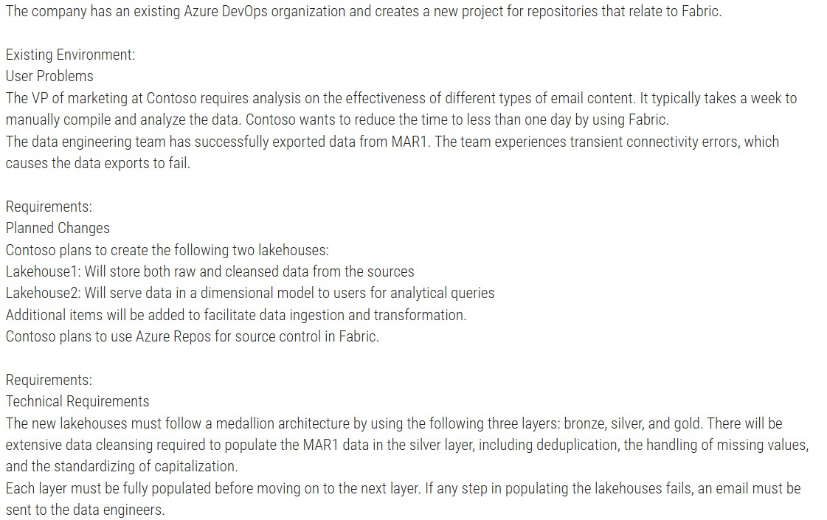


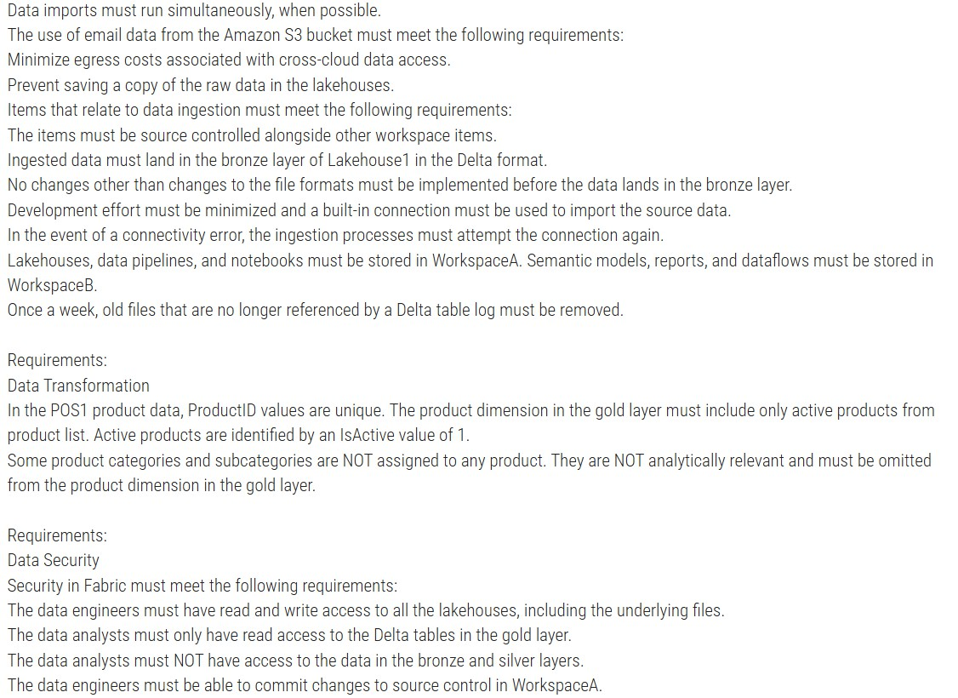

- You need to schedule the population of the medallion layers to meet the technical
requirements.
What should you do?
  - Schedule a data pipeline that calls other data pipelines.

  - Schedule a notebook.

  - Schedule an Apache Spark job.

  - Schedule multiple data pipelines.

Answer: A

The technical requirements specify that: Why Use a Data Pipeline That Calls Other Data Pipelines?
- Sequential execution of child pipelines.
- Error handling to send email notifications upon failures.
- Parallel execution of tasks where possible (e.g., simultaneous imports into the bronze layer).

- You have a Fabric notebook named Notebook1 that has been executing successfully
for the last week.
During the last run, Notebook1executed nine jobs. You need to view the jobs in a timeline chart.
What should you use?
- Real-Time hub

- Monitoring hub

- the job history from the application run

- Spark History Server

- the run series from the details of the application run Answer: E
The run series from the details of the application run is the most detailed and relevant feature for visualizing job execution
in a timeline format, making it the correct choice for this scenario. It provides an intuitive way to analyze job execution patterns and improve the efficiency of the notebook.
Explanation:
The run series from the details of the application run is the most detailed and relevant feature for visualizing job execution in a timeline format, making it the correct choice for this scenario.
It provides an intuitive way to analyze job execution patterns and improve the efficiency of the notebook.

- You have a Fabric warehouse named DW1 that loads data by using a data pipeline named Pipeline1. Pipeline1 uses a Copy data activity with a dynamic SQL source. Pipeline1 is scheduled to run every 15minutes.
You discover that Pipeline1 keeps failing.
You need to identify which SQL query was executed when the pipeline failed.
What should you do?

- From Monitoring hub, select the latest failed run of Pipeline1, and then view the output JSON.

- From Monitoring hub, select the latest failed run of Pipeline1, and then view the input JSON.

- From Real-time hub, select Fabric events, and then review the details of Microsoft.Fabric.ItemReadFailed.

- From Real-time hub, select Fabric events, and then review the details of Microsoft. Fabric.ItemUpdateFailed.

Answer: B

Explanation:The input JSON contains the configuration details and parameters passed to the Copy data activity during execution, including the dynamically generated SQL query.
Viewing the input JSON for the failed pipeline run provides direct insight into what query was executed at the time of failure.

- You have a Fabric workspace that contains an eventstream named EventStream1. EventStream1 outputs events
to a table in a lakehouse.
You need to remove files that are older than seven days and are no longer in use. Which command should you run?
  - VACUUM

  - COMPUTE

  - OPTIMIZE

  - CLONE
Answer: A

Explanation: VACUUM is used to clean up storage by removing files no longer in use by a Delta table. It removes old and unreferenced files from Delta tables. For example, to remove files older than 7 days:
VACUUM delta.`/path_to_table` RETAIN 7 HOURS;

- You have a Fabric workspace that contains a warehouse named Warehouse1. Data is loaded daily into Warehouse1 by using data pipelines and stored procedures.
You discover that the daily data load takes longer than expected.
You need to monitor Warehouse1 to identify the names of users that are actively running queries.
Which view should you use?

  - sys.dm_exec_connections

  - sys.dm_exec_requests

  - queryinsights.long_running_queries

  - queryinsights.frequently_run_queries

  - sys.dm_exec_sessions
Answer: E
Explanation:sys.dm_exec_sessions provides real-time information about all active sessions, including the user, session ID, and status of the session. You can filter on session status to see users actively running queries.
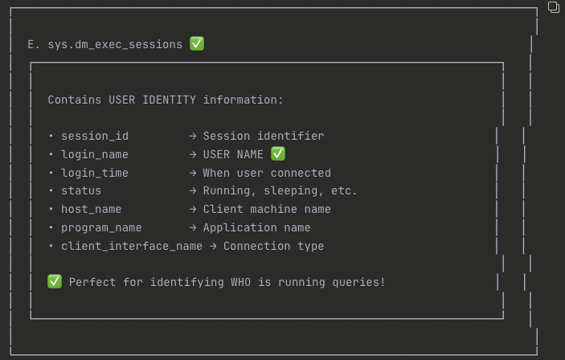

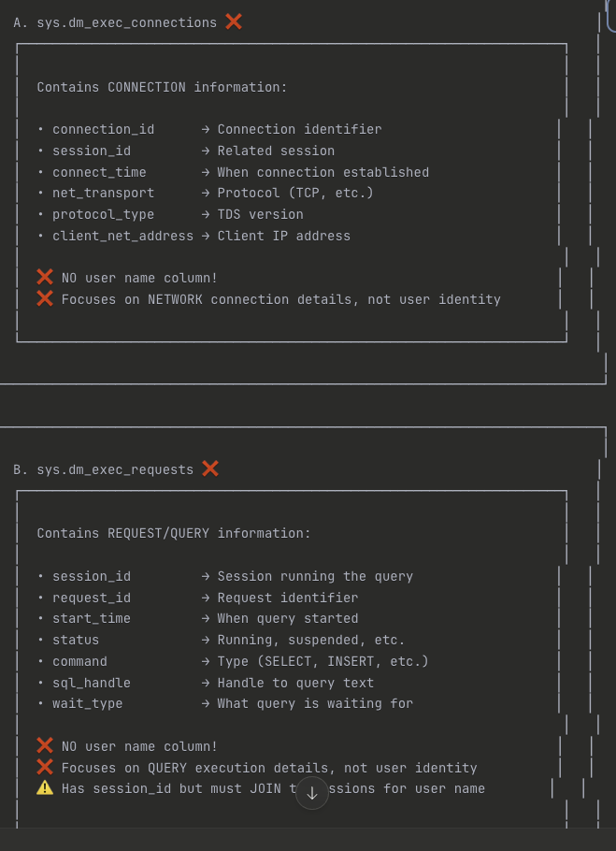

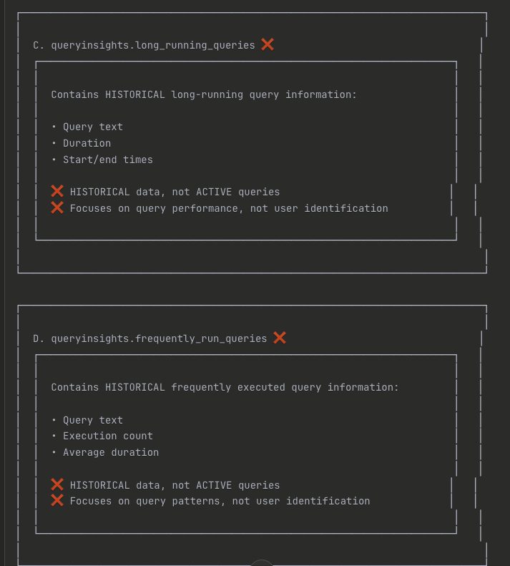
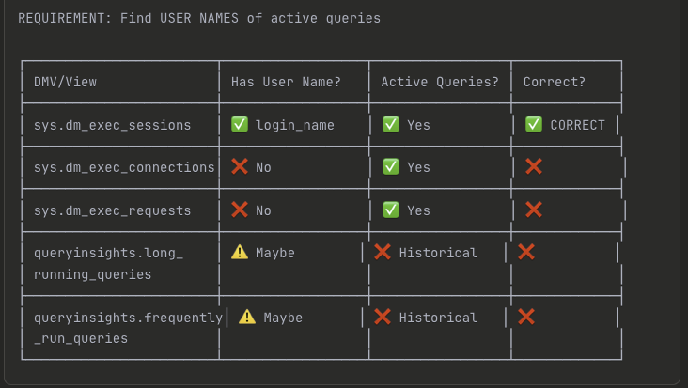
- You have a Fabric workspace that contains a lakehouse named Lakehouse1.
In an external data source, you have data files that are 500GB each. A new file is added every day.
You need to ingest the data into Lakehouse1 without applying any transformations. The solution must meet the following requirements
Trigger the process when a new file is added.
Provide the highest throughput.
Which type of item should you use to ingest the data?

  - Data pipeline
  - Environment
  - KQL queryset
  - Dataflow Gen2

Correct Answer: A

To efficiently ingest large data files (500 GB each) into Lakehouse1 with high throughput and trigger the process when a new file is added, a Data pipeline is the most suitable solution. Data pipelines in Fabric are ideal for orchestrating data movement and can be configured to automatically trigger based on file arrivals or other events. This solution meets both requirements: ingesting the data without transformations (since you just need to copy the data) and triggering the process when new files are added.

- You have a Fabric workspace that contains an eventhouse and a KQL database named Database1. Database1 has the following:
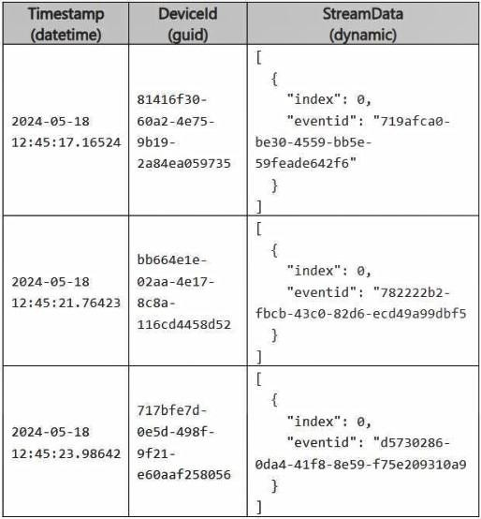
Policy1 sends data from Table1 to Table2.
The following is a sample of the data in Table2.

Recently, the following actions were performed on Table1: You plan to load additional records to Table2.
Which two records will load from Table1 to Table2? Each correct answer
presents a complete solution.
NOTE: Each correct selection is worth one point. A)
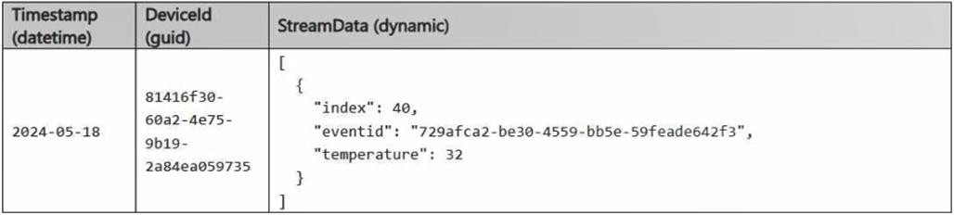
B)
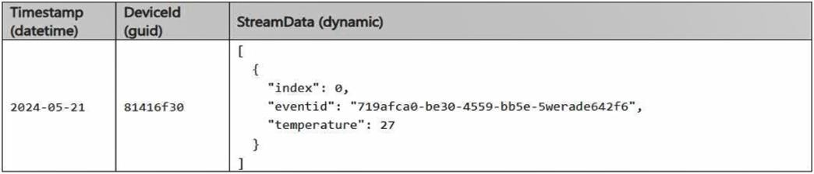
https://shapingpixel.com

C)
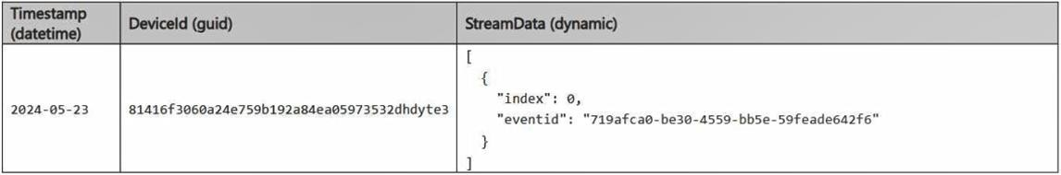
D)
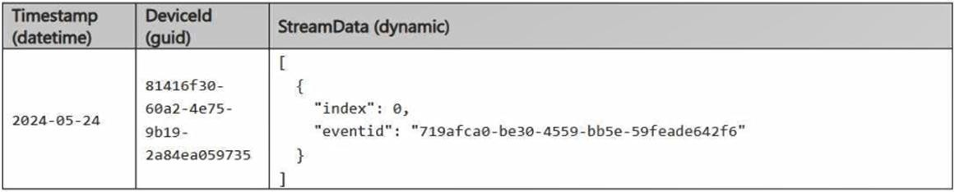

- Option A

- Option B

- Option c

- Option D

Correct Answer: B, D Changes to Table1 Structure:
Impact of Changes:
Record B:
Accepted because it fully matches Table2's structure and data types. Record D:
Accepted because it fully matches Table2's structure and data types.

- You have a Fabric workspace that contains a warehouse named DW1. DW1 is loaded by using a
notebook named Notebook1.
You need to identify which version of Delta was used when Notebook1 was executed. What should you use?
- Real-Time hub
- OneLake data hub
- the Admin monitoring workspace
- Fabric Monitor
- the Microsoft Fabric Capacity Metrics app

Answer(s): D

https://learn.microsoft.com/en-us/fabric/enterprise/metrics-app-compute-page


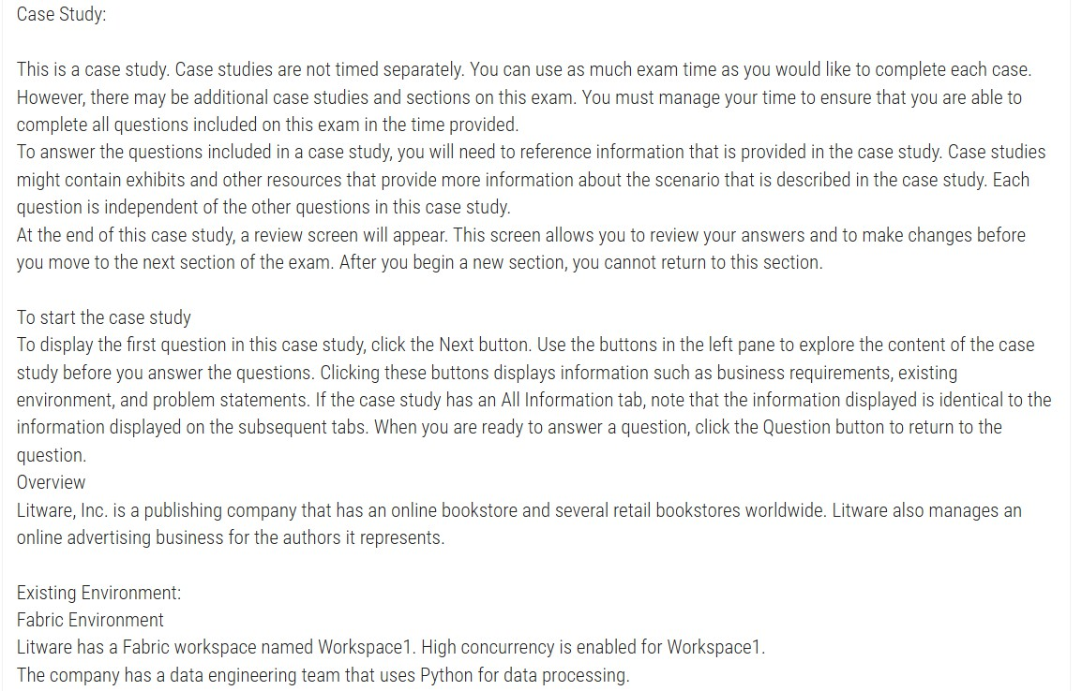


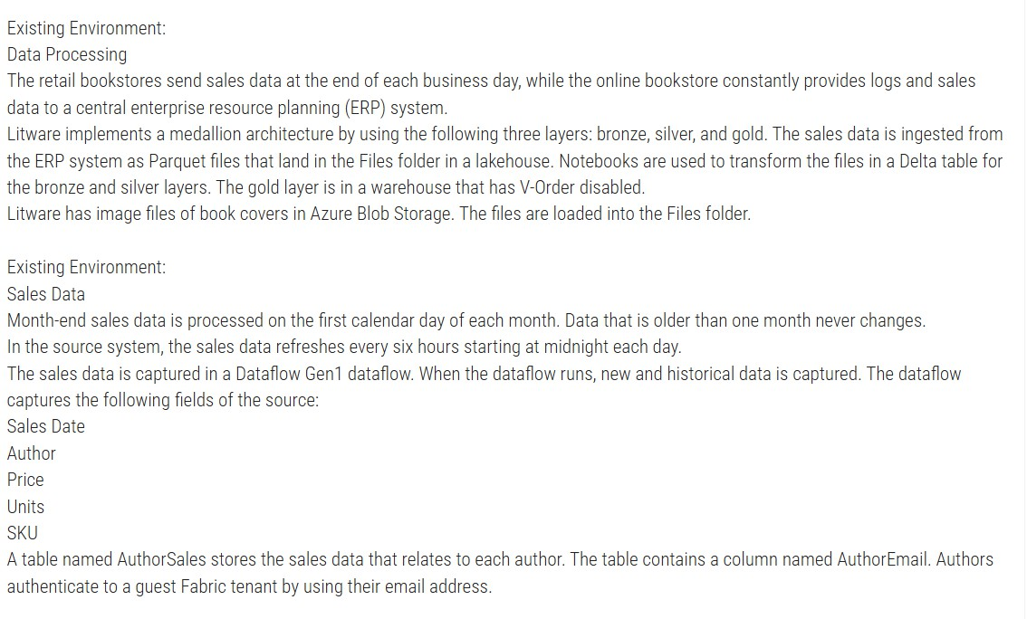


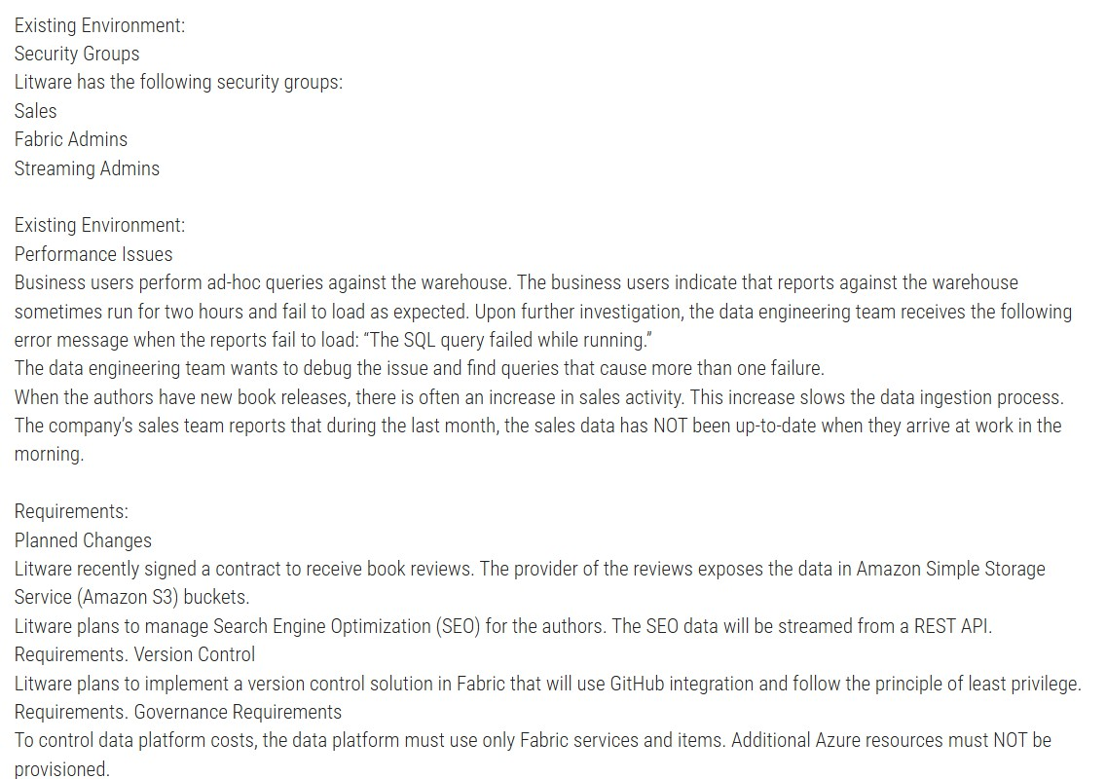

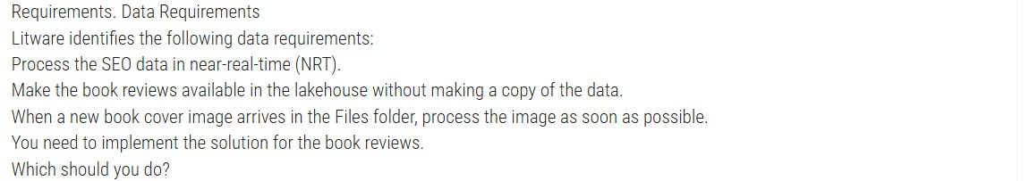

- You need to implement the solution for the book reviews.
Which should you do? ( case Study 3 )
  - Create a Dataflow Gen2 dataflow.
  - Create a shortcut.
  - Enable external data sharing.
  - Create a data pipeline.

Answer(s): B

Explanation:
The requirement specifies that Litware plans to make the book reviews available in the lakehouse without making a copy of the data. In this case, creating a shortcut in Fabric is the most appropriate solution. A shortcut is a reference to the external data, and it allows Litware to access the book reviews stored in Amazon S3 without duplicating the data into the lakehouse.

- You have a Fabric workspace that contains an eventstream named EventStream1. You discover that an EventStream1 transformation fails.
You need to find the following error information:
The error details, including the occurrence time The total number of errors -
What should you use? To answer, select the appropriate options in the answer area. NOTE: Each correct selection is worth one point.

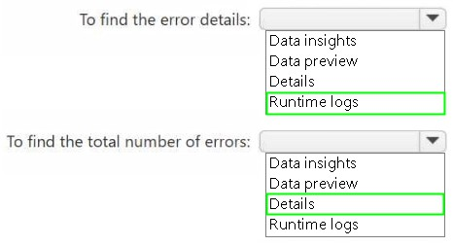

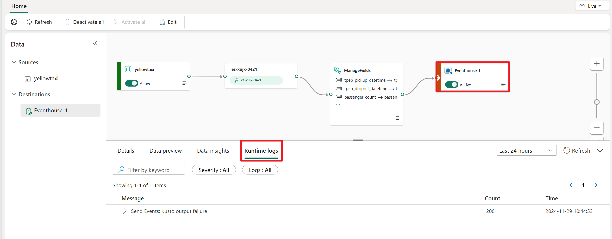

https://learn.microsoft.com/en-us/fabric/real-time-intelligence/event-streams/monitor

- You have a Fabric workspace that contains a lakehouse named Lakehouse1. Lakehouse1 contains a Delta table named Table1. You analyze Table1 and discover that Table1 contains 2,000 Parquet files of 1MB each. You need to minimize how long it takes to query Table1. What should you do?

A- Disable V-Order and run the OPTIMIZE command.
B- Disable V-Order and run the VACUUM command.
C- Run the OPTIMIZE and VACUUM commands.

Answer: C

Commands and Their Roles:- Compacts small Parquet files into larger files to improve query performance.- It supports optional features like V-Order, which organizes data for efficient scanning.- Removes old, unreferenced data files and metadata from the Delta table.- Running VACUUM after OPTIMIZE ensures unnecessary files are cleaned up, reducing storage overhead and improving performance.

- You have a KQL database that contains two tables named Stream and Reference. Stream contains streaming data in the following format.
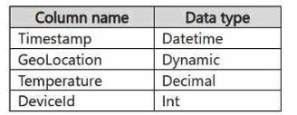
Reference contains reference data in the following format.
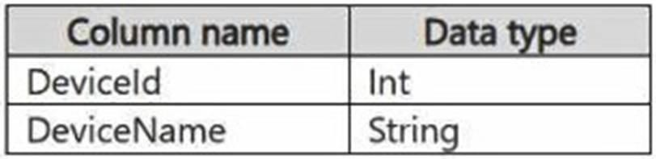
Both tables contain millions of rows. You have the following KQL queryset.
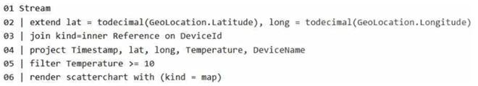

You need to reduce how long it takes to run the KQL queryset. Solution: You add the make_list() function to the output columns. Does this meet the goal?
A: Yes B: No

You need to reduce how long it takes to run the KQL queryset. Solution: You add the make_list() function to the output columns. Does this meet the goal?
A: Yes B: No

Answer: B

Adding an aggregation like make_list() would require additional processing and memory, which could make
the query slower.

- You have a Fabric workspace that contains a warehouse named Warehouse1.
Warehouse1 contains the following tables and columns.
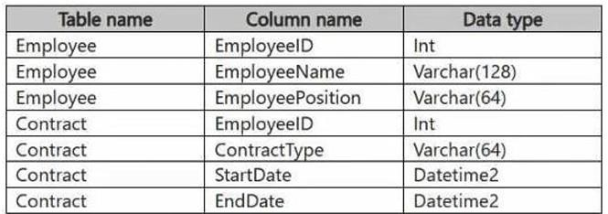

You need to denormalize the tables and include the ContractType and StartDate columns in the

Employee table. The solution must meet the following requirements: How should you complete the statement? To answer, select the appropriate options in the answer area.

NOTE: Each correct selection is worth one point.

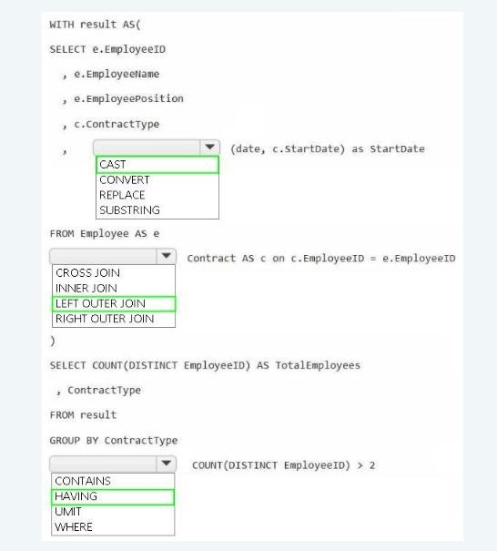

WITH result AS (
SELECT
e.EmployeeID,
e.EmployeeName,
e.EmployeePosition,
c.ContractType,
CAST(c.StartDate AS date) AS StartDate
FROM Employee AS e
LEFT OUTER JOIN Contract AS c
ON c.EmployeeID = e.EmployeeID
)

SELECT
COUNT(DISTINCT EmployeeID) AS TotalEmployees,
ContractType
FROM result
GROUP BY ContractType
HAVING COUNT(DISTINCT EmployeeID) > 2
- You have a Fabric workspace named Workspace1 that contains a data pipeline named Pipeline1 and a lakehouse named Lakehouse1. You have a deployment pipeline named deployPipeline1 that deploys Workspace1 to Workspace2. You restructure Workspace1 by adding a folder named Folder1 and moving Pipeline1 to Folder1. You use deployPipeline1 to deploy Workspace1 to Workspace2.
What occurs to Workspace2?

  - Folder1 is created, Pipeline1 moves to Folder1, and Lakehouse1 is deployed.
  - Only Pipeline1 and Lakehouse1 are deployed.
  - Folder1 is created, and Pipeline1 and Lakehouse1 move to Folder1.
  - Only Folder1 is created and Pipeline1 moves to Folder1.

Answer: A

Explanation: When you restructure Workspace1 by adding a new folder (Folder1) and moving Pipeline1 into it, deployPipeline1 will deploy the entire structure of Workspace1 to Workspace2, preserving the changes made in Workspace1.
This includes:
Folder1 will be created in Workspace2, mirroring the structure in Workspace1. Pipeline1 will be moved into Folder1 in Workspace2, maintaining the same folder structure.
Lakehouse1 will be deployed to Workspace2 as it exists in Workspace1.

- You have a Fabric eventstream that loads data into a table named Bike_Location in a KQL database. The table contains the following columns: You need to apply transformation and filter logic to prepare the data for consumption. The solution must return data for a neighbourhood named Sands End when No_Bikes is at least 15. The results must be ordered by No_Bikes in ascending order. Solution: You use the following code segment:
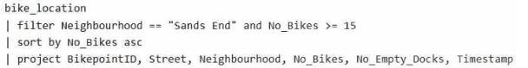

Does this meet the goal?
  - Yes
  - no

Answer: A Explanation:
Filter Condition: It correctly filters rows where Neighbourhood is "Sands End" and No_Bikes is greater than or equal to 15.
Sorting: The sorting is explicitly done by No_Bikes in ascending order using sort by No_Bikes asc.
Projection: It projects the required columns (BikepointID, Street, Neighbourhood, No_Bikes, No_Empty_Docks, Timestamp), which minimizes the data returned for consumption.

38) You have a Fabric workspace that contains two lakehouses named Lakehouse1 and Lakehouse2. Lakehouse1 contains staging data in a Delta table named Orderlines. Lakehouse2 contains a Type 2 slowly changing dimension (SCD) dimension table named Dim_Customer. You need to build a query that will combine data from Orderlines and Dim_Customer to create a new fact table named Fact_Orders. The new table must meet the following requirements: Enable the analysis of customer orders based on historical attributes. Enable the analysis of customer orders based on the current attributes. How should you complete the statement? To answer, select the appropriate options in the answer area. NOTE: Each correct selection is worth one point.

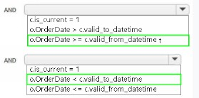


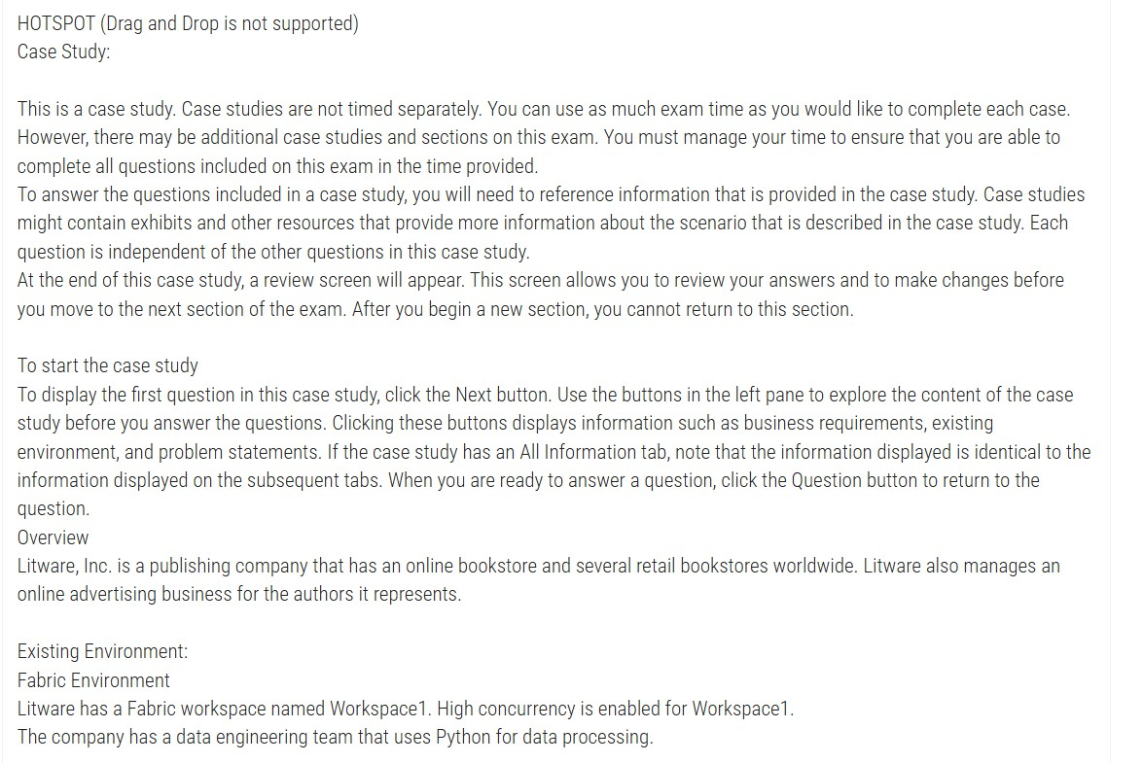
39)


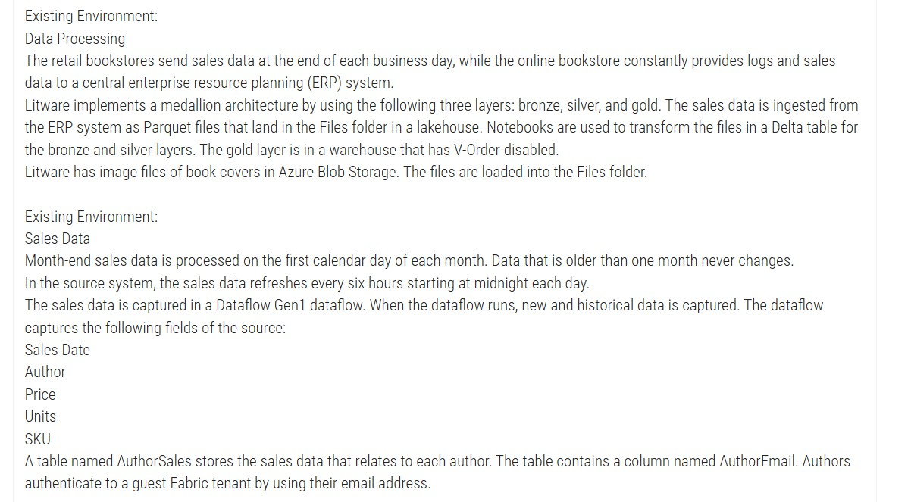


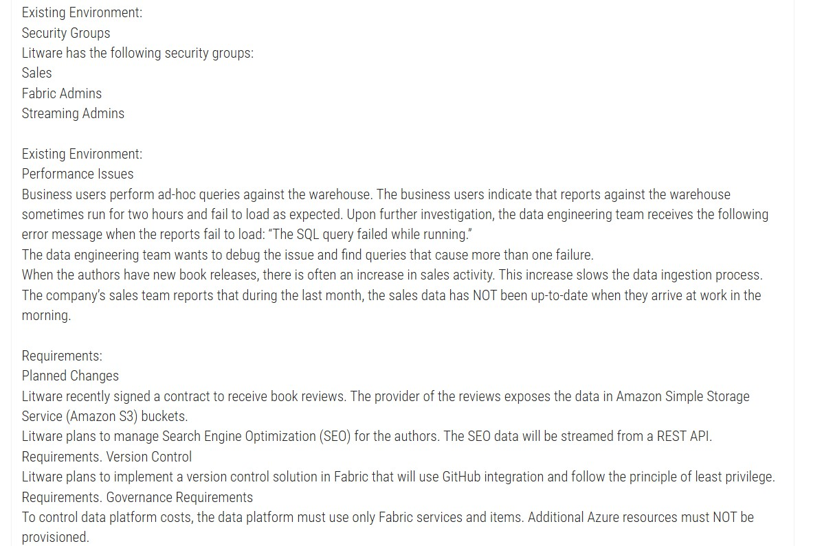


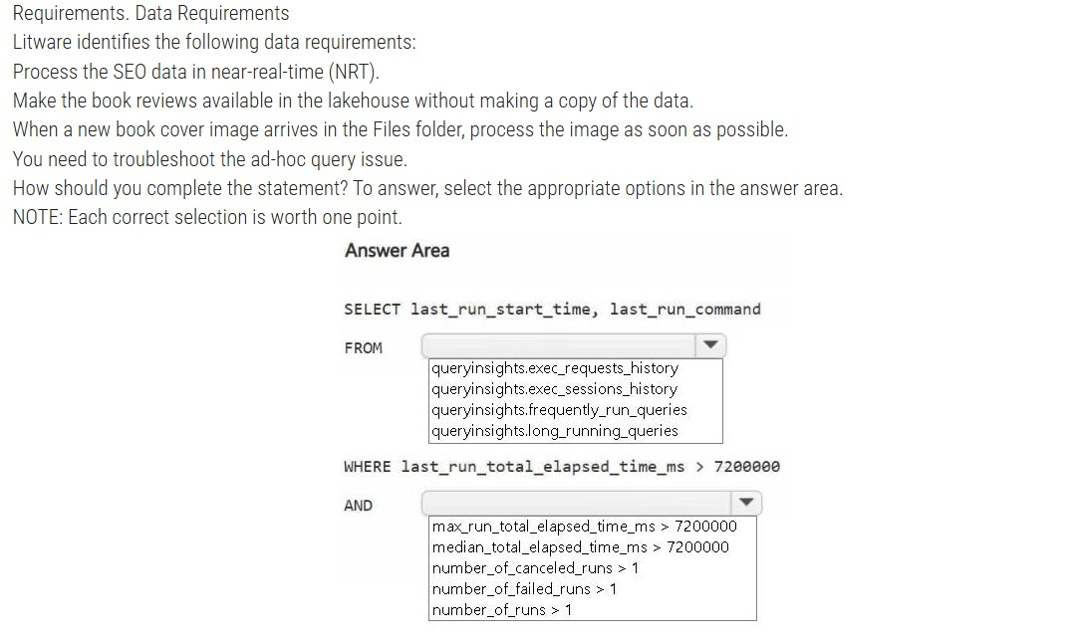

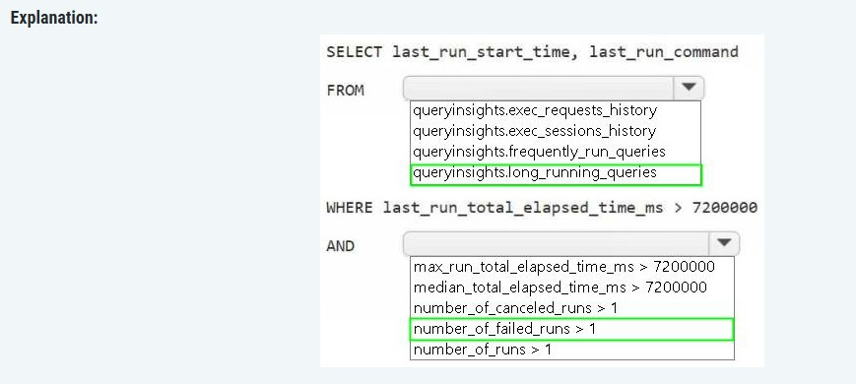

https://learn.microsoft.com/en-us/sql/relational-databases/system-views/queryinsights-frequently-run-queries-transact-sql?view=fabric&preserve-view=true

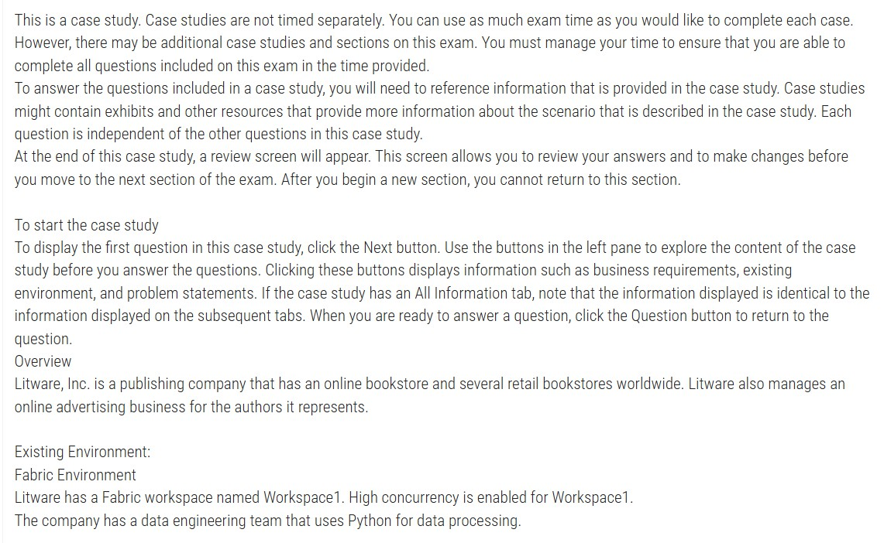
40)


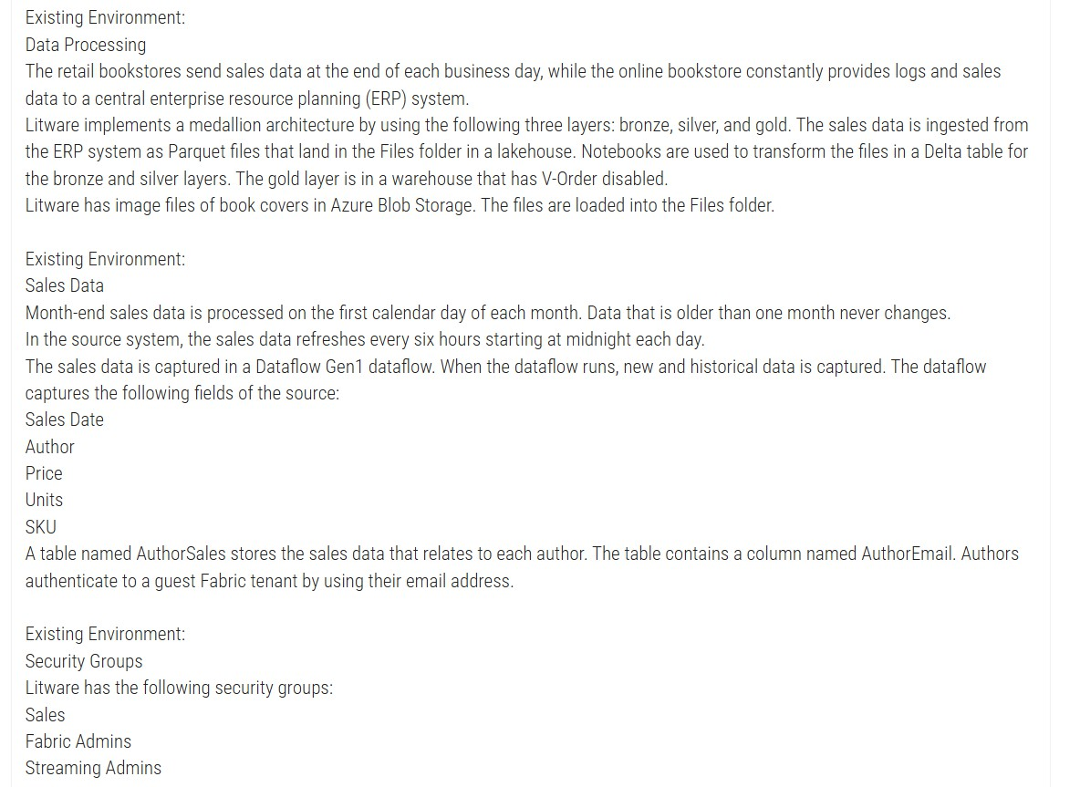


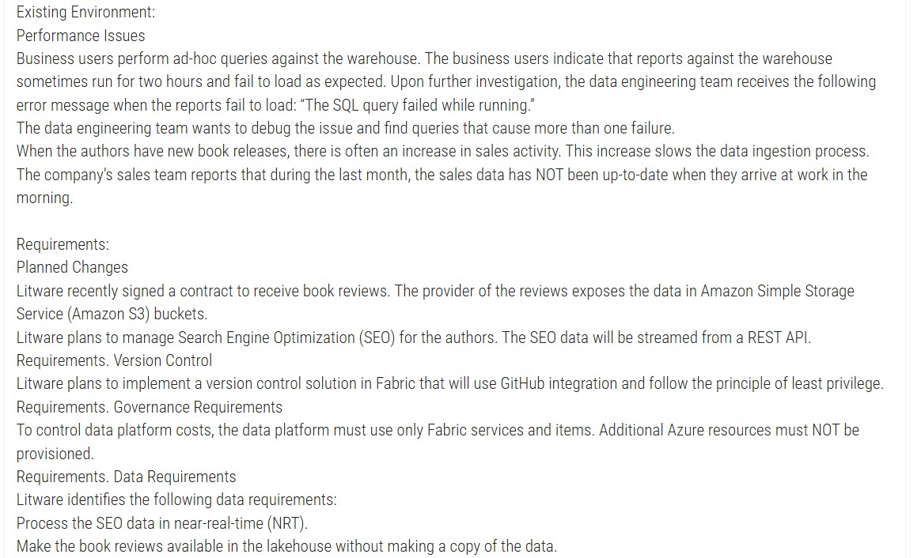

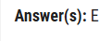
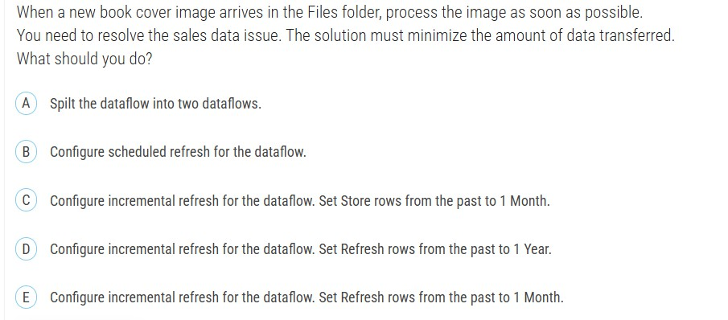
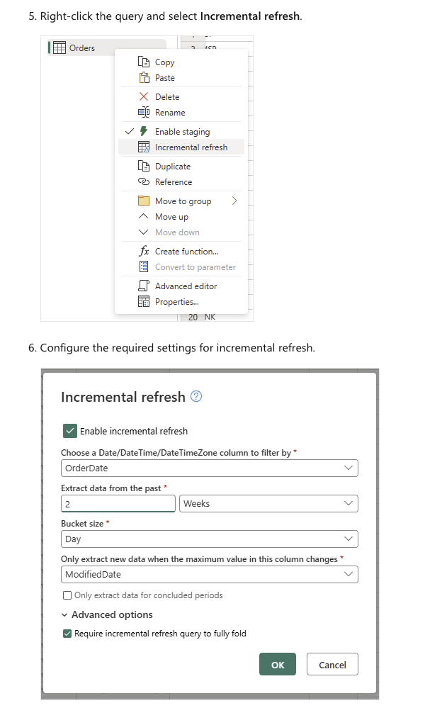

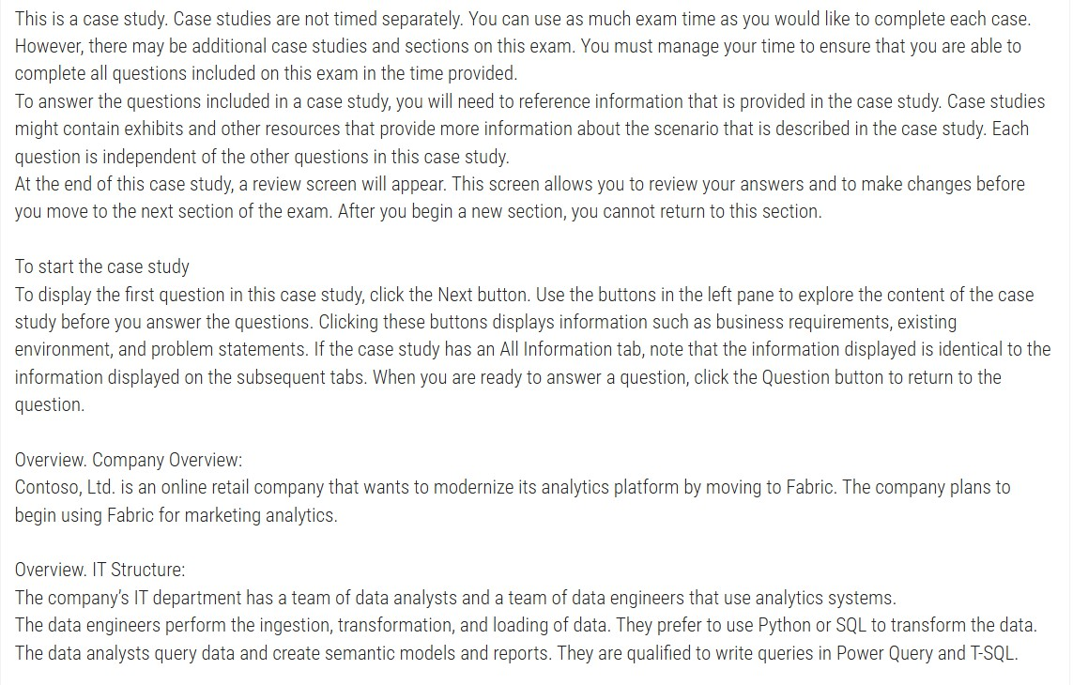

41)

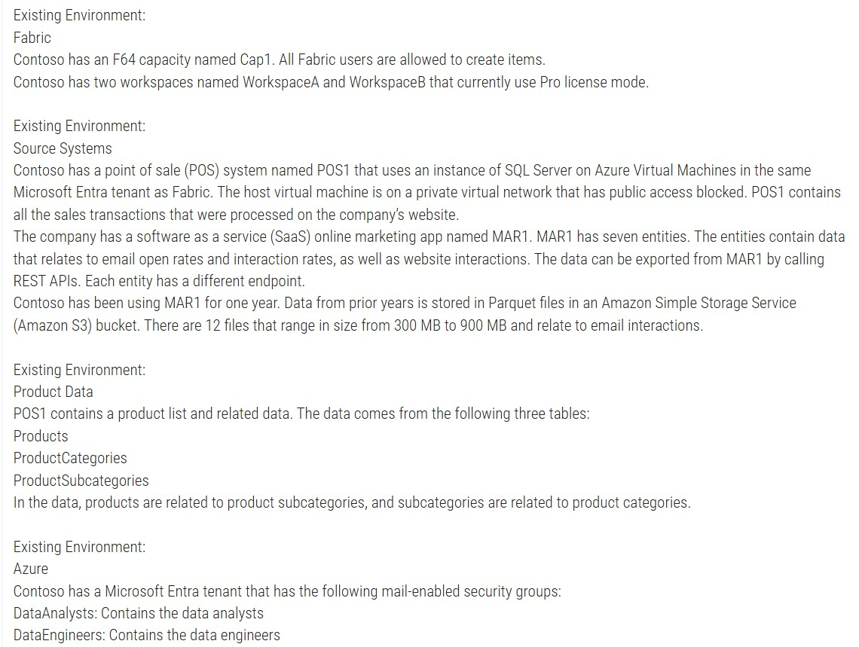

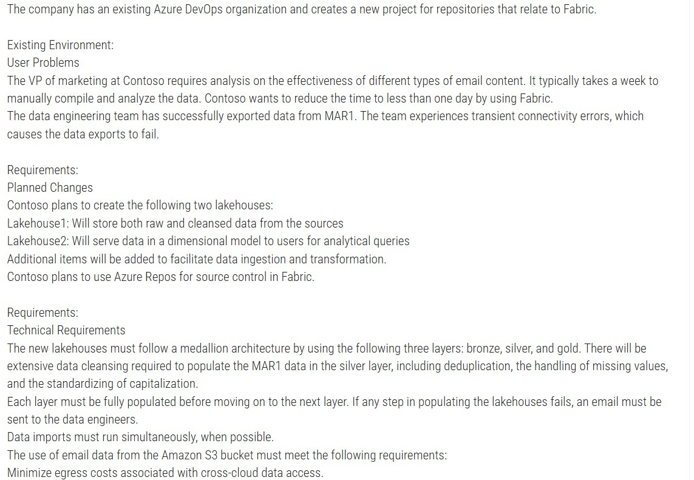



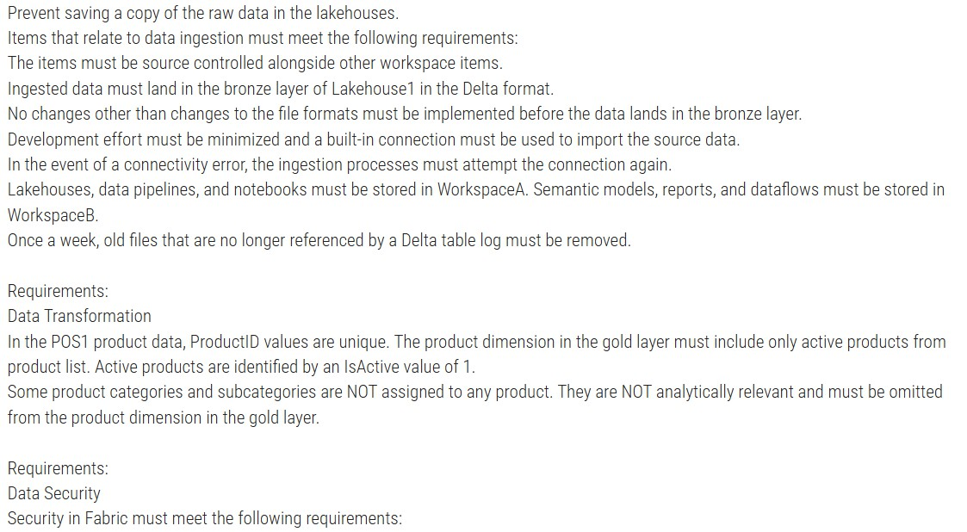


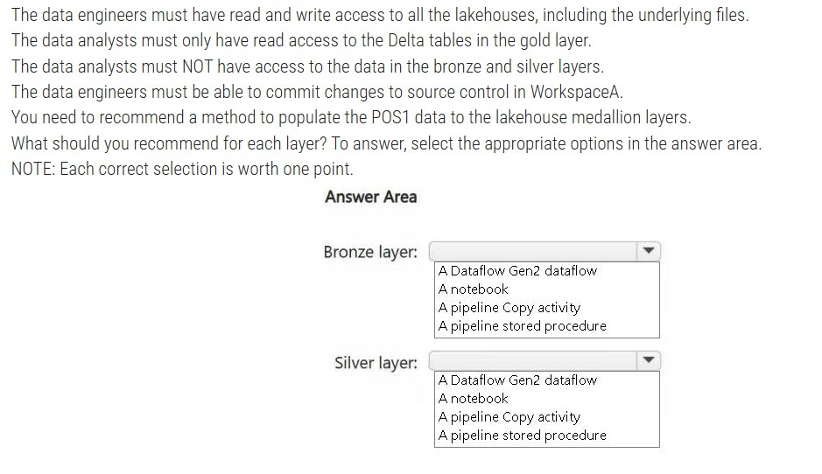

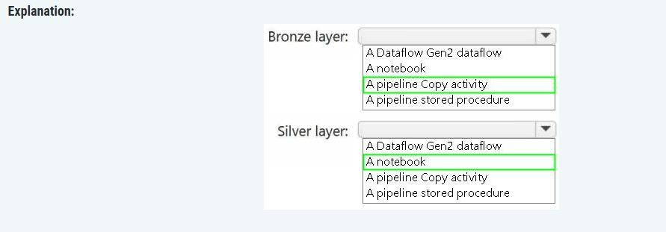

Bronze Layer: Pipeline Copy Activity

The case study specifies these key requirements for bronze layer ingestion:

1. "No changes other than changes to the file formats must be implemented before the data lands in the bronze layer" - Copy activity performs simple data movement with format conversion
(to Delta) without transformation logic.
2. "Development effort must be minimized and a built-in connection must be used" - Copy activity is a low-code solution with built-in connectors for SQL Server (POS1) that requires
minimal development effort.
3. "In the event of a connectivity error, the ingestion processes must attempt the connection again" - Copy activity has built-in retry policies that handle transient connectivity
errors automatically.
4. "Ingested data must land in the bronze layer in Delta format" - Copy activity can write directly to Delta tables in a Lakehouse.

Silver Layer: Notebook

The case study specifies these requirements for the silver layer:

1. "Extensive data cleansing required... including deduplication, the handling of missing values, and the standardizing of capitalization" - These complex transformations require
programmatic control that notebooks provide.
2. Data engineers "prefer to use Python or SQL to transform the data" - Notebooks support both PySpark (Python) and Spark SQL, matching the team's skills.
3. "Items must be source controlled alongside other workspace items" - Notebooks in Fabric can be integrated with Azure Repos for source control.
4. Storage requirement - Notebooks must be stored in WorkspaceA (where lakehouses and pipelines go), while Dataflows must go to WorkspaceB, ruling out Dataflow Gen2 for this purpose.
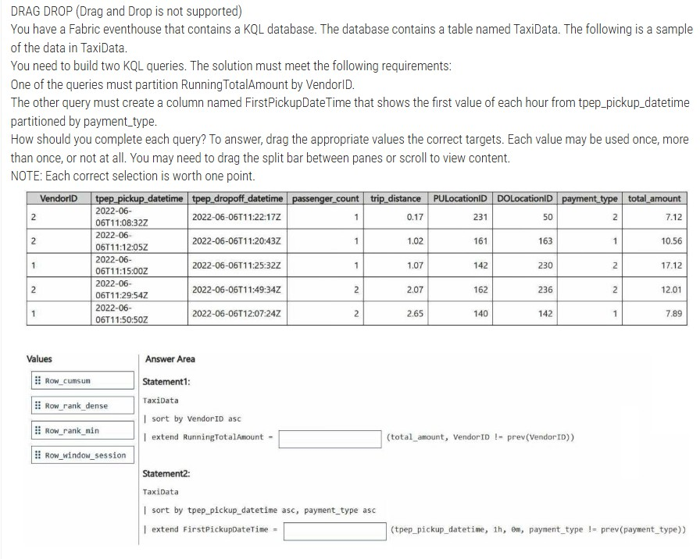
42)

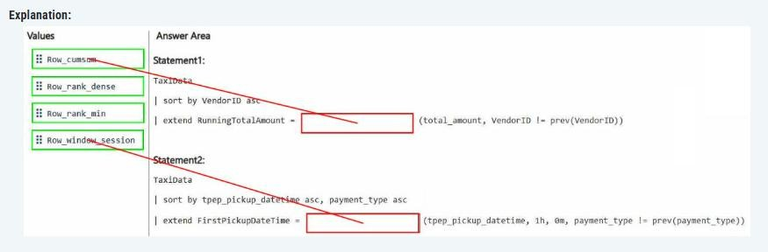

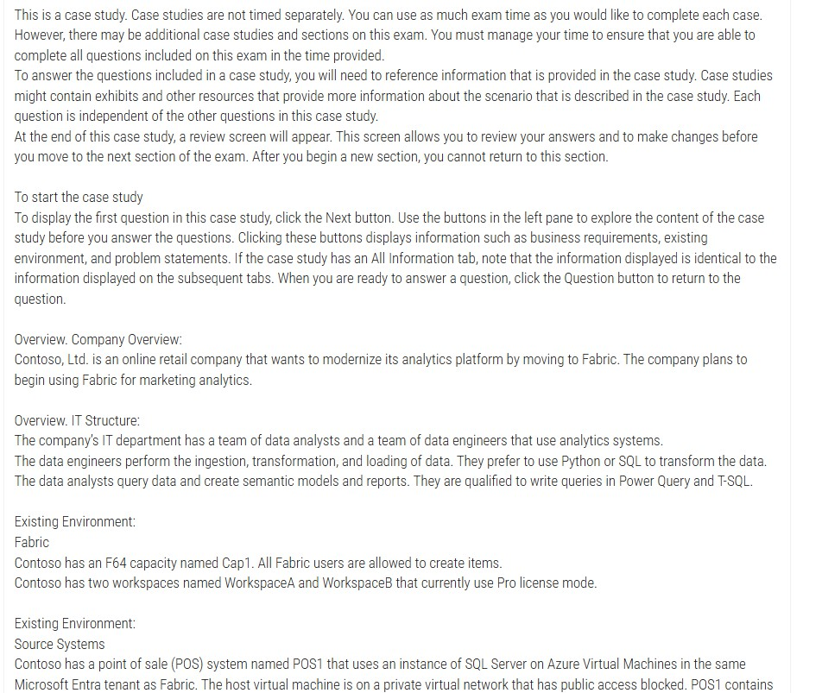
43)

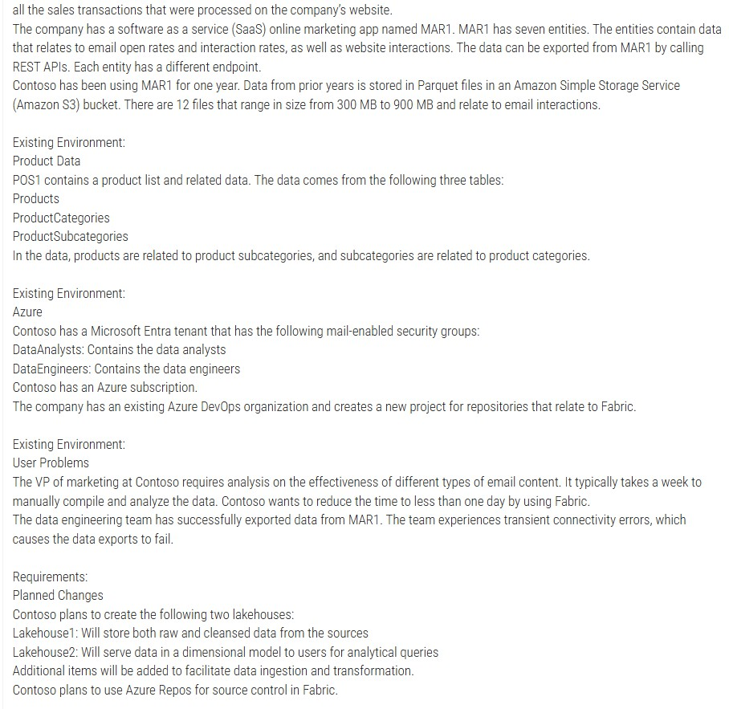

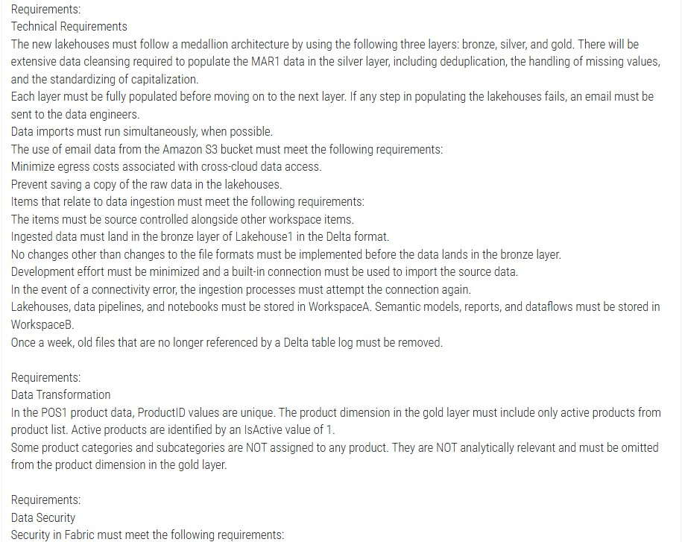

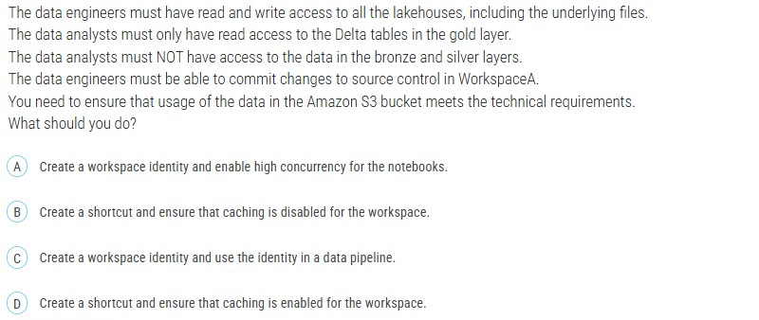



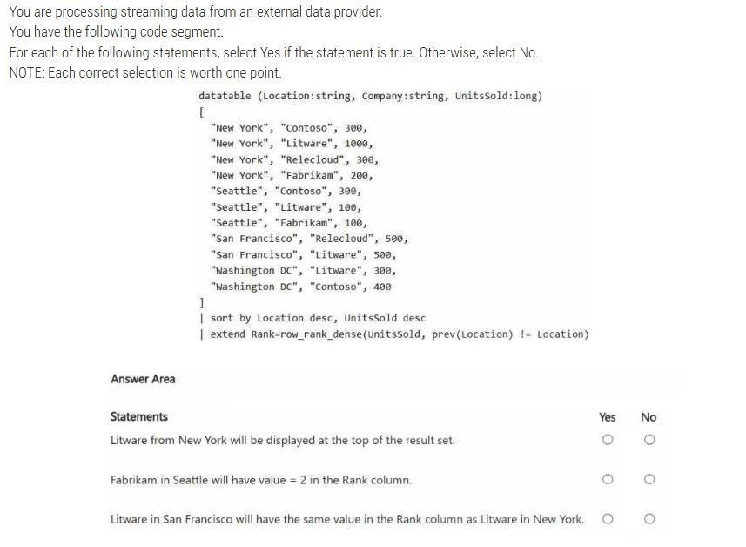
44)


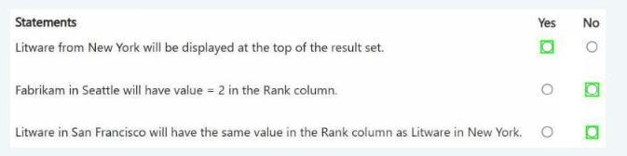
44)

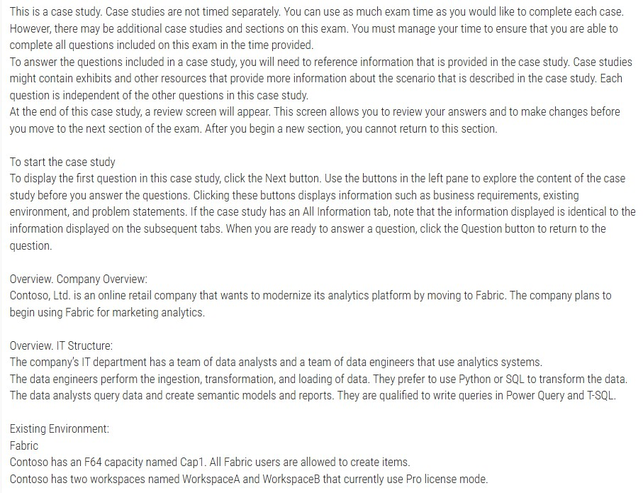
45)

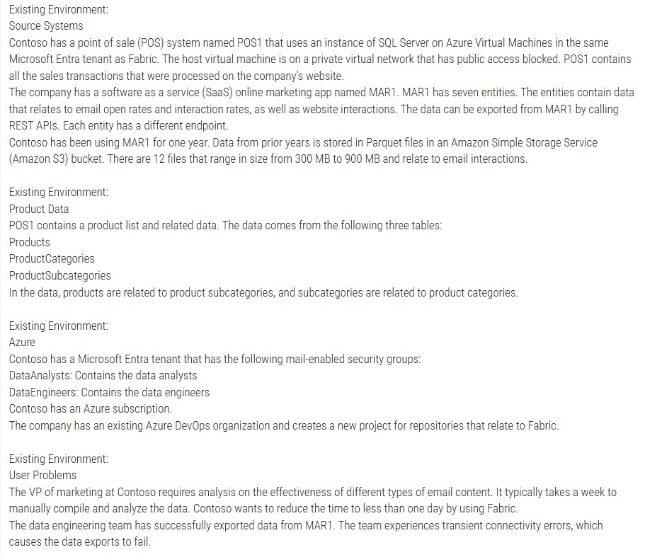

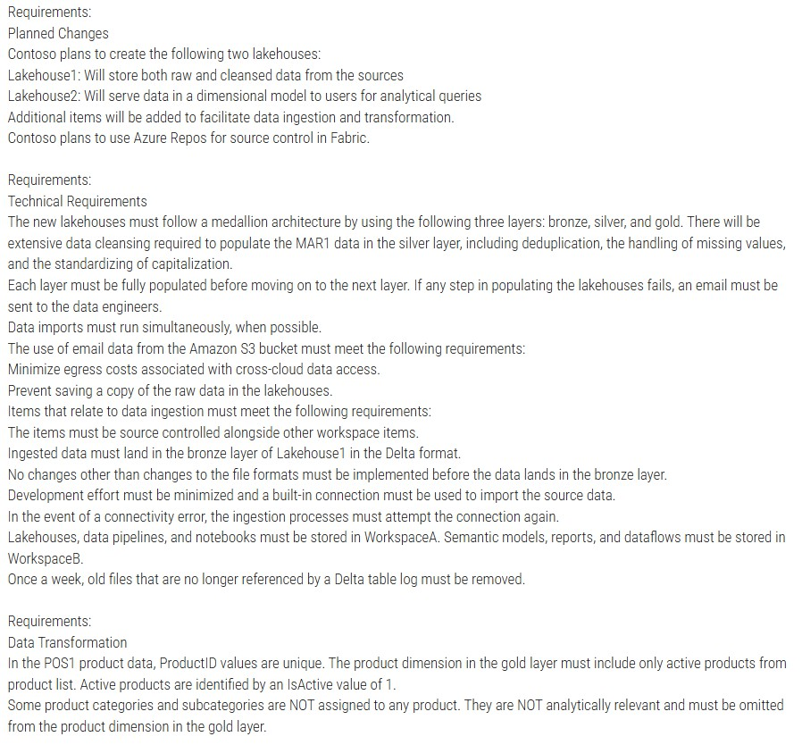

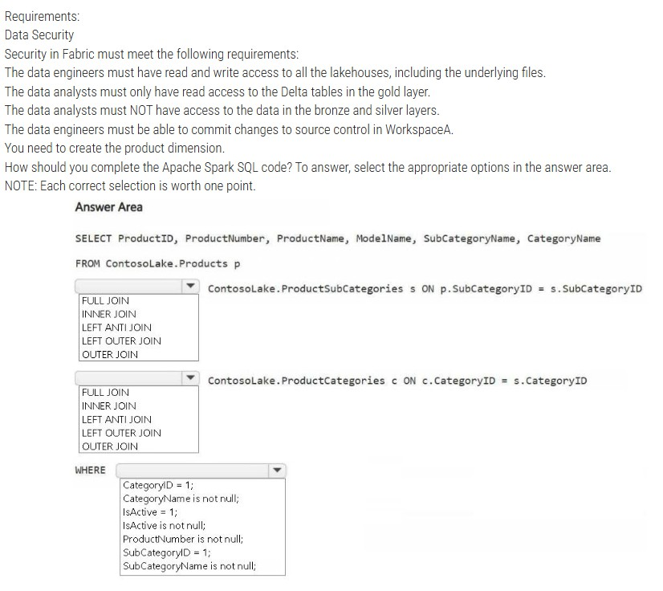

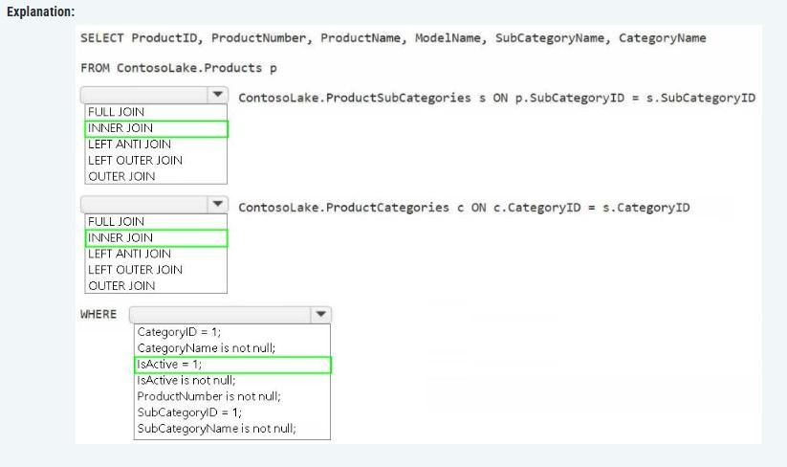

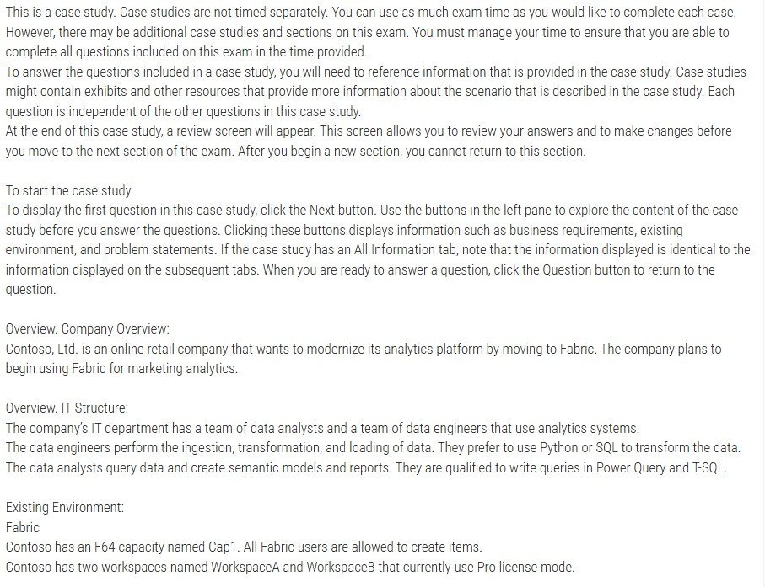
46)

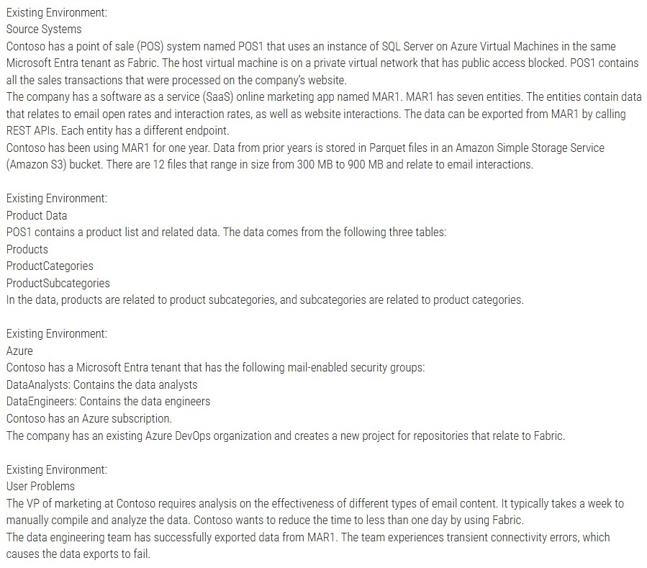

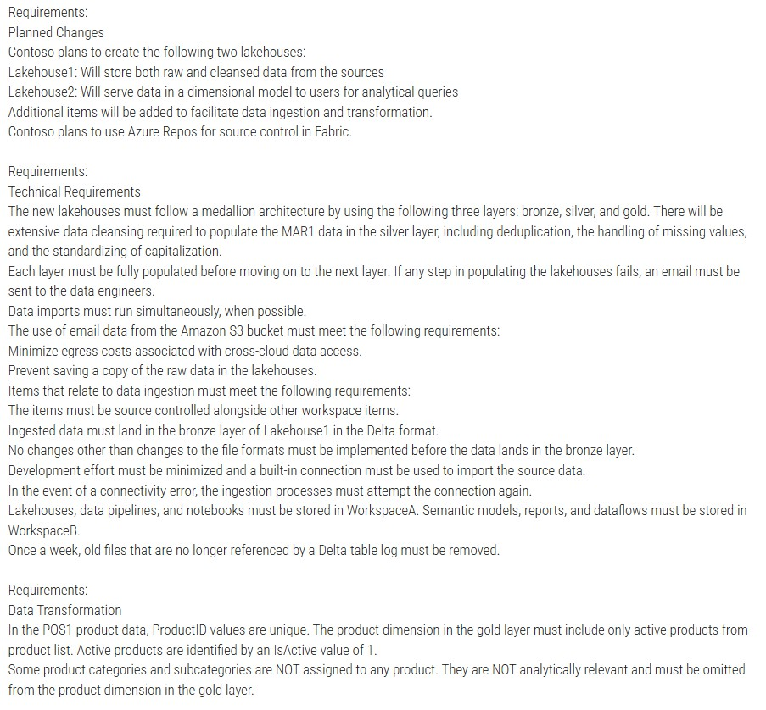

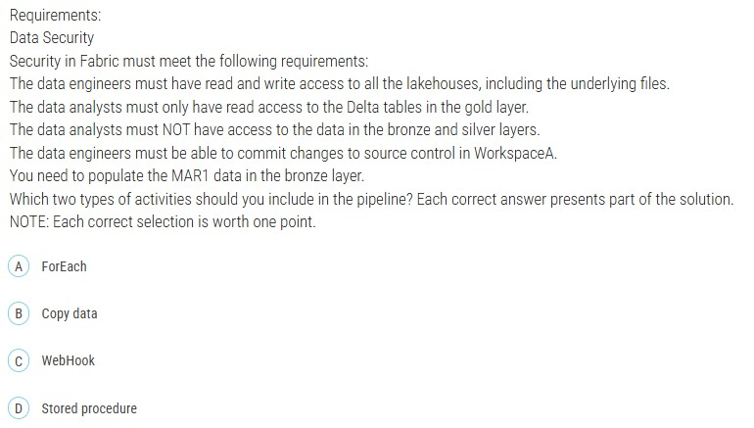

47)

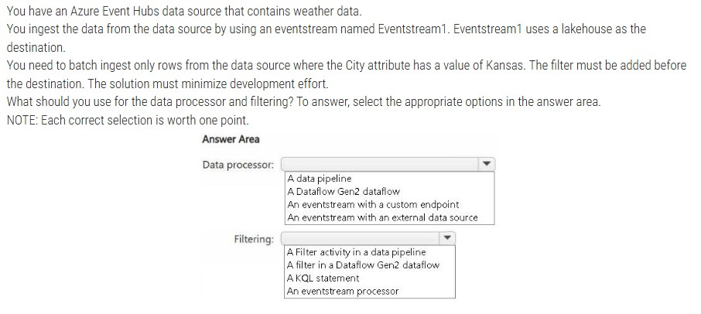
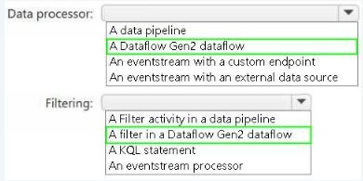

https://learn.microsoft.com/en-us/fabric/data-factory/dataflows-gen2-overview

48)

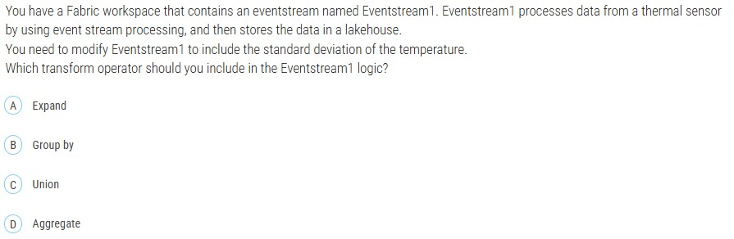

49)

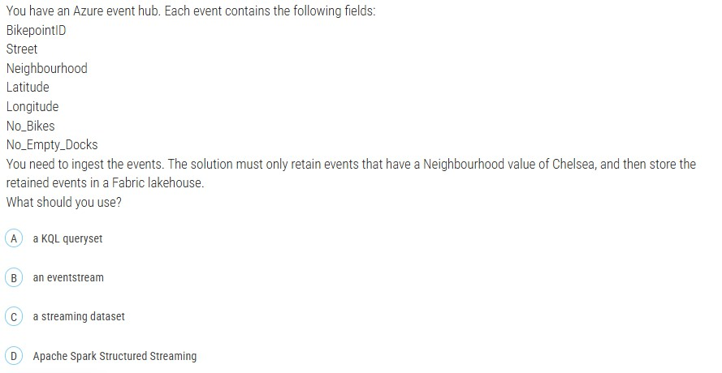

- You have a Fabric workspace that contains a lakehouse and a notebook named Notebook1. Notebook1 reads data into a DataFrame from a table named Table1 and applies transformation logic. The data from the DataFrame is then written to a new Delta table named Table2 by using a merge operation.
You need to consolidate the underlying Parquet files in Table1. Which command should you run?

- VACUUM
- CACHE
- OPTIMIZE
- BROADCAST

Correct Answer: C

- You have a Fabric workspace that contains a semantic model named Model1. You need to dynamically execute and monitor the refresh progress of Model1. What should you use?

- dynamic management views in Azure Data Studio
- Monitoring hub
- dynamic management views in Microsoft SQL Server Management Studio
- a semantic link in a notebook

Correct Answer: D

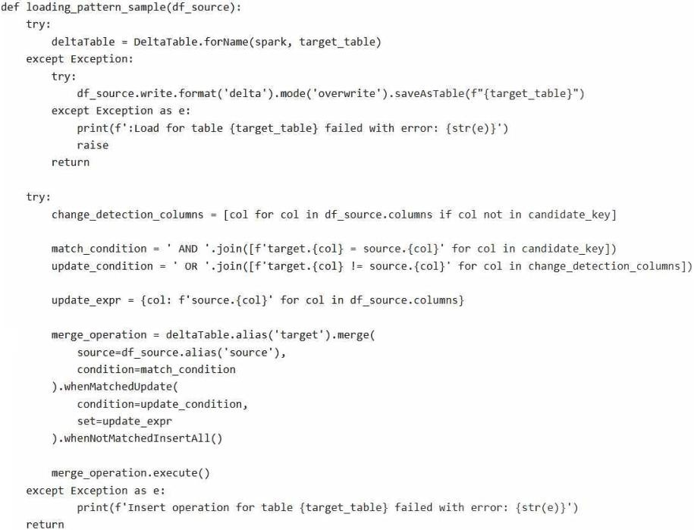
- You are building a data loading pattern for Fabric notebook workloads.
You have the following code segment:

For each of the following statements, select Yes if the statement is true. Otherwise, select No. NOTE: Each correct selection is worth one point.

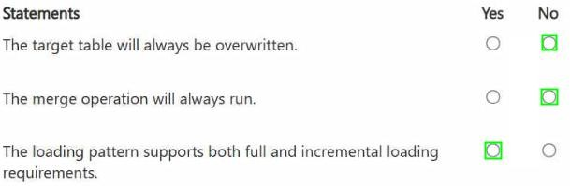

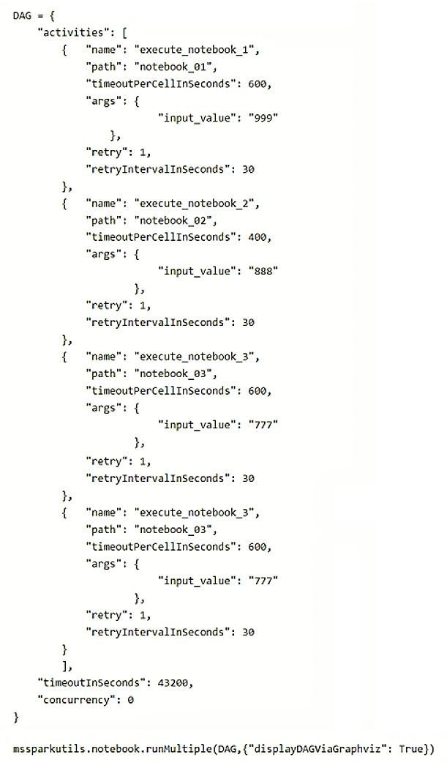
- You are building a Fabric notebook named MasterNotebook1 in a workspace. MasterNotebook1 contains the following code.

You need to ensure that the notebooks are executed in the following sequence:
- Notebook_03
- Notebook_01
- Notebook_02

Which two actions should you perform? Each correct answer presents part of the solution. NOTE: Each correct selection is worth one point.

  - Move the declaration of Notebook_02 to the bottom of the Directed Acyclic Graph (DAG) definition.

  - Add dependencies to the execution of Notebook_03.

  - Split the Directed Acyclic Graph (DAG) definition into three separate definitions.

  - Add dependencies to the execution of Notebook_02.

  - Change the concurrency to 3.

  - Move the declaration of Notebook_03 to the top of the Directed Acyclic Graph (DAG) definition.

https://datameerkat.com/orchestration-fabric-notebooks-with-dag
Which two actions should you perform? Each correct answer presents part of the solution. NOTE: Each correct selection is worth one point.

- Move the declaration of Notebook_02 to the bottom of the Directed Acyclic Graph (DAG) definition.

- Add dependencies to the execution of Notebook_03.

- Split the Directed Acyclic Graph (DAG) definition into three separate definitions.

- Add dependencies to the execution of Notebook_02.

- Change the concurrency to 3.

- Move the declaration of Notebook_03 to the top of the Directed Acyclic Graph (DAG) definition.

Answer: DF

- You need to recommend a Fabric streaming solution that will use the sources shown in the following table.
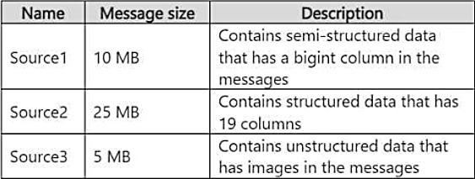

The solution must minimize development effort.

What should you include in the recommendation for each source? To answer, select the appropriate options in the answer area.

NOTE: Each correct selection is worth one point.
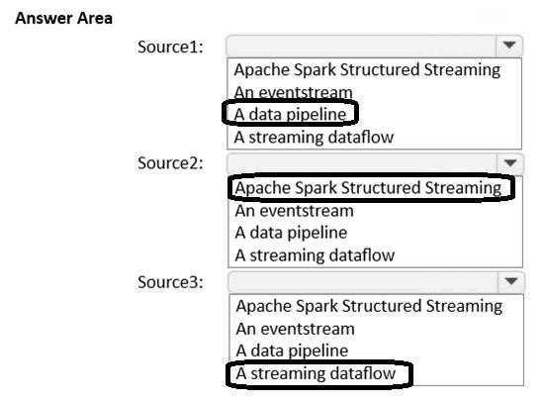

- Note: This question is part of a series of questions that present the same scenario. Each question in the series contains a unique solution that might meet the stated goals. Some question sets might have more than one correct solution, while others might not have a correct solution.
After you answer a question in this section, you will NOT be able to return to it. As a result, these questions will not appear in the review screen.
You have an Azure key vault named KeyVault1 that contains secrets.
You have a Fabric workspace named Workspace1. Workspace contains a notebook named Notebook1 that performs the
following tasks:

  - Loads stage data to the target tables in a lakehouse
  - Triggers the refresh of a semantic model

You plan to add functionality to Notebook1 that will use the Fabric API to monitor the semantic model refreshes. You need to retrieve the registered application ID and secret from KeyVault1 to generate the authentication token. Solution: You use the following code segment:
Use notebookutils.credentials.putSecret and specify the key vault URL and key vault secret. Does this meet the goal?
- Yes
- No

Answer: B


- You are building a data orchestration pattern by using a Fabric data pipeline named Dynamic Data Copy as shown in the exhibit. (Click the Exhibit tab.)
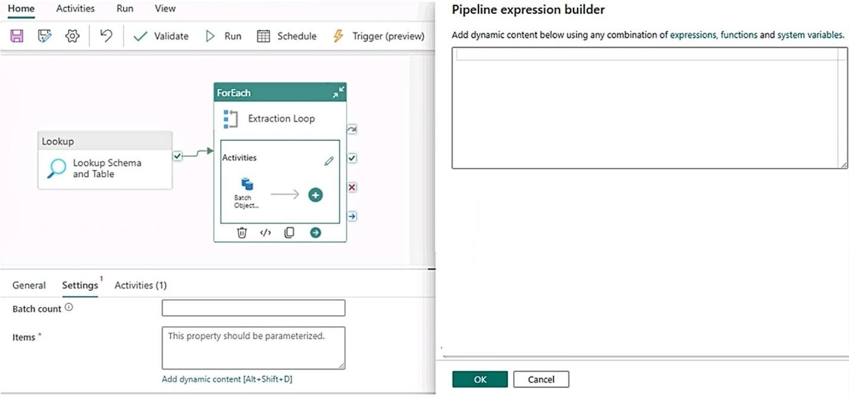

Dynamic Data Copy does NOT use parametrization.

You need to configure the ForEach activity to receive the list of tables to be copied.

How should you complete the pipeline expression? To answer, select the appropriate options in the answer area.

NOTE: Each correct selection is worth one point.

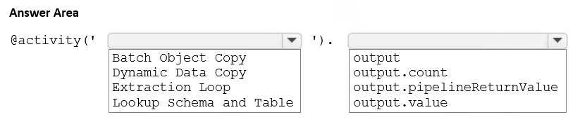

Dynamic Data Copy does NOT use parametrization.

You need to configure the ForEach activity to receive the list of tables to be copied.

How should you complete the pipeline expression? To answer, select the appropriate options in the answer area.

NOTE: Each correct selection is worth one point.

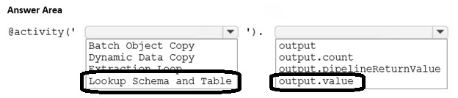

- You need to ensure that usage of the data in the Amazon S3 bucket meets the technical requirements. ( Case Study 4 )
What should you do?
  - Create a shortcut and ensure that caching is enabled for the workspace.
  - Create a workspace identity and use the identity in a data pipeline.
  - Create a shortcut and ensure that caching is disabled for the workspace.
  - Create a workspace identity and enable high concurrency for the notebooks.

Correct Answer: C

To ensure that the usage of the data in the Amazon S3 bucket meets the technical requirements, we must address two key points:
Minimize egress costs associated with cross-cloud data access: Using a shortcut ensures that Fabric does not replicate the data from the S3 bucket into the lakehouse but rather provides direct access to the data in its original location. This minimizes cross-cloud data transfer and avoids additional egress costs.
Prevent saving a copy of the raw data in the lakehouses: Disabling caching ensures that the raw data is not copied or persisted in the Fabric workspace. The data is accessed on- demand directly from the Amazon S3 bucket.

- You are developing a data pipeline named Pipeline1.
You need to add a Copy data activity that will copy data from a Snowflake data source to a Fabric warehouse.
What should you configure?

  - Degree of copy parallelism
  - Fault tolerance
  - Enable staging
  - Enable logging

Correct Answer: C

- You have a Fabric workspace named Workspace1 that contains a lakehouse named Lakehouse1. Workspace1 contains the following items:

  - A Dataflow Gen2 dataflow that copies data from an on-premises Microsoft SQL Server database to Lakehouse1
  - A notebook that transforms files and loads the data to Lakehouse1
  - A data pipeline that loads a CSV file to Lakehouse1

You need to develop an orchestration solution in Fabric that will load each item one after the other. The solution must be
scheduled to run every 15 minutes.

Which type of item should you use?
- notebook
- warehouse
- Dataflow Gen2 dataflow
- data pipeline

Correct Answer: D

- (Case Study 4)

You need to populate the MAR1 data in the bronze layer.
Which two types of activities should you include in the pipeline? Each correct answer presents part of the solution.
NOTE: Each correct selection is worth one point.

  - ForEach
  - Copy data
  - WebHook
  - Stored procedure

Correct Answer: AB
Explanation:
MAR1 has seven entities, each accessible via a different API endpoint. A ForEach activity is required to iterate over these endpoints to fetch data from each one. It enables dynamic execution of API calls for each entity.
The Copy data activity is the primary mechanism to extract data from REST APIs and load it into the bronze layer in Delta format. It supports native connectors for REST APIs and Delta, minimizing development effort.

- You are implementing a medallion architecture in a Fabric lakehouse.

You plan to create a dimension table that will contain the following columns:

- ID
- CustomerCode
- CustomerName
- CustomerAddress
- CustomerLocation
- ValidFrom
- ValidTo
You need to ensure that the table supports the analysis of historical sales data by customer location at the time of each sale. Which type of slowly changing dimension (SCD) should you use?
  - Type 2
  - Type 0
  - Type 1
  - Type 3

Correct Answer: A

- HOTSPOT -
You have three users named User1, User2, and User3.
You have the Fabric workspaces shown in the following table.

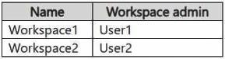
You have a security group named Group1 that contains User1 and User3. The Fabric admin creates the domains shown in the following table.

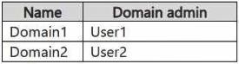

User1 creates a new workspace named Workspace3.
You add Group1 to the default domain of Domain1.
For each of the following statements, select Yes if the statement is true. Otherwise, select No. NOTE: Each correct selection is worth one point.

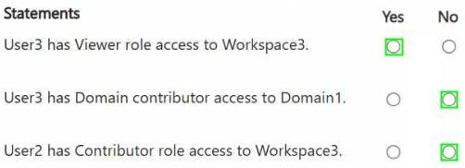

- You have a Fabric workspace named Workspace1 that contains the items shown in the
following table.
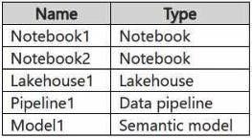

For Model1, the Keep your Direct Lake data up to date option is disabled.
You need to configure the execution of the items to meet the following requirements: Notebook1 must execute every weekday at 8:00 AM.
Notebook2 must execute when a file is saved to an Azure Blob Storage container.
Model1 must refresh when Notebook1 has executed successfully.
How should you orchestrate each item? To answer, select the appropriate options in the answer area. NOTE: Each correct selection is worth one point.

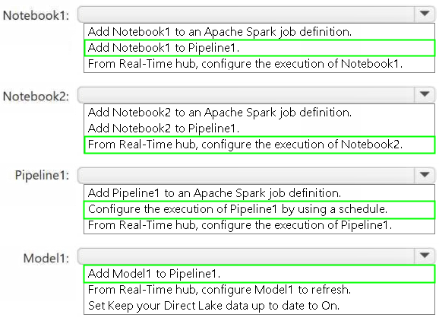

- You have an Azure event hub. Each event contains the following fields:

BikepointID - Street - Neighbourhood - Latitude - Longitude - No_Bikes - No_Empty_Docks -
You need to ingest the events. The solution must only retain events that have a Neighbourhood value of Chelsea, and then store the retained events in a Fabric lakehouse.
What should you use?
  - a KQL queryset
  - an eventstream
C. a streaming dataset
D. Apache Spark Structured Streaming

Answer: B

- You have two Fabric notebooks named Load_Salesperson and Load_Orders that read data from Parquet files in a lakehouse. Load_Salesperson writes to a Delta table named dim_salesperson. Load_Orders writes to a Delta table named fact_orders and is dependent on the successful execution of Load_Salesperson.

You need to implement a pattern to dynamically execute Load_Salesperson and Load_Orders in the appropriate order by using a notebook.

How should you complete the code? To answer, drag the appropriate values the correct targets. Each value may be used once, more than once, or not at all. You may need to drag the split bar between panes or scroll to view content.

NOTE: Each correct selection is worth one point.

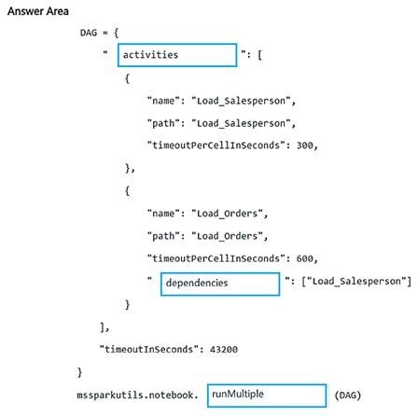

- You plan to process the following three datasets by using Fabric:

Dataset1: This dataset will be added to Fabric and will have a unique primary key between the source and the destination. The unique primary key will be an integer and will start from 1 and have an increment of 1.
Dataset2: This dataset contains semi-structured data that uses bulk data transfer. The dataset must be handled in one process between the source and the destination. The data transformation process will include the use of custom visuals to understand and work with the dataset in development mode.
Dataset3: This dataset is in a lakehouse. The data will be bulk loaded. The data transformation process will include row-based
windowing functions during the loading process.

You need to identify which type of item to use for the datasets. The solution must minimize development effort and use built- in functionality, when possible.

What should you identify for each dataset? To answer, select the appropriate options in the answer area. NOTE: Each correct selection is worth one point.

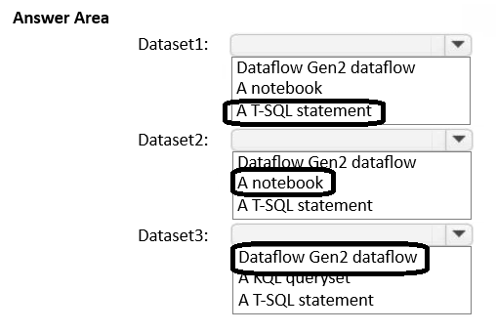

Dataset1 → T-SQL statement

Requirements: Auto-incrementing integer primary key (starts at 1, increments by 1)

Why T-SQL: This describes a classic SQL IDENTITY column. T-SQL natively supports this with:
CREATE TABLE ... (
ID INT IDENTITY(1,1) PRIMARY KEY,
...
)
This is built-in functionality requiring minimal effort—no need for notebooks or dataflows.

---
Dataset2 → A notebook

Requirements:
- Semi-structured data (JSON, XML, etc.)
- Bulk transfer in one process
- Custom visuals for exploration in development mode

Why Notebook:
- Notebooks (PySpark/Python) excel at parsing semi-structured data
- They provide interactive visualization and exploration capabilities for development
- Spark can handle bulk transfers efficiently
- The "custom visuals in development mode" is the key indicator—notebooks offer interactive data exploration that Dataflows and T-SQL don't

---
Dataset3 → Dataflow Gen2 dataflow

Requirements:
- Data already in a lakehouse
- Bulk loading with row-based windowing functions

Why Dataflow Gen2:
- It's a low-code/no-code solution (minimizes development effort)
- Supports windowing operations through Power Query
- Has native lakehouse connectivity
- Designed specifically for bulk ETL transformations

---
Summary: The exam tests your ability to match tool capabilities to requirements while minimizing development complexity.
- You have a Fabric workspace named Workspace1 that contains a warehouse named Warehouse2.
A team of data analysts has Viewer role access to Workspace1. You create a table by running the following statement.
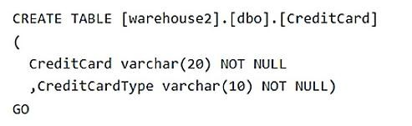

You need to ensure that the team can view only the first two characters and the last four characters of the CreditCard attribute.

How should you complete the statement? To answer, select the appropriate options in the answer area. NOTE: Each correct selection is worth one point.

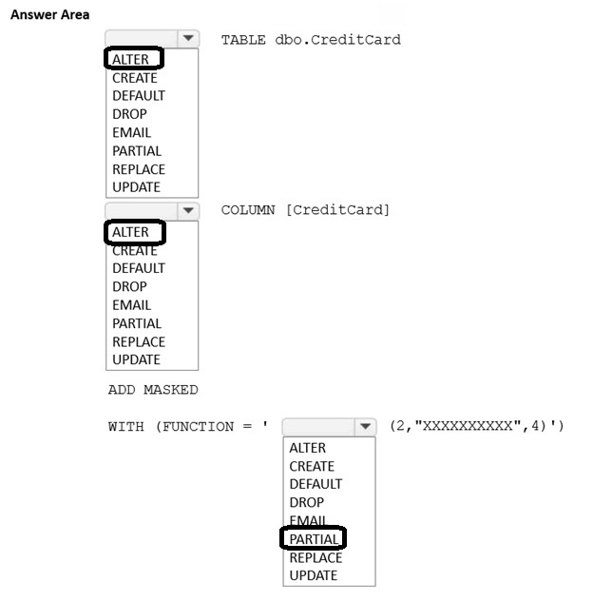

ALTER TABLE dbo.CreditCard
ALTER COLUMN [CreditCard]
ADD MASKED
WITH (FUNCTION = 'PARTIAL(2,"XXXXXXXXXX",4)')

- Case study
Overview. Company Overview
-
Contoso, Ltd. is an online retail company that wants to modernize its analytics platform by moving to Fabric. The
company plans to begin using Fabric for marketing analytics.

Overview. IT Structure
-

The company’s IT department has a team of data analysts and a team of data engineers that use analytics systems.
The data engineers perform the ingestion, transformation, and loading of data. They prefer to use Python or SQL to transform the data.
The data analysts query data and create semantic models and reports. They are qualified to write queries in Power
Query and T-SQL.
Existing Environment. Fabric
-

Contoso has an F64 capacity named Cap1. All Fabric users are allowed to create items.
Contoso has two workspaces named WorkspaceA and WorkspaceB that currently use Pro license mode.
Existing Environment. Source Systems
Contoso has a point of sale (POS) system named POS1 that uses an instance of SQL Server on Azure Virtual Machines in the same Microsoft Entra tenant as Fabric. The host virtual machine is on a private virtual network that has public access blocked. POS1 contains all the sales transactions that were processed on the company’s website.

The company has a software as a service (SaaS) online marketing app named MAR1. MAR1 has seven entities. The entities contain data that relates to email open rates and interaction rates, as well as website interactions. The data can be exported from MAR1 by calling REST APIs. Each entity has a different endpoint.

Contoso has been using MAR1 for one year. Data from prior years is stored in Parquet files in an Amazon Simple Storage Service (Amazon S3) bucket. There are 12 files that range in size from 300 MB to 900 MB and relate to email interactions. Existing Environment. Product Data

POS1 contains a product list and related data. The data comes from the following three tables:
- Products
- ProductCategories
- ProductSubcategories

In the data, products are related to product subcategories, and subcategories are related to product categories.

Existing Environment. Azure
Contoso has a Microsoft Entra tenant that has the following mail-enabled security groups:

  - DataAnalysts: Contains the data analysts
  - DataEngineers: Contains the data engineers Contoso has an Azure subscription.
The company has an existing Azure DevOps organization and creates a new project for repositories that relate to Fabric.

Existing Environment. User Problems

The VP of marketing at Contoso requires analysis on the effectiveness of different types of email content. It typically takes a week to manually compile and analyze the data. Contoso wants to reduce the time to less than one day by using Fabric.

The data engineering team has successfully exported data from MAR1. The team experiences transient connectivity
errors, which causes the data exports to fail.

Requirements. Planned Changes

Contoso plans to create the following two lakehouses:

- Lakehouse1: Will store both raw and cleansed data from the sources
- Lakehouse2: Will serve data in a dimensional model to users for analytical queries Additional items will be added to facilitate data ingestion and transformation. Contoso plans to use Azure Repos for source control in Fabric.

Requirements. Technical Requirements

The new lakehouses must follow a medallion architecture by using the following three layers: bronze, silver, and gold. There will be extensive data cleansing required to populate the MAR1 data in the silver layer, including deduplication, the handling of missing values, and the standardizing of capitalization.

Each layer must be fully populated before moving on to the next layer. If any step in populating the lakehouses fails, an email must be sent to the data engineers.

Data imports must run simultaneously, when possible.

The use of email data from the Amazon S3 bucket must meet the following requirements:

- Minimize egress costs associated with cross-cloud data access.
- Prevent saving a copy of the raw data in the lakehouses.

Items that relate to data ingestion must meet the following requirements:

  - The items must be source controlled alongside other workspace items.
  - Ingested data must land in the bronze layer of Lakehouse1 in the Delta format.
  - No changes other than changes to the file formats must be implemented before the data lands in the bronze
layer.
  - Development effort must be minimized and a built-in connection must be used to import the source data.
  - In the event of a connectivity error, the ingestion processes must attempt the connection again.

Lakehouses, data pipelines, and notebooks must be stored in WorkspaceA. Semantic models, reports, and dataflows must be stored in WorkspaceB.

Once a week, old files that are no longer referenced by a Delta table log must be removed.

Requirements. Data Transformation

In the POS1 product data, ProductID values are unique. The product dimension in the gold layer must include only active products from product list. Active products are identified by an IsActive value of 1.

Some product categories and subcategories are NOT assigned to any product. They are NOT analytically relevant and must be omitted from the product dimension in the gold layer.

Requirements. Data Security
-
Security in Fabric must meet the following requirements:

- The data engineers must have read and write access to all the lakehouses, including the underlying files.
- The data analysts must only have read access to the Delta tables in the gold layer.
- The data analysts must NOT have access to the data in the bronze and silver layers.
- The data engineers must be able to commit changes to source control in WorkspaceA.

You need to ensure that the data engineers are notified if any step in populating the lakehouses fails. The solution must
meet the technical requirements and minimize development effort.

What should you use? To answer, select the appropriate options in the answer area. NOTE: Each correct selection is worth one point.

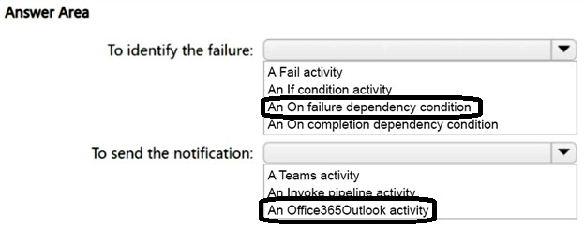
- You have a Fabric workspace that contains a lakehouse named Lakehouse1.
In an external data source, you have data files that are 500 GB each. A new file is added every day.
You need to ingest the data into Lakehouse1 without applying any transformations. The solution must meet the following requirements
Trigger the process when a new file is added.
Provide the highest throughput.
Which type of item should you use to ingest the data?

- Eventstream

- Dataflow Gen2

- Streaming dataset

- Data pipeline

Answer: D

- You have a Fabric workspace that contains a lakehouse named Lakehouse1.

In an external data source, you have data files that are 500 GB each. A new file is added every day.

You need to ingest the data into Lakehouse1 without applying any transformations. The solution must meet the following
requirements:

  - Trigger the process when a new file is added.
  - Provide the highest throughput.

Which type of item should you use to ingest the data?

- KQL queryset

- Streaming dataset

- Notebook

- Dataflow Gen2

Answer: D

- You need to recommend a method to populate the POS1 data to the lakehouse medallion layers. ( Case Study 3) What should you recommend for each layer? To answer, select the appropriate options in the answer area.

NOTE: Each correct selection is worth one point.

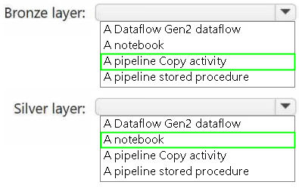

- You need to troubleshoot the ad-hoc query issue.
How should you complete the statement? To answer, select the appropriate options in the answer area. ( Case Study Q.1)
NOTE: Each correct selection is worth one point.

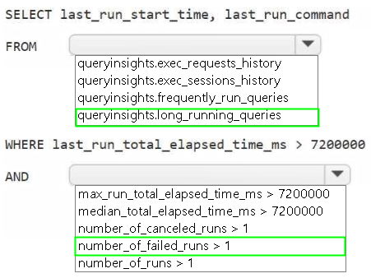

- You have a KQL database that contains a table named Readings.

You need to build a KQL query to compare the MeterReading value of each row to the previous row base on the Timestamp value.

A sample of the expected output is shown in the following table.

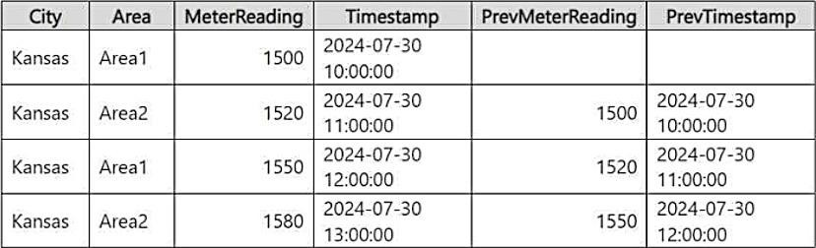
How should you complete the query? To answer, drag the appropriate values the correct targets. Each value may be used once, more than once, or not at all. You may need to drag the split bar between panes or scroll to view content.

NOTE: Each correct selection is worth one point.

How should you complete the query? To answer, drag the appropriate values the correct targets. Each value may be used once, more than once, or not at all. You may need to drag the split bar between panes or scroll to view content.

NOTE: Each correct selection is worth one point.

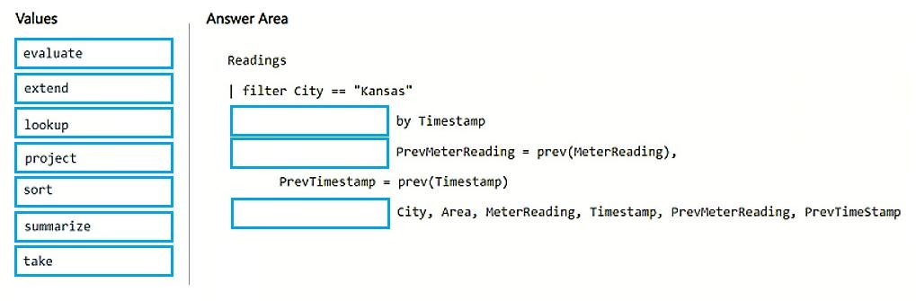
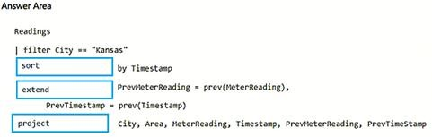

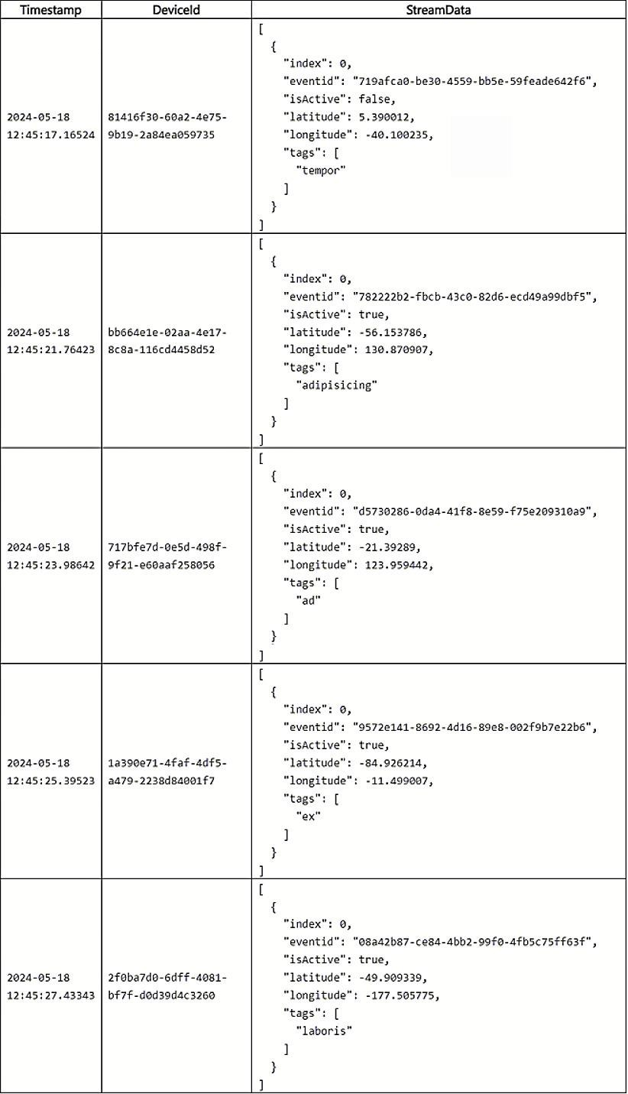
- You have a Fabric workspace that contains an eventhouse named Eventhouse1.

In Eventhouse1, you plan to create a table named DeviceStreamData in a
KQL database. The table will contain data based on the following sample.
You need to use a KQL query to develop the solution for Eventhouse1.

Which three code segments should you run in sequence? To answer, move the appropriate code segments from the list of code segments to the answer area and arrange them in the correct order.

You need to use a KQL query to develop the solution for Eventhouse1.

Which three code segments should you run in sequence? To answer, move the appropriate code segments from the list of code segments to the answer area and arrange them in the correct order.

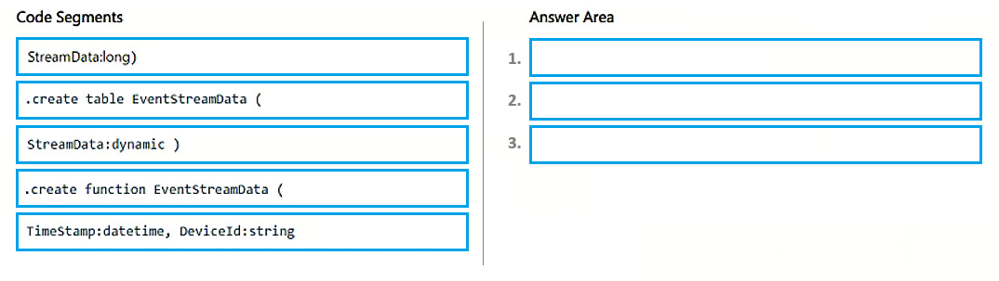
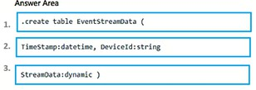

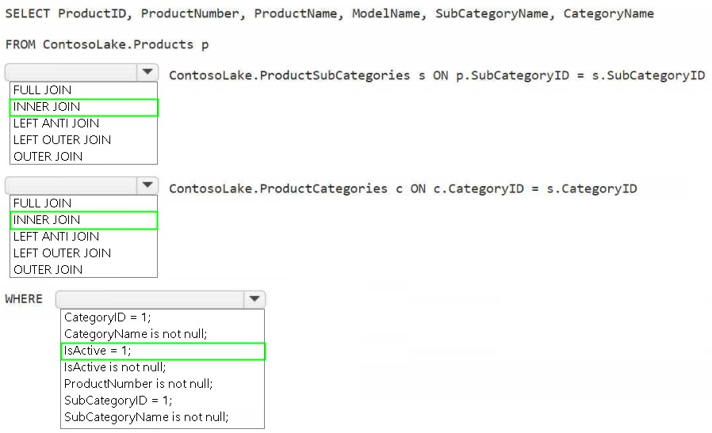
- You need to create the product dimension.
How should you complete the Apache Spark SQL code? To answer, select the appropriate options in the answer area. (Case Study 4)
NOTE: Each correct selection is worth one point.

- You have an Azure SQL database named DB1.
In a Fabric workspace, you deploy an eventstream named EventStreamDBI to stream record changes from DB1 into a lakehouse.
You discover that events are NOT being propagated to EventStreamDBI.
You need to ensure that the events are propagated to EventStreamDBI. What should you do?

  - Create a read-only replica of DB1.
  - Create an Azure Stream Analytics job.
  - Enable Extended Events for DB1.
  - Enable change data capture (CDC) for DB1.

Answer: D

- You have a Fabric workspace that contains a warehouse named Warehouse1.
While monitoring Warehouse1, you discover that query performance has degraded during the last 60 minutes.

You need to isolate all the queries that were run during the last 60 minutes. The results must include the username of the users that submitted the queries and the query statements.

What should you use?

  - the Microsoft Fabric Capacity Metrics app
  - views from the queryinsights schema
  - Query activity
  - the sys.dm_exec_requests dynamic management view

Answer: B

SELECT

login_name, -- username who submitted

command, -- query statement

start_time,

end_time,

total_elapsed_time_ms

FROM queryinsights.exec_requests_history

WHERE start_time >= DATEADD(MINUTE, -60, GETUTCDATE())

ORDER BY total_elapsed_time_ms DESC

- You need to ensure that the authors can see only their respective sales data. ( Case Study 1)

How should you complete the statement? To answer, drag the appropriate values the correct targets. Each value may be used once, more than once, or not at all. You may need to drag the split bar between panes or scroll to view content.

NOTE: Each correct selection is worth one point.

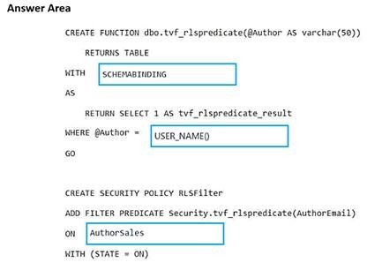

-- 1. Create predicate function (filters rows)
CREATE FUNCTION dbo.tvf_rlspredicate(@Author AS varchar(50))
RETURNS TABLE
WITH SCHEMABINDING
AS
RETURN SELECT 1 AS tvf_rlspredicate_result
WHERE @Author = USER_NAME() -- Only return rows where Author = current user
GO

-- 2. Apply security policy to table
CREATE SECURITY POLICY RLSFilter
ADD FILTER PREDICATE Security.tvf_rlspredicate(AuthorEmail)
ON AuthorSales -- Apply to this table
WITH (STATE = ON)
- You need to resolve the sales data issue. The solution must minimize the amount of data transferred. What should you do? ( Case Study 3)

  - Spilt the dataflow into two dataflows.
  - Configure scheduled refresh for the dataflow.
  - Configure incremental refresh for the dataflow. Set Store rows from the past to 1 Month.
  - Configure incremental refresh for the dataflow. Set Refresh rows from the past to 1 Year.
  - Configure incremental refresh for the dataflow. Set Refresh rows from the past to 1 Month.

- You have a Fabric workspace that contains an eventstream named EventStream1. EventStream1 outputs events to a table named Table1 in a lakehouse. The streaming data is sourced from motorway sensors and represents the speed of cars.

You need to add a transformation to EventStream1 to average the car speeds. The speeds must be grouped by non- overlapping and contiguous time intervals of one minute. Each event must belong to exactly one window.

Which windowing function should you use?

- sliding
- hopping
- tumbling
- session

Answer: C

- You have an Azure Event Hubs data source that contains weather data.
You ingest the data from the data source by using an eventstream named Eventstream1. Eventstream1 uses a lakehouse
as the destination.
You need to batch ingest only rows from the data source where the City attribute has a value of Kansas. The filter must be added before the destination. The solution must minimize development effort.
What should you use for the data processor and filtering? To answer, select the appropriate options in the answer area. NOTE: Each correct selection is worth one point.
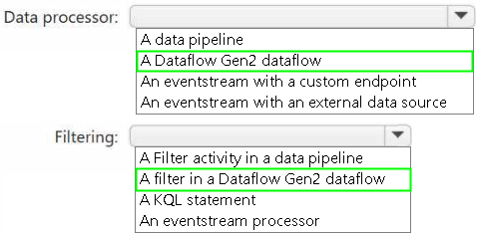

- You are building a data loading pattern by using a Fabric data pipeline. The source is an Azure SQL database that
contains 25 tables. The destination is a lakehouse.

In a warehouse, you create a control table named Control.Object as shown in the exhibit. (Click the Exhibit tab.)

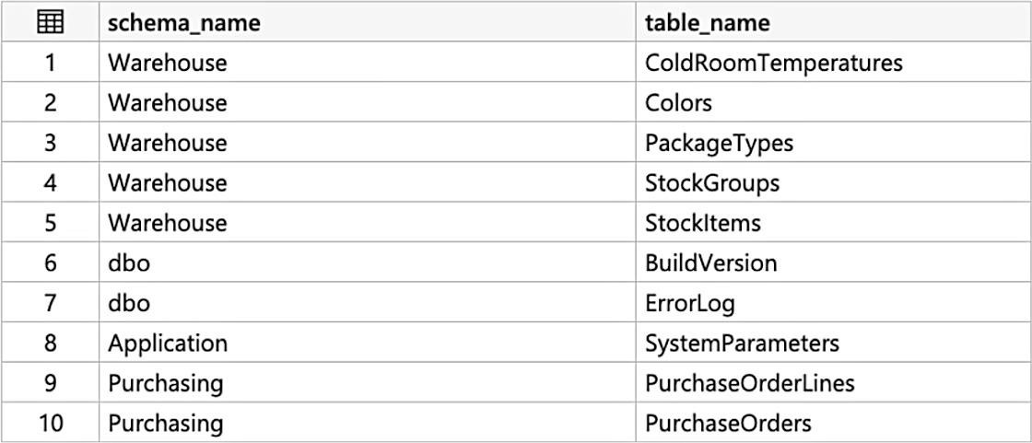

You need to build a data pipeline that will support the dynamic ingestion of the tables listed in the control table by using a
single execution.

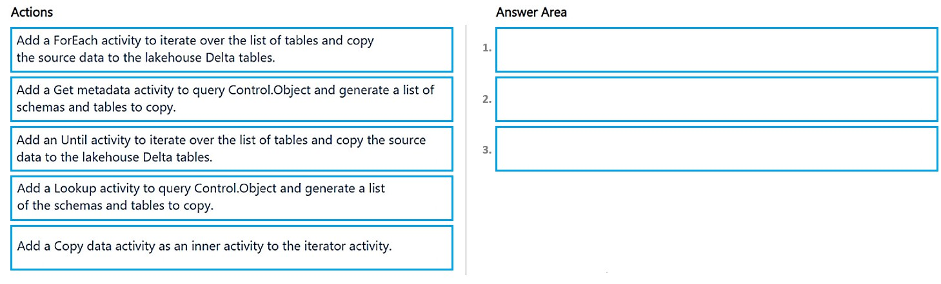
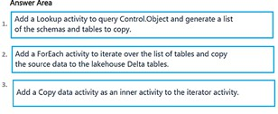
Which three actions should you perform in sequence? To answer, move the appropriate actions from the list of actions to the answer area and arrange them in the correct order.

- You have a Fabric eventhouse that contains a KQL database. The database contains a table named TaxiData. The following is a sample of the data in TaxiData.

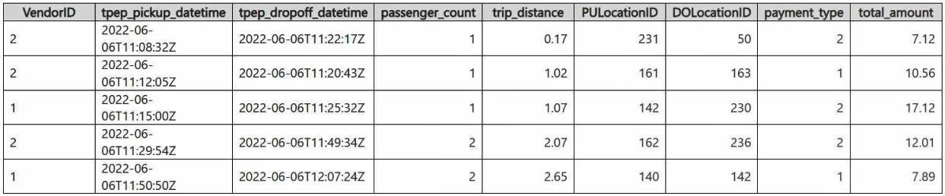

You need to build two KQL queries. The solution must meet the following requirements: One of the queries must partition RunningTotalAmount by VendorID.

The other query must create a column named FirstPickupDateTime that shows the first value of each hour from tpep_pickup_datetime partitioned by payment_type.
How should you complete each query? To answer, drag the appropriate values the correct targets. Each value may be used
once, more than once, or not at all. You may need to drag the split bar between panes or scroll to view content.
NOTE: Each correct selection is worth one point.

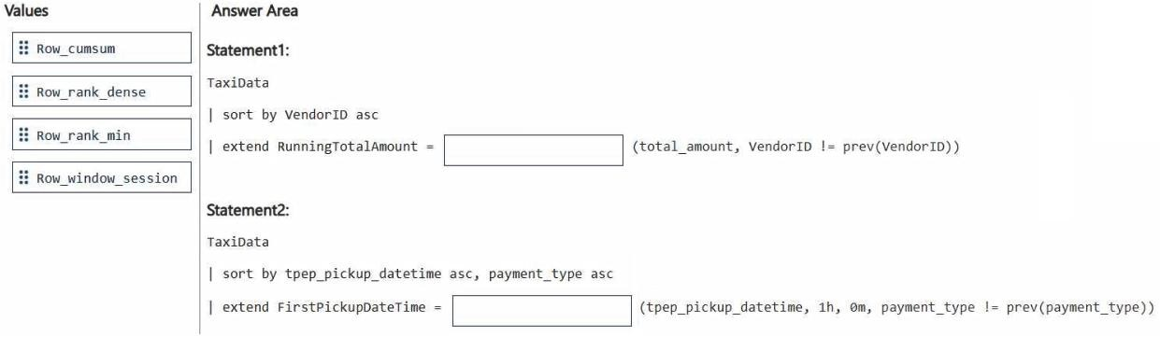



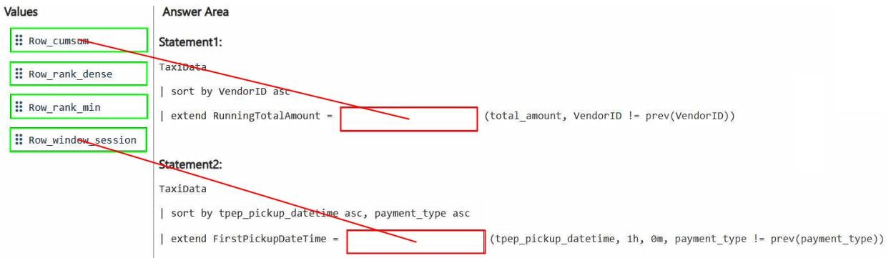

- You have a Fabric workspace named Workspace1 that contains the following items:

  - A Microsoft Power BI report named Report1
  - A Power BI dashboard named Dashboard1
  - A semantic model named Model1
  - A lakehouse name Lakehouse1

Your company requires that specific governance processes be implemented for the items. Which items can you endorse in Fabric?
    - Lakehouse1, Model1, and Dashboard1 only
    - Lakehouse1, Model1, Report1 and Dashboard1
    - Report1 and Dashboard1 only
    - Model1, Report1, and Dashboard1 only
    - Lakehouse1, Model1, and Report1 only

Answer: E

- You need to ensure that processes for the bronze and silver layers run in isolation. How should you configure the Apache Spark settings? ( Case Study 1)

  - Disable high concurrency.
  - Create a custom pool.
  - Modify the number of executors.
  - Set the default environment.

Answer(s): B

Explanation:
Isolated Compute
The Isolated Compute option provides more security to Spark compute resources from untrusted services by dedicating the physical compute resource to a single customer. Isolated compute option is best suited for workloads that require a high degree of isolation from other customer's workloads for reasons that include meeting compliance and regulatory requirements. The Isolate Compute option is only available with the XXXLarge (80 vCPU / 504 GB) node size and only available in the following regions. *The isolated compute option can be enabled or disabled after pool creation although the instance might need to be restarted*.
Scenario:

Existing Environment. Data Processing
Litware implements a medallion architecture by using the following three layers: bronze, silver, and gold. The sales data is ingested from the ERP system as Parquet files that land in the Files folder in a lakehouse. Notebooks are used to transform the files in a Delta table for the bronze and silver layers. The gold layer is in a warehouse that has V-Order disabled.

- You need to ensure that WorkspaceA can be configured for source control.
Which two actions should you perform? Each correct answer presents part of the solution.
Note: Each correct selection is worth one point. ( Case Study 2 )
- From Tenant setting, set Users can synchronize workspace items with their Git repositories to Enabled.
- From Tenant setting, set Users can sync workspace items with GitHub repositories to Enabled.
- Configure WorkspaceA to use a Premium Per User (PPU) license.
- Assign WorkspaceA to Cap1.

Answer(s): A,D

Explanation:
A F64 capacity is a Microsoft Fabric Capacity (Pay-as-you-go or Reservation). Note: Microsoft Fabric, Get started with Git integration
Prerequisites
To integrate Git with your Microsoft Fabric workspace, you need to set up the following prerequisites for
both Fabric and Git.
Fabric prerequisites

To access the Git integration feature, you need a Fabric capacity. A Fabric capacity is required to use all supported Fabric items [D]. If you don't have one yet, sign up for a free trial. Customers that already have a Power BI Premium capacity, can use that capacity, but keep in mind that certain Power BI SKUs only support Power BI items.
In addition, the following tenant switches must be enabled from the Admin portal:
* Users can create Fabric items
*-> Users can synchronize workspace items with their Git repositories [A, not B] For GitHub users only: Users can synchronize workspace items with GitHub repositories Scenario:

Existing Environment. Fabric
Contoso has an F64 capacity named Cap1 [D]. All Fabric users are allowed to create items.
Contoso has two workspaces named WorkspaceA and WorkspaceB that currently use Pro license mode.

Requirements. Planned Changes
Contoso plans to use Azure Repos for source control in Fabric.

Requirements. Technical Requirements
Items that relate to data ingestion must meet the following requirements:
*-> The items must be source controlled alongside other workspace items.

Requirements. Data Security
Security in Fabric must meet the following requirements:

- You are implementing the following data entities in a Fabric environment:
  - Entity1: Available in a lakehouse and contains data that will be used as a core organization entity
  - Entity2: Available in a semantic model and contains data that meets organizational standards
  - Entity3: Available in a Microsoft Power BI report and contains data that is ready for sharing and reuse
  - Entity4: Available in a Power BI dashboard and contains approved data for executive-level decision making
Your company requires that specific governance processes be implemented for the data.
You need to apply endorsement badges to the entities based on each entity's use case.
Which badge should you apply to each entity? To answer, drag the appropriate badges the correct entities. Each badge may be used once, more than once, or not at all. You may need to drag the split bar between panes or scroll to view content.
Note: Each correct selection is worth one point.
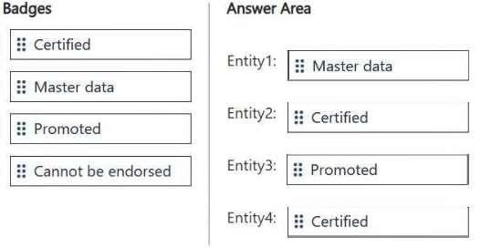
Select and Place:

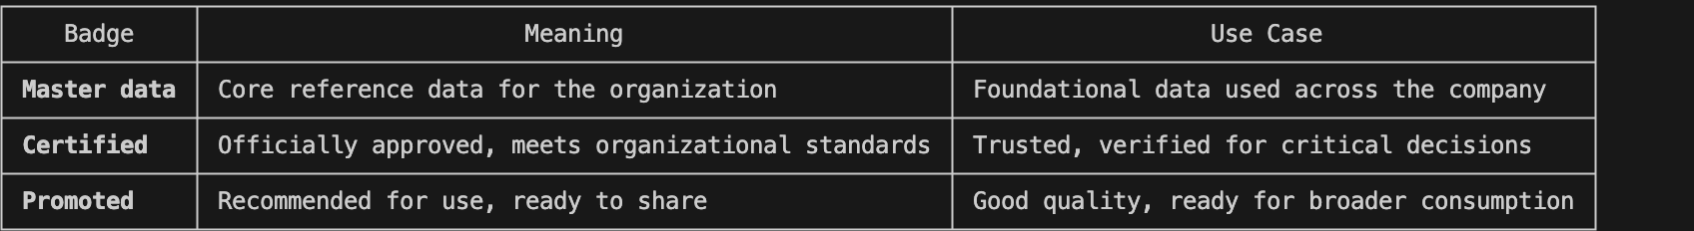
Entity1: Master data
Entity1 is available in a lakehouse and contains data that will be used as a core organizational entity. This type of data, essential for the organization's operation, qualifies as Master data, which is foundational and authoritative within the business.
Entity2: Certified
Entity2 is available in a semantic model and contains data that meets organizational standards. Since it conforms to defined standards and has been validated, it should be Certified, signifying that it has passed the required data quality checks and is trusted for reporting and analysis.
Entity3: Promoted
Entity3 is available in a Microsoft Power BI report and contains data that is ready for sharing and reuse. Since the data is actively promoted for sharing and reuse within the organization, it receives the Promoted badge.
This signifies that the data has been curated for wider consumption and distribution.
Entity4: Certified
Entity4 is available in a Power BI dashboard and contains approved data for executive-level decision making. This data is trusted and vetted for high-level decision-making and is thus Certified, indicating that it meets rigorous standards and is fit for executive-level use.

- Your company has a team of developers. The team creates Python libraries of reusable code that is used to transform data.
You create a Fabric workspace name Workspace1 that will be used to develop extract, transform, and load (ETL) solutions by using notebooks.
You need to ensure that the libraries are available by default to new notebooks in Workspace1.
Which three actions should you perform in sequence? To answer, move the appropriate actions from the list
of actions to the answer area and arrange them in the correct order. Select and Place:

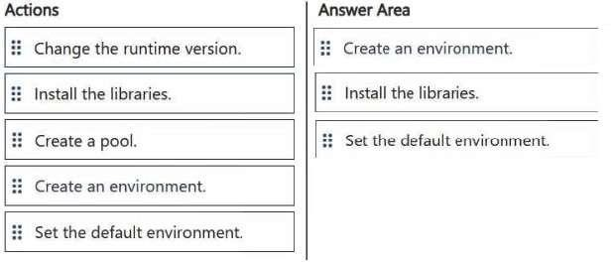

To ensure that your Python libraries are available by default to new notebooks in Workspace1, you need to follow these steps:
  - Create an environment: First, you need to create an environment where your libraries can be installed. This environment will be used by notebooks to access the required libraries.
  - Install the libraries: After creating the environment, you install the required Python libraries into that environment. These libraries can then be used by notebooks within Workspace1.
  - Set the default environment: Finally, to make sure that the libraries are available to new notebooks by default, you set this environment as the default environment for notebooks. When you create a new notebook, it will automatically use the environment with the installed libraries.

- You have five Fabric workspaces.
You are monitoring the execution of items by using Monitoring hub.
You need to identify in which workspace a specific item runs.
Which column should you view in Monitoring hub?
A.Start time B.Capacity C.Activity name D.Submitter
- Item type
- Job type G.Location

Answer(s): G https://learn.microsoft.com/en-us/fabric/admin/monitoring-hub
Explanation:
To identify in which workspace a specific item runs in Monitoring hub, you should view the Location
column.
This column indicates the workspace where the item is executed. Since you have multiple workspaces and need to track the execution of items across them, the Location column will show you the exact workspace associated with each item or job execution.

- You have a Fabric workspace that contains a warehouse named Warehouse1.
In Warehouse1, you create a table named DimCustomer by running the following statement.

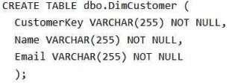
You need to set the Customerkey column as a primary key of the DimCustomer table.
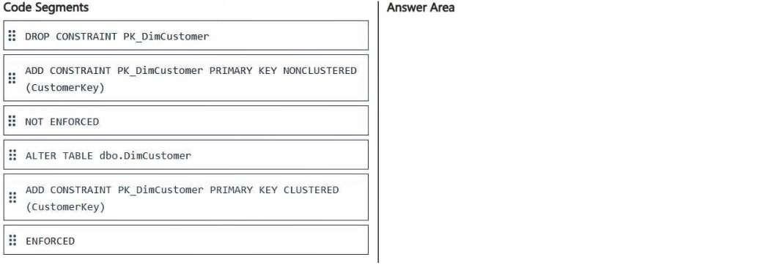
Which three code segments should you run in sequence? To answer, move the appropriate code segments from the list of code segments to the answer area and arrange them in the correct order. Select and Place:

- You have a Fabric workspace that contains a warehouse named Warehouse1.
In Warehouse1, you create a table named DimCustomer by running the following statement.


You need to set the Customerkey column as a primary key of the DimCustomer table.
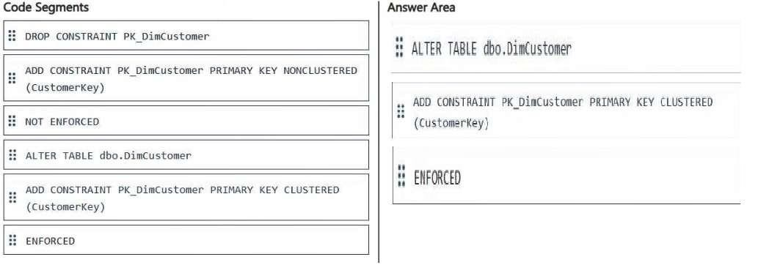
Which three code segments should you run in sequence? To answer, move the appropriate code segments from the list of code segments to the answer area and arrange them in the correct order. Select and Place:

To set the CustomerKey column as the primary key of the DimCustomer table, the steps need to follow the logical sequence of ensuring that the table structure can accommodate the primary key constraint.
- ALTER TABLE dbo.DimCustomer
This command prepares the table for modification. It ensures the DimCustomer table is being updated to include the primary key.
- ADD CONSTRAINT PK_DimCustomer PRIMARY KEY CLUSTERED (CustomerKey) This command creates a clustered primary key constraint on the CustomerKey column. A primary key uniquely identifies each record and enforces uniqueness.
- ENFORCED
This ensures that the primary key constraint is enforced, meaning it will actively validate and enforce uniqueness and nullability on the CustomerKey column.

- You have a Fabric workspace that contains a warehouse named Warehouse1. Warehouse1 contains a table
named DimCustomers. DimCustomers contains the following columns:
CustomerName CustomerID BirthDate EmailAddress
You need to configure security to meet the following requirements:
BirthDate in DimCustomer must be masked and display 1900-01-01.
EmailAddress in DimCustomer must be masked and display only the first leading character and the last five characters.
How should you complete the statement? To answer, select the appropriate options in the answer area. Note: Each correct selection is worth one point.
Hot Area:

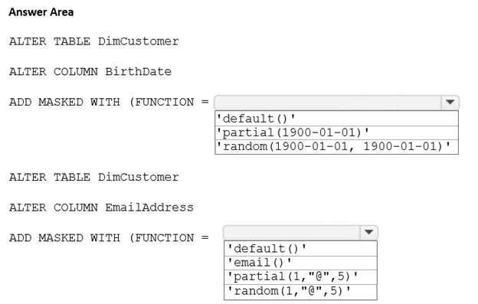

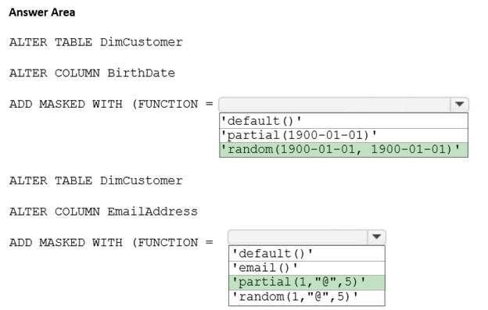

Box 1: random(1900-01-01, 1900-01-01)
BirthDate in DimCustomer must be masked and display 1900-01-01.
Random
A random masking function for use on any numeric type to mask the original value with a random value within a specified range. Example definition syntax: Account_Number bigint MASKED WITH (FUNCTION = 'random ([start range], [end range])')
Example of alter syntax: ALTER COLUMN [Month] ADD MASKED WITH (FUNCTION = 'random(1, 12)')
Box 2: 'partial(1,"@",5)'
EmailAddress in DimCustomer must be masked and display only the first leading character and the last five characters.
Custom String Masking method that exposes the first and last letters and adds a custom padding string in the middle. prefix,[padding],suffix
If the original value is too short to complete the entire mask, part of the prefix or suffix isn't exposed. xample definition syntax: FirstName varchar(100) MASKED WITH (FUNCTION = 'partial(prefix, [padding],suffix)') NULL
Example of alter syntax: ALTER COLUMN [Phone Number] ADD MASKED WITH (FUNCTION = 'partial (1,"XXXXXXX",0)')
This turns a phone number like 555.123.1234 into 5XXXXXXX.
Incorrect:
* 'default()'
Full masking according to the data types of the designated fields. default() displays XXXX.

- You have a Fabric workspace named Workspace1. Your company acquires GitHub licenses.
You need to configure source control for Workpace1 to use GitHub. The solution must follow the
principle of least privilege.
Which permissions do you require to ensure that you can commit code to GitHub?
- Actions (Read and write) and Contents (Read and write)
- Actions (Read and write) only
- Contents (Read and write) only
- Contents (Read) and Commit statuses (Read and write)

Answer(s): C

Explanation:
Microsoft Fabric Git integration Git roles
The following table describes the Git permissions needed to perform various common operations: If you're using a fine-grained access token, the following permissions are needed for common operations:
- Commit workspace changes to Git
Contents= Access: Read and write branch policy should allow direct commit Note:
- Commit workspace changes to Git All of the following roles:
Contributor in the workspace (WRITE permission on all items) Owner of the item (if the tenant switch blocks updates for nonowners) BUILD on external dependencies (where applicable)

- You have a Fabric workspace named Workspace1.
You plan to configure Git integration for Workspace1 by using an Azure DevOps Git repository. An Azure DevOps admin creates the required artifacts to support the integration of Workspace1. Which details do you require to perform the integration?
  - the organization, project, Git repository, and branch
  - the personal access token (PAT) for Git authentication and the Git repository URL
  - the project, Git repository, branch, and Git folder
  - the Git repository URL and the Git folder

Answer(s): A

Explanation:
Microsoft Fabric Git integration
Connect to your new Azure DevOps git repository, then click on the Connect and sync button:

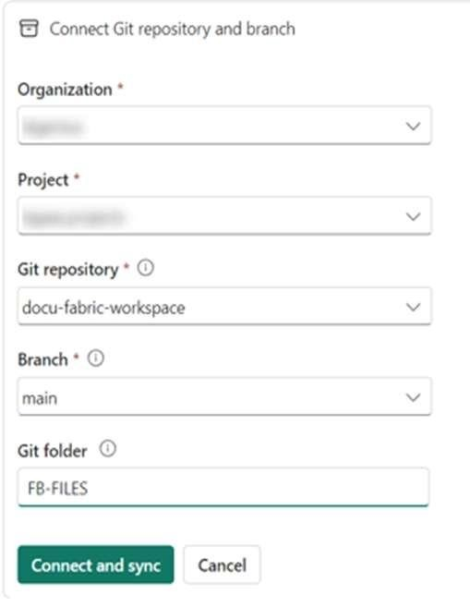

- You have a Fabric workspace that contains a lakehouse and a semantic model named Model1. You use a notebook named Notebook1 to ingest and transform data from an external data source.
You need to execute Notebook1 as part of a data pipeline named Pipeline1. The process must meet the following requirements:
Run daily at 07:00 AM UTC.
Attempt to retry Notebook1 twice if the notebook fails. After Notebook1 executes successfully, refresh Model1.
Which three actions should you perform? Each correct answer presents part of the solution. Note: Each correct selection is worth one point.
- Place the Semantic model refresh activity after the Notebook activity and link the activities by using the
On success condition.
- From the Schedule settings of Pipeline1, set the time zone to UTC.
- Set the Retry setting of the Notebook activity to 2.
- From the Schedule settings of Notebook1, set the time zone to UTC.
- Set the Retry setting of the Semantic model refresh activity to 2.
- Place the Semantic model refresh activity after the Notebook activity and link the activities by using an On completion condition.
Answer(s): A,B,C

- You have a Fabric workspace that contains a lakehouse named Lakehouse1.
You plan to create a data pipeline named Pipeline1 to ingest data into Lakehouse1. You will use a parameter named param1 to pass an external value into Pipeline1. The param1 parameter has a data type of int.
You need to ensure that the pipeline expression returns param1 as an int value.
How should you specify the parameter value?
A."@pipeline().parameters.param1" B."@{pipeline().parameters.param1}" C."@{pipeline().parameters.[param1]}" D."@@{pipeline().parameters.param1}"
https://learn.microsoft.com/en-us/azure/data-factory/how-to-expression-language-functions

Answer(s): B => A
Explanation:
Parameters for Data Factory in Microsoft Fabric
Expressions can appear inside strings, using a feature called string interpolation where expressions are wrapped in @{ ... }. For example, the following string includes parameter values and literal string values: "First Name: @{pipeline().parameters.firstName} Last Name: @{pipeline().parameters.lastName}" Using string interpolation, the result is always a string. For example, if you defined myNumber as 42: "@pipeline().parameters.myNumber"
Returns 42 as a number.

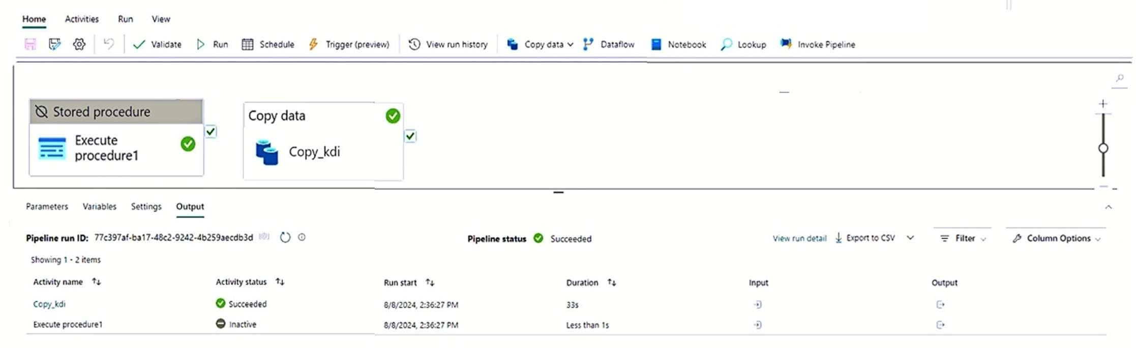
- You have a Fabric workspace that contains a data pipeline named Pipeline1 as shown in the exhibit. (Click the Exhibit tab.)

What will occur the next time Pipeline1 runs?

  - Copy_kdi will run first, and then Execute procedure1 will run.
  - Execute procedure1 will run first, and then Copy_kdi will run.
  - Execute procedure1 will run and Copy_kdi will be
skipped.
  - Copy_kdi will run and Execute procedure1 will be skipped.
  - Both activities will run simultaneously.
  - Both activities will be skipped.

What will occur the next time Pipeline1 runs?

- Copy_kdi will run first, and then Execute procedure1 will run.
- Execute procedure1 will run first, and then Copy_kdi will run.
- Execute procedure1 will run and Copy_kdi will be
skipped.
- Copy_kdi will run and Execute procedure1 will be skipped.
- Both activities will run simultaneously.
- Both activities will be skipped.

Answer(s): F

- You have a Fabric workspace that contains a warehouse named Warehouse1. Warehouse1
contains a table named Customer. Customer contains the following data.
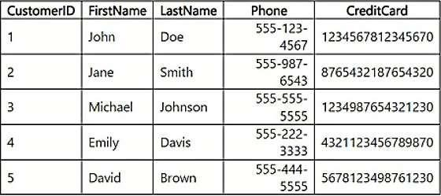

You have an internal Microsoft Entra user named User1 that has an email address of user1@contoso.com.
You need to provide User1 with access to the Customer table. The solution must prevent User1 from
accessing the CreditCard column.
How should you complete the statement? To answer, select the appropriate options in the answer area.
Note: Each correct selection is worth one point. Hot Area:

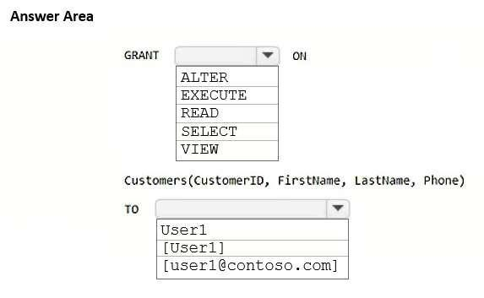

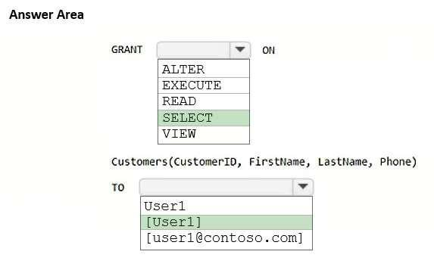

Box 1: SELECT
Implement column-level security in Fabric data warehousing
Column-level security (CLS) in Microsoft Fabric allows you to control access to columns in a table based on specific grants on these tables.
Define column-level access for tables
- Identify user or roles and the data tables you want to secure with column-level security.
- Implement column-level security with the GRANT T-SQL statement and a column list. For simplicity of management, assigning permissions to roles is preferred to using individuals.
-- Grant select to subset of columns of a table GRANT SELECT ON YourSchema.YourTable (Column1, Column2, Column3, Column4, Column5) TO [SomeGroup];
Replace YourSchema with the name of your schema and YourTable with the name of your target table.
- Replace SomeGroup with the name of your User/Group.
- Replace the comma-delimited columns list with the columns you want to give the role access to.
- Repeat these steps to grant specific column access for other tables if needed. Box 2: [User1]

- You have a Fabric workspace named Workspace1 that contains a warehouse named Warehouse1. You plan to deploy Warehouse 1 to a new workspace named Workspace2.
As part of the deployment process, you need to verify whether Warehouse1 contains invalid references. The solution must minimize development effort and provide detailed information about the invalid references. What should you use?
A.a dbt project
B.a deployment pipeline
C.a Python script
D.a database project

- You have a Fabric workspace named Workspace1 that contains a warehouse named Warehouse1. You plan to deploy Warehouse 1 to a new workspace named Workspace2.
As part of the deployment process, you need to verify whether Warehouse1 contains invalid references. The solution must minimize development effort and provide detailed information about the invalid references. What should you use?
A.a dbt project
B.a deployment pipeline
C.a Python script
D.a database project

Answer(s): B

Explanation:
Correct:
- a deployment pipeline Incorrect:
- a database project
- a dbt project
- a Python script
- a T-SQL script
Note:
A deployment pipeline in Fabric allows you to deploy assets like warehouses, datasets, and reports between different workspaces (such as from Workspace1 to Workspace2). One of the key features of a deployment pipeline is the ability to check for invalid references before deployment. This can help identify issues with assets, such as broken links or dependencies, ensuring the deployment is successful without introducing errors. This is the most efficient way to verify references and manage the deployment with minimal development effort.

Reference:
https://learn.microsoft.com/en-us/fabric/cicd/deployment-pipelines/understand-the-deployment-process

- You need to create a workflow for the new book cover images.
Which two components should you include in the workflow? Each correct answer presents part of the
solution. ( Case Study 3)
Note: Each correct selection is worth one point.
- an activator item
- a data pipeline
- a blob storage action
- a time-based schedule
- a streaming dataflow
F.a notebook that uses Apache Spark Structured Streaming

- You need to create a workflow for the new book cover images.
Which two components should you include in the workflow? Each correct answer presents part of the
solution. ( Case Study 3)
Note: Each correct selection is worth one point.
- an activator item
- a data pipeline
- a blob storage action
- a time-based schedule
- a streaming dataflow
- a notebook that uses Apache Spark Structured Streaming

Answer(s): C,E

- You need to create a workflow for the new book cover images.
Which two components should you include in the workflow? Each correct answer presents part of the solution. ( Case Study 3)
Note: Each correct selection is worth one point.
A.a time-based schedule
B.a streaming dataflow
C.a blob storage action
D.a data pipeline
E.a notebook that uses Apache Spark Structured Streaming
F.a reflex item

Answer(s): B,C

- What should you recommend that the data engineering team use to ingest the SEO data? ( Case Study 3)
A.a streaming dataflow
B.a streaming dataset
C.a notebook that uses Apache Spark Structured Streaming D.an eventstream

Answer(s): D

Explanation:
Microsoft Fabric Real-Time Intelligence,
Eventstream REST API The Microsoft Fabric REST APIs enable you to automate Fabric procedures and processes, helping your organization complete tasks more efficiently and accurately.
By automating these workflows, you can reduce errors, improve productivity, and achieve cost savings across your operations.
In Fabric, an item represents a set of capabilities within a specific experience. For example, Eventstream is an item under the Real-time Intelligence experience. Each item in Fabric is defined by an item definition--an object that outlines the structure, format, and key components that make up the item.
Scenario:

Requirements. Planned Changes
Litware plans to manage Search Engine Optimization (SEO) for the authors. The SEO data will be streamed from a REST API.

Requirements. Data Requirements
Litware identifies the following data requirements:
*-> Process the SEO data in near-real-time (NRT).

- You need to recommend a solution to resolve the MAR1 connectivity issues. The solution must minimize development effort. ( Case Study 4 )
What should you recommend?
A.Add a ForEach activity to the data pipeline. B.Configure retries for the Copy data activity. C.Call a notebook from the data pipeline.
D.Configure Fault tolerance for the Copy data activity.

Answer(s): B

Explanation:
Retry Feature in Azure Data Factory
Enhancing Data Pipeline Reliability with Retry Feature in Azure Data Factory Understanding the Retry Feature The Retry feature in ADF's Copy activity allows users to automatically retry failed operations in the event of transient failures. These failures could be caused by factors such as network disruptions, Java Native Interface errors, or temporary service unavailability.
By configuring the retry settings, users can specify the number of retry attempts and the interval between retries, providing flexibility to tailor the retry behavior according to specific requirements.
Scenario:
Requirements. Technical Requirements
Items that relate to data ingestion must meet the following requirements:
*-> In the event of a connectivity error, the ingestion processes must attempt the connection again.
* Etc.
Note: Existing environment:
The company has a software as a service (SaaS) online marketing app named MAR1. MAR1 has seven entities. The entities contain data that relates to email open rates and interaction rates, as well as website interactions. The data can be exported from MAR1 by calling REST APIs. Each entity has a different endpoint. Contoso has been using MAR1 for one year.
Requirements. Technical Requirements
The new lakehouses must follow a medallion architecture by using the following three layers: bronze, silver, and gold. There will be extensive data cleansing required to populate the MAR1 data in the silver layer, including deduplication, the handling of missing values, and the standardizing of capitalization.

- You need to recommend a solution for handling old files. The solution must meet the technical requirements. ( Case Study 4 )
What should you include in the recommendation?
A.a data pipeline that includes a Copy data activity
B.a data pipeline that includes a Delete data activity
C.a notebook that runs the VACUUM command
D.a notebook that runs the OPTIMIZE command

Answer(s): C
Explanation:
Scenario:
Technical requirements include:
Once a week, old files that are no longer referenced by a Delta table log must be removed. Note: Remove unused data files with vacuum
Predictive optimization automatically runs VACUUM on Unity Catalog managed tables. Databricks recommends enabling predictive optimizations for all Unity Catalog managed tables to simplify data maintenance and reduce storage costs.

You can remove data files no longer referenced by a Delta table that are older than the retention threshold by running the VACUUM command on the table. Running VACUUM regularly is important for cost and compliance because of the following considerations:
Deleting unused data files reduces cloud storage costs.
Data files removed by VACUUM might contain records that have been modified or deleted. Permanently removing these files from cloud storage ensures these records are no longer accessible.

- Your company has three newly created data engineering teams named Team1, Team2, and Team3 that plan to use Fabric. The teams have the following personas:

  - Team1 consists of members who currently use Microsoft Power BI. The team wants to transform data by using by a low-
code approach.
  - Team2 consists of members that have a background in Python programming. The team wants to use PySpark code to transform data.
  - Team3 consists of members who currently use Azure Data Factory. The team wants to move data between source and
sink environments by using the least amount of effort.

You need to recommend tools for the teams based on their current personas.

What should you recommend for each team? To answer, select the appropriate options in the answer area. NOTE: Each correct selection is worth one point.

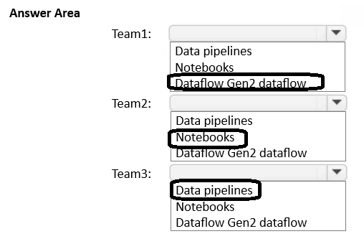

- You have a Fabric workspace that contains a warehouse named DW1. DW1 contains the following tables and
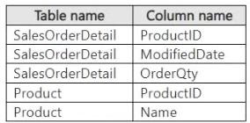
columns.
You need to summarize order quantities by year and product. The solution must include the yearly sum of order quantities for all the products in each row.

How should you complete the T-SQL statement? To answer, select the
appropriate options in the answer area.

NOTE: Each correct selection is worth one point.

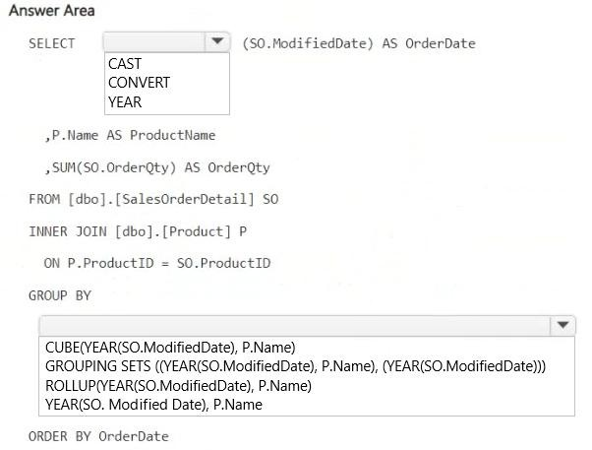

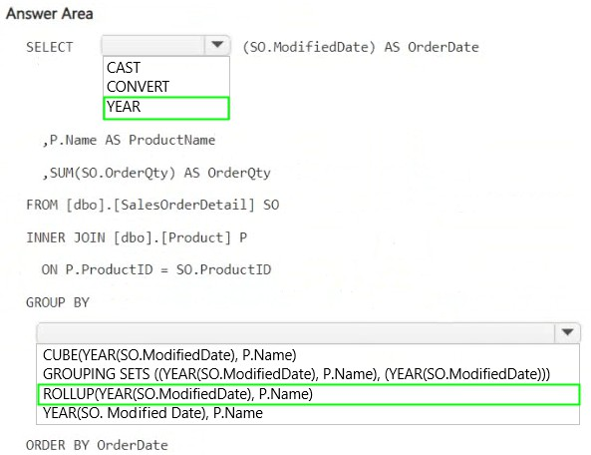

- You have a Fabric warehouse named DW1 that contains four staging tables named ProductCategory, ProductSubcategory, Product, and SalesOrder. ProductCategory, ProductSubcategory, and Product are used often in analytical queries.

You need to implement a star schema for DW1. The solution must minimize development effort. Which design approach should you use? To answer, select the appropriate options in the answer area. NOTE: Each correct selection is worth one point.
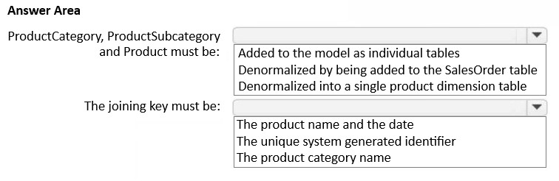

- You have a Fabric warehouse named DW1 that contains four staging tables named ProductCategory, ProductSubcategory, Product, and SalesOrder. ProductCategory, ProductSubcategory, and Product are used often in analytical queries.

You need to implement a star schema for DW1. The solution must minimize development effort. Which design approach should you use? To answer, select the appropriate options in the answer area. NOTE: Each correct selection is worth one point.
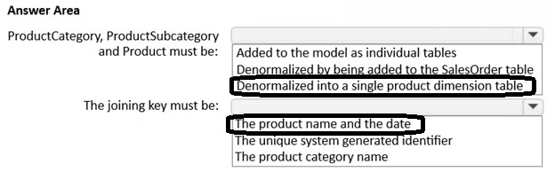

- You have a Fabric warehouse named DW1 that contains a Type 2 slowly changing dimension (SCD) dimension table named DimCustomer. DimCustomer contains 100 columns and 20 million rows. The columns are of various data types, including int, varchar, date, and varbinary.
You need to identify incoming changes to the table and update the records when there is a change. The solution must
minimize resource consumption.

What should you use to identify changes to attributes?

A. a hash function to compare the attributes in the source table.

B. a direct attributes comparison across the attributes in the DimCustomer table.

C. a direct attributes comparison for the attributes in the source table.

D. a hash function to compare the attributes in the DimCustomer table.

- You have a Fabric warehouse named DW1 that contains a Type 2 slowly changing dimension (SCD) dimension table named DimCustomer. DimCustomer contains 100 columns and 20 million rows. The columns are of various data types, including int, varchar, date, and varbinary.
You need to identify incoming changes to the table and update the records when there is a change. The solution must
minimize resource consumption.

What should you use to identify changes to attributes?

A. a hash function to compare the attributes in the source table.

B. a direct attributes comparison across the attributes in the DimCustomer table.

C. a direct attributes comparison for the attributes in the source table.

D. a hash function to compare the attributes in the DimCustomer table.

Answer: A

- You have a table in a Fabric lakehouse that contains the following data.
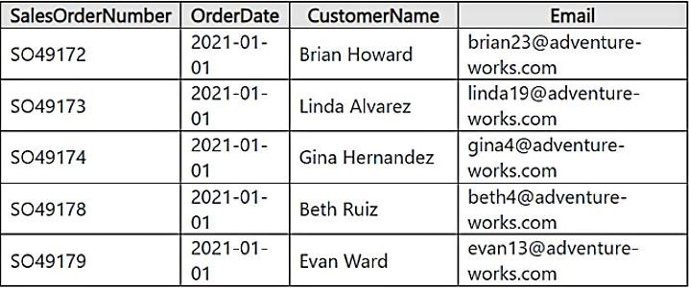

You have a notebook that contains the following code segment.

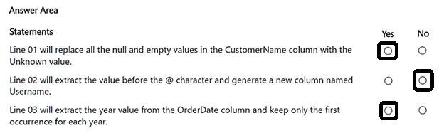

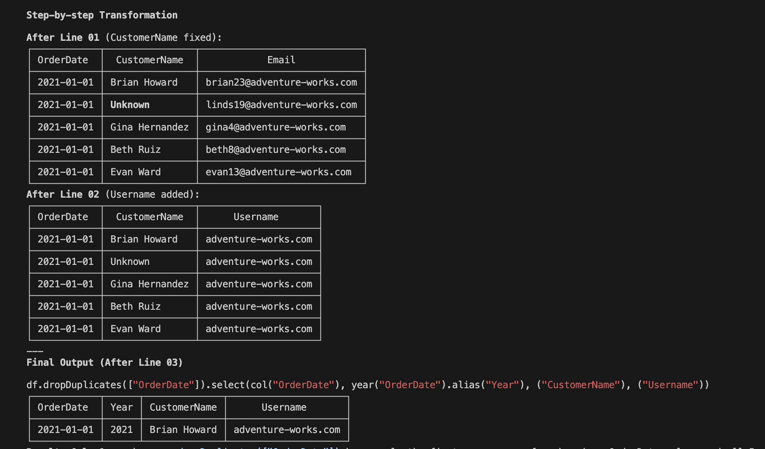
- You have a Fabric workspace that contains a write-intensive warehouse named DW1. DW1 stores staging tables that are used to load a dimensional model. The tables are often read once, dropped, and then recreated to process new data.

You need to minimize the load time of DW1. What should you do?
  - Enable V-Order.

  - Create statistics.

  - Drop statistics.

  - Disable V-Order.

Answer: D

- You have a Fabric workspace that contains a lakehouse named Lakehouse1. Lakehouse1 contains a table named Status_Target that has the following columns:

- Key
- Status
- LastModified

The data source contains a table named Status_Source that has the same columns as Status_Target. Status_Source is used to populate Status_Target.
In a notebook name Notebook1, you load Status_Source to a DataFrame named sourceDF and Status_Target to a DataFrame named targetDF.
You need to implement an incremental loading pattern by using Notebook1. The solution must meet the following requirements:
- For all the matching records that have the same value of key, update the value of LastModified in Status_Target to the value of LastModified in Status_Source.
- Insert all the records that exist in Status_Source that do NOT exist in Status_Target.
- Set the value of Status in Status_Target to inactive for all the records that were last modified more than seven days ago and that do NOT exist in Status_Source.
How should you complete the statement? To answer, select the appropriate options in the answer area. NOTE: Each correct selection is worth one point.

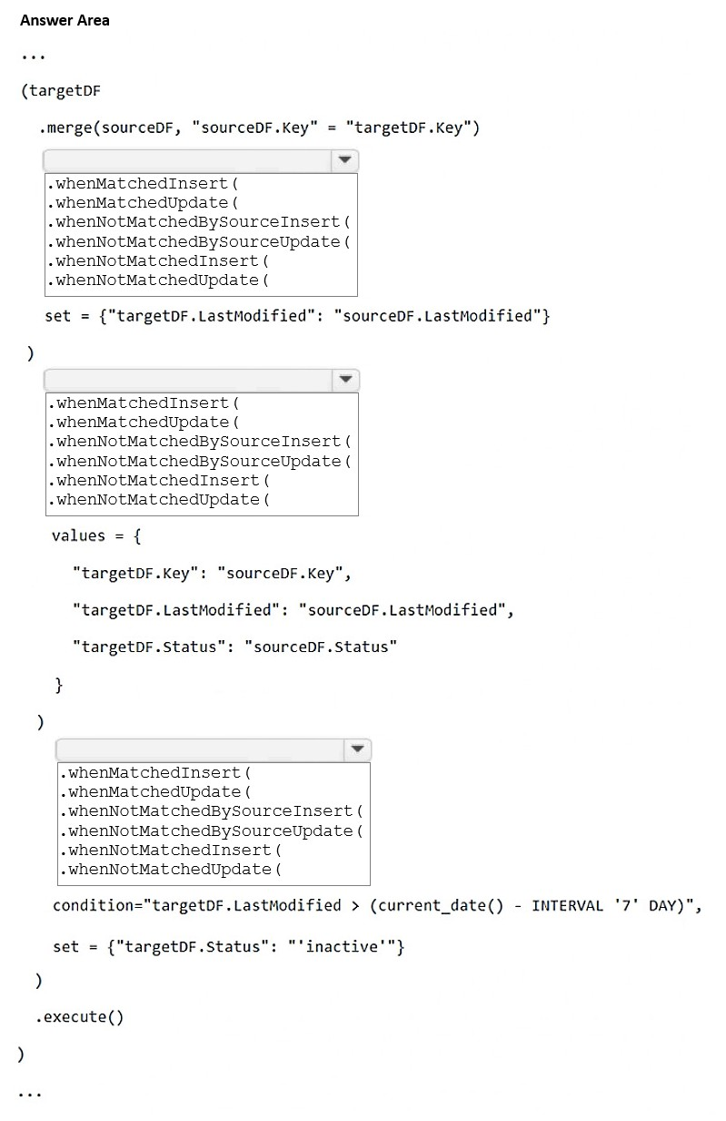

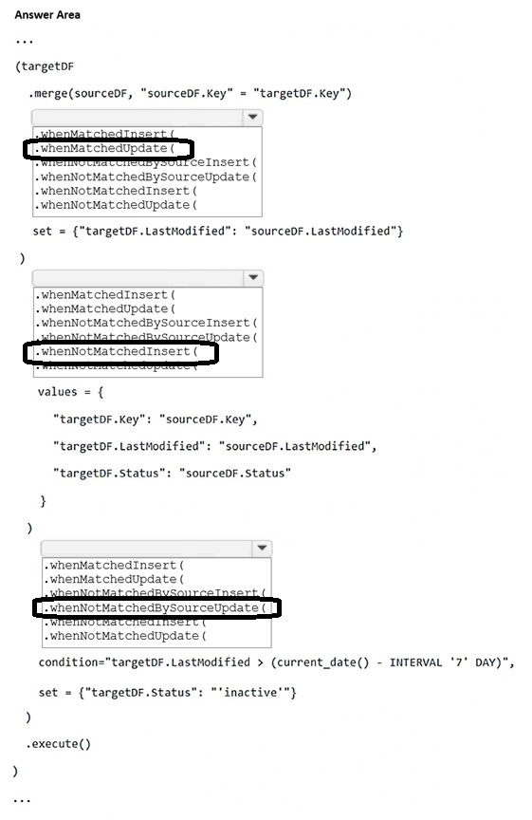

- Note: This question is part of a series of questions that present the same scenario. Each question in the series contains a unique solution that might meet the stated goals. Some question sets might have more than one correct solution, while others might not have a correct solution.
After you answer a question in this section, you will NOT be able to return to it. As a result, these questions will not appear in
the review screen.
You have a Fabric eventstream that loads data into a table named Bike_Location in a KQL database. The table contains the following columns:
BikepointID - Street - Neighbourhood - No_Bikes - No_Empty_Docks -
Timestamp -
You need to apply transformation and filter logic to prepare the data for consumption. The solution must return data for a neighbourhood named Sands End when No_Bikes is at least 15. The results must be ordered by No_Bikes in ascending order. Solution: You use the following code segment:

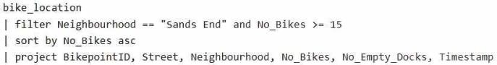

Does this meet the goal?

- Yes

- No

Answer: A

- You have a Fabric workspace that contains an eventstream named Eventstream1. Eventstream1 processes data from a thermal sensor by using event stream processing, and then stores the data in a lakehouse.
You need to modify Eventstream1 to include the standard deviation of the temperature. Which transform operator should you include in the Eventstream1 logic?

  - Expand

  - Group by

  - Union

  - Aggregate

Answer: B

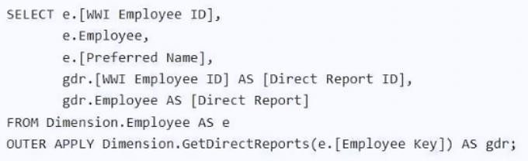
- You have a Fabric tenant that contains a warehouse named WH1. You run the following T-SQL query against WH1.

For each of the following statements, select Yes if the statement is true. Otherwise, select No. NOTE: Each correct selection is worth one point.

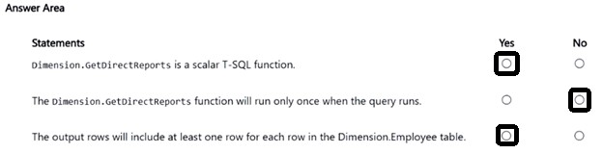

- You have a Fabric tenant named Tenant1 that contains a lakehouse named Lakehouse1.

You need to add data to Lakehouse1 from a CSV file in an Azure Storage account outside of Fabric. The solution must
minimize development effort.

What should you use to add the data?

- copy job

- shortcut

- pipeline

- Dataflow Gen2

Answer: B

- You have a Fabric warehouse named DW1 that loads data by using a data pipeline named Pipeline1. Pipeline1 uses a Copy data activity with a dynamic SQL source. Pipeline1 is scheduled to run every 15 minutes.
You discover that Pipeline1 keeps failing.
You need to identify which SQL query was executed when the pipeline failed. What should you do?

- From Monitoring hub, select the latest failed run of Pipeline1, and then view the output JSON.

- From Monitoring hub, select the latest failed run of Pipeline1, and then view the input JSON.

- From Real-time hub, select Fabric events, and then review the details of Microsoft.Fabric.ItemReadFailed.

- From Real-time hub, select Fabric events, and then review the details of Microsoft. Fabric.ItemUpdateFailed.

Answer: B

- You have a Fabric workspace that contains a lakehouse named Lakehouse1.
In an external data source, you have data files that are 500 GB each. A new file is added every day.
You need to ingest the data into Lakehouse1 without applying any transformations. The solution must meet the following requirements
Trigger the process when a new file is added. Provide the highest throughput.
Which type of item should you use to ingest the data?

- Data pipeline

- Environment

- KQL queryset

- Dataflow Gen2

Answer: A

- You have a Fabric workspace.
You are debugging a statement and discover the following issues:
Sometimes, the statement fails to return all the expected rows.
The PurchaseDate output column is NOT in the expected format of mmm dd, yy.
You need to resolve the issues. The solution must ensure that the data types of the results are retained. The results can contain blank cells.
How should you complete the statement? To answer, select the appropriate options in the answer area.

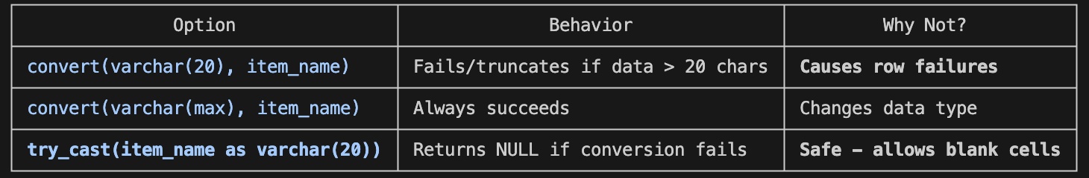
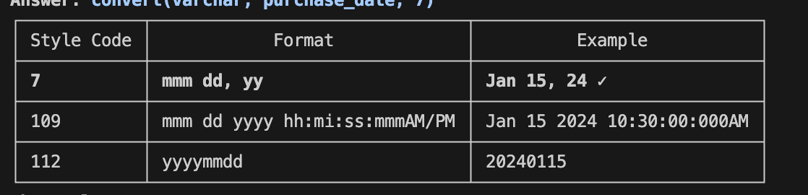

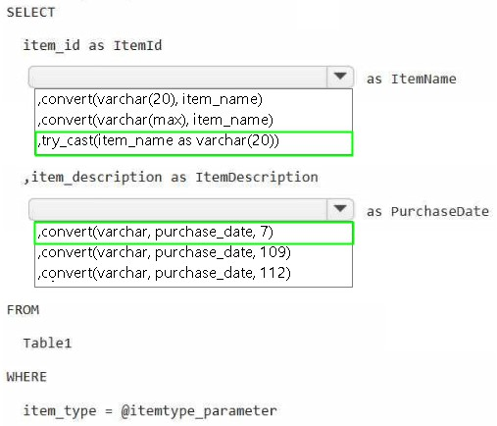

- You have a Fabric workspace that contains a semantic model named Modell. You need to monitor the refresh history of Model 1 and visualize the refresh history in a chart. What should you use?

A. a data pipeline
B. a notebook
C. a Dataflow Gen2 dataflow
D. the refresh history from the settings of Model1.

Correct Answer: B

- You are processing streaming data from an external data provider.
You have the following code segment.
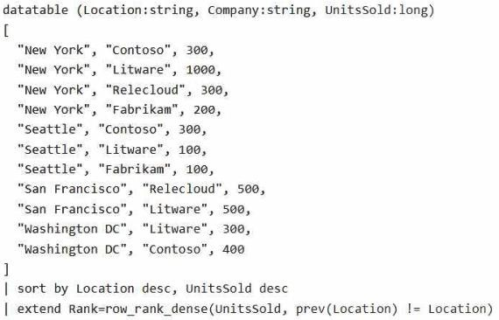

For each of the following statements, select Yes if the statement is true. Otherwise, select No. NOTE: Each correct selection is worth one point.

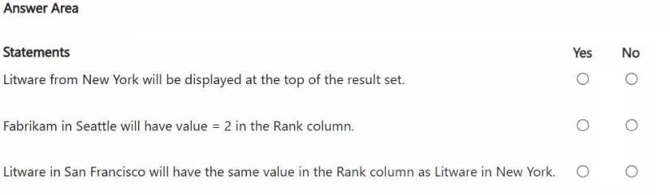

For each of the following statements, select Yes if the statement is true. Otherwise, select No. NOTE: Each correct selection is worth one point.

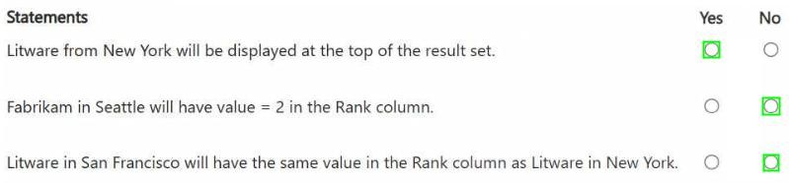

- You have a Fabric workspace that contains an eventstream named EventStreaml. EventStreaml outputs events to a table named Tablel in a lakehouse. The streaming data is souiced from motorway sensors and represents the speed of cars.
You need to add a transformation to EventStream1 to average the car speeds. The speeds must be grouped by non-overlapping and contiguous time intervals of one minute. Each event must belong to exactly one window.
Which windowing function should you use?

  - sliding
  - session
  - tumbling
  - hopping Correct Answer: C

A. Sliding Window

Time → 0 1 2 3 4 5 6 7 8 9 10 (seconds)
Events: • • • • • • • •

├────────────────┤ Window 1 (triggered by event)
├────────────────┤ Window 2 (triggered by event)
├────────────────┤ Window 3
├────────────────┤ Window 4

✗ OVERLAPPING - events can belong to multiple windows
✗ NOT contiguous - windows triggered by events

Characteristics:
- Window starts when event arrives
- Windows overlap
- Event can be in multiple windows

Use case: Real-time alerts, monitoring

---
B. Session Window

Time → 0 1 2 3 4 5 6 7 8 9 10 11 12
Events: • • • • • • •

├──────────┤ Session 1
(gap timeout)
├────────────┤ Session 2
(gap timeout)
├────┤ Session 3

✗ NOT fixed intervals - depends on activity
✗ NOT contiguous - gaps between sessions
✓ Non-overlapping

Characteristics:
- Window based on activity gaps
- No fixed duration
- Closes after inactivity timeout

Use case: User sessions, activity tracking

---
C. Tumbling Window ✓ CORRECT ANSWER

Time → 0 1 2 3 4 5 (minutes)
| | | | | |
Events: • • • | • • • | • | • •• • | • |

├─────────┤ Window 1 (0-1 min)
├─────────┤ Window 2 (1-2 min)
├─────────┤ Window 3 (2-3 min)
├─────────┤ Window 4 (3-4 min)
├─────────┤ Window 5 (4-5 min)

✓ NON-OVERLAPPING - windows don't overlap
✓ CONTIGUOUS - no gaps between windows
✓ FIXED INTERVALS - exactly 1 minute each
✓ EACH EVENT IN EXACTLY ONE WINDOW

Characteristics:
- Fixed size windows
- Windows are adjacent (back-to-back)
- No overlap, no gaps
- Each event belongs to exactly one window

Use case: Periodic aggregations (avg speed per minute)

---
D. Hopping Window

Time → 0 1 2 3 4 5 (minutes)
| | | | | |
Events: • • • | • • • | • | • •• • | • |

├───────────────────┤ Window 1 (2 min size)
├───────────────────┤ Window 2 (2 min size)
├───────────────────┤ Window 3 (2 min size)
├───────────────────┤ Window 4

|←─ hop ─→|←─ hop ─→|
(1 min) (1 min)

✗ OVERLAPPING - windows overlap each other
✓ Contiguous
✗ Events belong to MULTIPLE windows

Characteristics:
- Fixed size windows
- Windows overlap (hop interval < window size)
- Events can be in multiple windows

Use case: Moving averages, trend analysis

---
Comparison Table
┌───────────────────────────┬─────────┬─────────┬──────────┬─────────┐
│ Feature │ Sliding │ Session │ Tumbling │ Hopping │
├───────────────────────────┼─────────┼─────────┼──────────┼─────────┤
│ Non-overlapping │ ✗ │ ✓ │ ✓ │ ✗ │
├───────────────────────────┼─────────┼─────────┼──────────┼─────────┤
│ Contiguous │ ✗ │ ✗ │ ✓ │ ✓ │
├───────────────────────────┼─────────┼─────────┼──────────┼─────────┤
│ Fixed intervals │ ✗ │ ✗ │ ✓ │ ✓ │
├───────────────────────────┼─────────┼─────────┼──────────┼─────────┤
│ Event in exactly 1 window │ ✗ │ ✓ │ ✓ │ ✗ │
└───────────────────────────┴─────────┴─────────┴──────────┴─────────┘
---
Why Tumbling is Correct

The question requires:
┌──────────────────────────────────┬──────────┐
│ Requirement │ Tumbling │
├──────────────────────────────────┼──────────┤
│ Non-overlapping │ ✓ │
├──────────────────────────────────┼──────────┤
│ Contiguous (no gaps) │ ✓ │
├──────────────────────────────────┼──────────┤
│ Fixed interval (1 minute) │ ✓ │
├──────────────────────────────────┼──────────┤
│ Each event in exactly one window │ ✓ │
└──────────────────────────────────┴──────────┘
Tumbling window is the ONLY option that meets ALL requirements.

Car Speed Data → [Tumbling 1-min Window] → AVG(Speed) per minute

Minute 1: 60, 65, 70 → AVG = 65 mph
Minute 2: 55, 58, 62 → AVG = 58 mph
Minute 3: 70, 75, 72 → AVG = 72 mph
121) What should you do to optimize the query experience for the business users?

- Introduce primary keys.
- Create and update statistics.
- Run the VACUUM command.
- Enable V-Order.

Correct Answer: B

